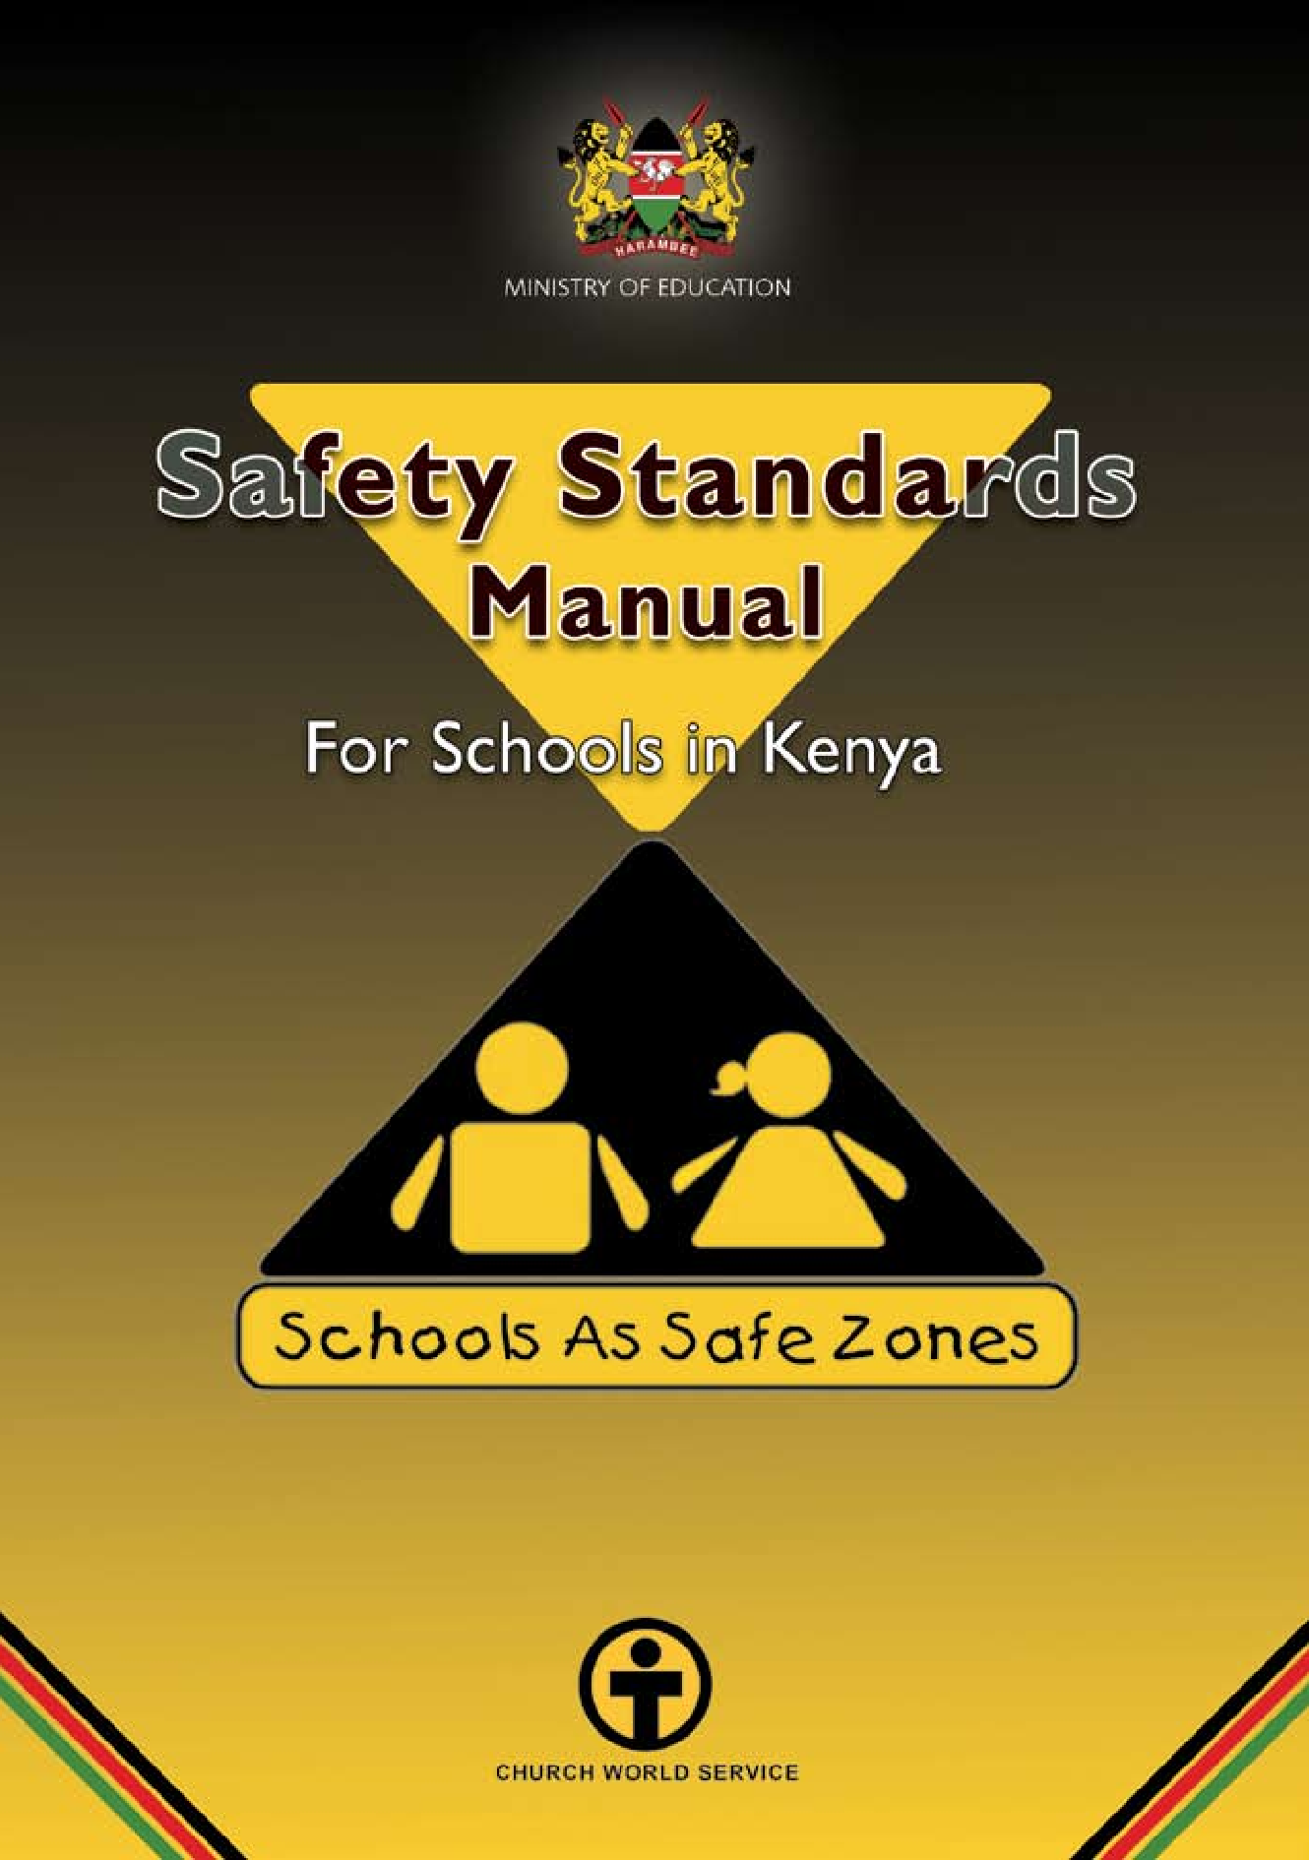
a SAFETY STANDARDS MANUAL For Schools in Kenya

SAFETY STANDARDS MANUAL For Schools in Kenya b

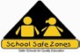

MINISTRY OF EDUCATION

Safety Standards
Manual

For Schools in Kenya

First Edition
April 2008

SAFETY STANDARDS MANUAL For Schools in Kenya ii

Message from the Minister

As we are all aware, early in 2008 our country experienced unprecedented insecurity, leading to internal displacement of over 300,000 people, many of them school children. In addition, many schools in the affected areas had their infrastructure destroyed thus disrupting learning in schools, when children returned to their home areas. These and many other cases of child abuse that continue to occur, among many other factors, necessitate the development of a school safety standards manual for use by schools.

Given the context described above, this Safety Standards Manual presents a timely rallying point for Kenyans to reflect on child safety both in and out of schools. I am happy to note that the Ministry in collaboration with Church World Service and other key stakeholders, saw it fit to initiate the School Safe Zones (SSZ) Programme through which 60 schools have been supported through the pilot phase of the initiative. Experiences gained from the pilot phase have enabled us to develop this Safety Standards Manual for application nationwide. Through this first edition of the school Safety Standards Manual, we have an opportunity for all Kenyans to come together to dialogue and agree on common standards for child protection. I, therefore, appeal to all heads of institutions, school management committee/board of governors, their teachers, parents, guardians and policymakers to critically scrutinise this edition and give us feedback so that we can improve on it for the good of our children.

I am happy to note that as a Ministry, we have already provided schools with several other guidelines, including those on social and environment standards, school infrastructure, career guidelines, and ECDE service guidelines. In addition to the guidelines, we gave all national and provincial schools funds to procure fire fighting equipment. With this support we have no doubt that these guidelines will improve the quality of education and training services and thus improve the quality of education and training at all levels.

I wish to remind all Kenyans that under the Children’s Act 2001, it is a crime to subject any child to any form of child abuse. For this reason, all the factors that reflect child abuse–including early marriage, female genital mutilation, canning, child labour, discrimination against the girl child–among others should be addressed as a matter of urgency. As educationists, we appeal to

iii SAFETY STANDARDS MANUAL For Schools in Kenya

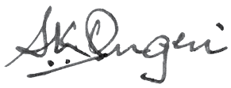

all parents and guardians to take keen interests in the safety of their children and to be vigilant against practices that constitute child abuse.

I also urge Kenyans to note that safety in our society calls for genuine tolerance and appreciation of one another and our cultural diversities. Such tolerance requires active efforts to understand the points of view of others and their contributions to our collective good as a nation. Let us all aspire to build bonds and values that unite us as a people. For us in education, we stand ready to work with all Kenyans in developing and propagating national ethos that will make Kenya a prosperous and cohesive nation, as envisaged in the Vision 2030.

The Ministry will carry out monitoring and evaluation of the implementation of this manual in order to ensure that progress is made towards the realisation of the noble goals for which it was developed. Towards this objective, I have no doubt that together WE CAN DO IT, and thus, guarantee every Kenyan child a bright future.

Finally, I thank Church World Service (CWS) for their contributions in the development of this School Safety Standards Manual.

Hon. Amb. Prof. Sam K. Ongeri, EGH, M.P.

Minister for Education

SAFETY STANDARDS MANUAL For Schools in Kenya iv

Foreword

The safety of our school children, at all times, and everywhere cannot be over-emphasised. It is in this respect that this Safety Standards Manual is both timely and invaluable. It underscores the Government’s commitment to the safety and overall welfare of our learners and especially children.

The safety of the learner is central to the provision of quality education in any country. While this is true for learners at all levels of education, it is particularly critical for learners at the basic education level in view of their relatively tender ages. Children of this early age are very vulnerable to threats such as bullying by their older colleagues, intimidation, verbal and physical abuse and all manner of harassments.

Apart from personal threats, insecurity for children can emanate from inappropriate school facilities and infrastructure. These may include poorly constructed classrooms and playing grounds, insufficient and broken-down toilet facilities, gender insensitive location of toilet and bathroom facilities, and inadequate and inappropriate desks and other furniture.

This School Safety Standards Manual will serve as a blueprint for enhancing the safety of our schools in the Republic. I am aware, and this is reflected in this Manual, that successful implementation of measures herein proposed will require partnerships with various stakeholders, among them learners, schools, parents, local communities, NGOs, religious organisations and other community based organisations (CBOs). My sincere appeal to all stakeholders is that we should work together with focus and commitment to assure our schools, and particularly the children, adequate safety.

We thank all those who have invested their resources, time and effort in the development of this manual

Professor Karega Mutahi, CBS,

Permanent Secretary, Ministry of Education

v SAFETY STANDARDS MANUAL For Schools in Kenya

Preface

Threats to learners require to be addressed through carefully thought out measures and strategies. It was in this context that the Ministry of Education, in 2003, entered into a partnership programme, School Safe Zones, with Church World Service (CWS). The programme promotes enhanced safety for learners in schools. This partnership came at the right time in view of the implementation of Free Primary Education that resulted in massive enrollment of learners at basic level in 2003. The School Safety Programme was successfully piloted in selected schools in Kajiado, Murang’a and Nairobi districts.

It was in view of the success of the pilot phase of the programme that the Ministry of Education with the support of CWS engaged a team of consultants to compile a Safety Standards Manual for use in all Kenyan schools. The consultants were guided and mandated to cast the concept of school safety widely to embrace diverse issues as they impinge upon the safety of learners, personnel, parents and the catchment communities around the schools.

Lastly, Section 6.12 is devoted to disaster and emergency preparedness, particularly to ways of handling these unforeseen events and circumstances. A careful reading of the measures proposed in this section to mitigate the impact of a variety of disasters and emergencies is strongly recommended.

In conclusion, let me thank the Government of Kenya, through the Ministry of Education, for coming up with this timely, informative and useful Safety Standards Manual for our schools.

Professor George I. Godia, Ph.D

Education Secretary, Ministry of Education

SAFETY STANDARDS MANUAL For Schools in Kenya vi

Table of Contents
Message from the Minister iii
Foreword v
Preface vi
Contextual definition of terms viii
1.0 Introduction 1
  - School Safety 4
  - The Benefits of School Safety 5
  - Threats to School Safety 5
3.0 Importance of Safe Schools 7
General Objective 8
Specific Objectives 8
4.0 Indicators of School Safety 9
  - Organisation of the School Safety Programme 11
  - Duties and Responsibilities of School Safety Sub-Committee 12
  - Functions of the School Safety Sub-Committee 13
  - Responsibilities and Functions of a Head Teacher as a Member
of the School Safety Sub-Committee 13
  - Responsibilities of the Teacher in-charge of School Safety 14
  - Safety Standards and Guidelines 15
  - Safety on School Grounds 17
  - Safety in Physical Infrastructure 19
  - Health and Hygiene Safety 25
  - Safety in School Environment 31
  - Food Safety 33
  - Safety Against Drug and Substance Abuse 35
  - Teaching and Learning Environment 41
  - Socio-cultural Environment of the School 42
  - Safety of Children with Special Needs/Disabilities 45
  - Safety Against Child Abuse 47
  - Transportation Safety 51
  - Disaster Risk Reduction 55
  - School-Community Relations 60
  - Monitoring and Evaluation of the School Safety Programme 62
References 66
vii SAFETY STANDARDS MANUAL For Schools in Kenya

Contextual definition of terms
Child | Is a person of below eighteen years (18) of age.
Disaster | Is a serious disruption of the functioning of a community or society, causing widespread human, material, or environmental losses which exceed the ability of the affected population to cope.
Natural disasters | Are calamities that occur without human causes, such as earthquakes, floods, landslides, volcanic eruptions etc.
Human-made disasters | Calamities caused by the actions of human beings either directly or indirectly, such as wild fires, accidental releases of oil, industrial accidents, pollutions, civil strife, among others.
Hazard | Natural or human made event that threatens to adversely affect human life to the extent of causing disaster.
Guidelines | Recommended practices that the school should undertake to meet the safety standards suggested.
Health | A state of physical, mental and social well-being, not merely the absence of disease infirmity of a learner.
Learner | A child between 6 and 18 years enrolled in a school.
Physical infrastructure | Refers to any built facility for use in the school to facilitate the provision of services.
School as a Safe Zone | A legally designated, identifiable physical space around the school that is a conducive environment for school children’s safety.
School Stakeholders | Groups of people with roles to play in the running of a school e.g. learners, staff, school committee members, parents, sponsors, NGOs supporting the school, local community, people in charge of security, etc.
Standard | The level of Quality achievement in relation to a School Safety component e.g. environmental safety, quality water, safe buildings.
Waste disposal | Refers to any method employed in discarding or destroying items considered to be of no value or items that are no longer useful in the school compounds.

SAFETY STANDARDS MANUAL For Schools in Kenya

viii

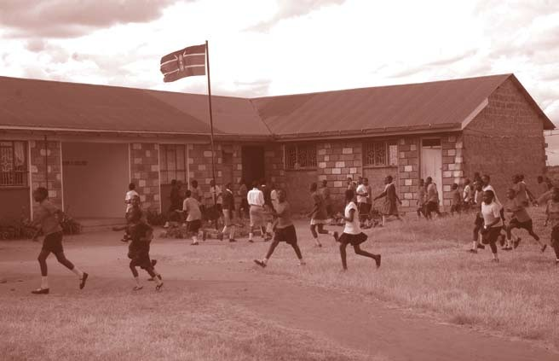

1.0

Introduction

I SAFETY STANDARDS MANUAL For Schools in Kenya

Since the attainment of independence in 1963, the Government of Kenya has committed itself to improving the standards of education at all levels. This commitment has been driven by several reasons, including the need to provide education as a fundamental human right, education as a social vaccine in the fight against poverty, and education as an integral and indispensable vehicle for achieving the goals of national development and integration, and peace. It is for this reason that the Government has from time to time appointed various educational commissions, committees and task forces to address various challenges facing our education sector. Examples include the Kenya Education Commission (1964), National Committee on Educational Objectives and Policies (1976), the Presidential Working Party on the Second University in Kenya (1981); the Presidential Working Party on Education and Manpower Training for the Next Decade and Beyond (1988), the Commission of Inquiry in the Education System in Kenya (2000); etc.

The Government is also a signatory to international conventions and protocols that have emphasised the right of every human being to quality education. Examples include UN Convention on the Rights of the Child (CRC), the Convention on Elimination of All Forms of Discrimination against Women (CEDAW) and The World Conference on Education for All. The Government’s commitment and seriousness in implementing the recommendations of the international conventions and protocols to meet the challenges of education training and research in the 21st century is evidenced by the various policies and strategies so far developed. One of the key policy documents this century is the Sessional Paper No. 1 of 2005 on Education, Training and Research and its implementation programme, through the Kenya Education Sector Support Programme (KESSP).

With regard to basic education, the Government focuses on (as outlined in Sessional Paper No. 1 of 2005) promotion of access, equity, relevance and quality of education. Specifically, the policy framework aims at achieving Education For All(EFA) by 2015, ensuring the right of children to basic education as underscored in the Children’s Act (2001), increasing access, equity and relevance of basic education, and delivering quality services efficiently and effectively at all times and at all levels.

Towards the realisation of the set goals, the Government has developed various interventional strategies to ensure safe and secure school environments. This strategy arises from the strong conviction that:
    - Safe and secure school environments facilitates and fosters quality teaching and learning in educational institutions. Safety, especially in

SAFETY STANDARDS MANUAL For Schools in Kenya h

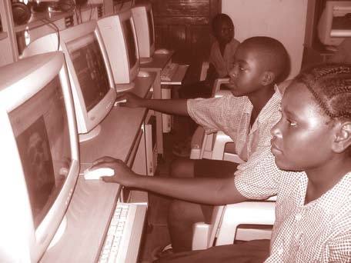schools, is even more critical given the fact that young children are vulnerable to insecurity.
    - In insecure school environments, delinquency, truancy and absenteeism, especially among girls, are common.
    - When teaching and learning is interrupted by acts of violence among learners,through ethnic or land clashes,cattle rustling,cultural practices such as female circumcision (commonly referred to as Female Genital Mutilation or FGM), learner performance in national examinations will inevitably be compromised. Comprehensive school safety is, therefore, fundamental to school success and learner achievement.
    - The Government’s commitment to the promotion of access, equity, participation, retention, completion and quality at school level of education is bound to be affected if safety and security concerns are not addressed fully.

In recognition of the critical importance of school safety, in the provision of quality education, the Government, through the Ministry of Education, is committed to institutionalising and mainstreaming school safety. However, it is critical to appreciate that school safety is not provided by fences and walls but by the community as a whole. For this reason, building strong bonds between the school and the community ensures child safety in and out of school.

) SAFETY STANDARDS MANUAL For Schools in Kenya

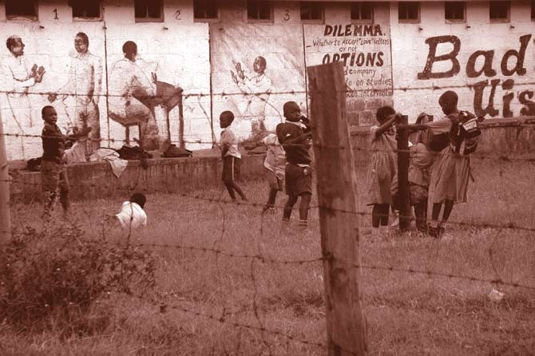

2.0

School Safety

SAFETY STANDARDS MANUAL For Schools in Kenya 4

The Benefits of School Safety
School Safety is an integral and indispensable component of the teaching and learning process. Indeed, no meaningful teaching and learning can take place in an environment that is unsafe and insecure to both learners and staff. It is, therefore, imperative that educational stakeholders foster safe and secure school environments to facilitate increased learner enrolment, retention and completion and hence attainment and quality education.

What is School Safety? Broadly and simply defined, School Safety are the measures undertaken by the learners, staff, parents and other stakeholders to either minimise or eliminate risky conditions or threats that may cause accidents, bodily injury as well as emotional and psychological distress. Accidents can lead to disability or death while emotional and psychological trauma can result in lack of self-esteem and ultimately lead to poor performance of tasks and responsibilities. Creating a School Safe Zones does not only mean ensuring an accident free school environment. Rather, it is the responsibility taken by learners, staff, parents and stakeholders to foster all-round safe living.

Threats to School Safety
Threats to School Safety can emanate internally–within the school environment– or externally,–from the wider community. Key among the threats to School Safety are:
    - Accidents – it has long been presumed, and wrongly so, that accidents ‘just happen’ and therefore trying to prevent them would be a futile exercise. The truth, however, is that accidents are caused by certain definable factors that can be prevented. The main causes of accidents in schools are human related, i.e. caused through carelessness, inattentiveness, ignorance, irresponsibility or negligence on the part of the learners, staff or other stakeholders in general. Accidental injuries can be caused by:
      - Slippery surfaces
      - Wet greasy spots
      - Clutter on the floor (too many scattered things)
      - Poorly placed furniture such as desks, benches, and tables.
      - Weak railings
      - Insufficient lighting

5 SAFETY STANDARDS MANUAL For Schools in Kenya

      - Sitting carelessly on desk e.g. with feet blocking aisles (paths)
      - Poor ventilation
      - Sharp instruments.
    - School violence and harassment – violence in schools takes the form of teacher-on-learner violence and learner-on-learner violence etc. Teacher-on-learner violence takes the form of physical violence such as corporal punishment, sexual assault, twisting/pulling of ears, slapping and pinching. Some teachers also emotionally abuse learners through verbal abuse and harassment, taunts and belittling. These abuses and harassments affect the learners’ ego and self esteem. On the other hand, learner-on-learner violence is often characterised by physical attacks, sexual assault and bullying etc (All these are illegal).
    - Lack of adequate healthcare and nutrition – it has been established that good health and nutrition are indispensable to effective learning among learners. Childhood diseases and other ailments such as malaria and worm infections have major implications for school attendance, retention and participation. Malnutrition and hunger among learners are common given the poverty levels among households. These impact on learning. Of concern also is the fact that children suffering from ill health and malnutrition are susceptible to accidents or body injury. Problems relating to health are also compounded by the increasing incidents of drug and substance abuse among learners, child pregnancy, female circumcision and HIV/AIDS pandemic etc.
    - Lack of sensitivity to sexual maturation challenges for both boys and girls.
    - Armed conflicts and insecurity – incidents of land or ethnic clashes, political violence and cattle rustling in certain parts of the country have had direct and indirect impacts on teaching and learning processes. A number of schools affected by insecurity have had their teaching processes interrupted through closure. Parents are unlikely to send their children to schools they deem insecure.
    - Hostile school environment – a school environment that does not accommodate the welfare of its learners or neglects the needs of its learners, especially girls, children with disabilities, orphans and other children with special needs, reflects a non-caring school. In addition, good interpersonal relationships in schools are key in fostering good teaching and learning processes.

SAFETY STANDARDS MANUAL For Schools in Kenya 6

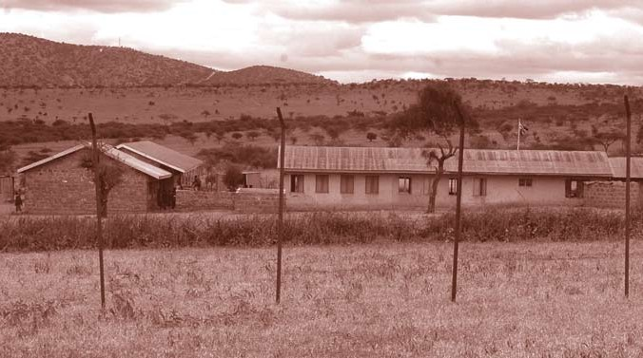

3.0

Importance of Safe Schools

7 SAFETY STANDARDS MANUAL For Schools in Kenya

General Objective
The objective of this manual is to create and maintain a Safe, Secure and Caring environment that facilitates and enhances quality teaching and learning processes in all schools in the country.

Specific Objectives
More specifically, School Safety seeks to:

    - provide opportunities for the learner to exploit and maximise potential for learning, growth and development.

    - provide opportunity for the learner to participate in enhancing school safety.

    - promote, maintain and contribute to the understanding of child and staff safety.

    - provide a benchmark for monitoring and appraising the safety status of schools.

    - empower members of the school community to handle disasters and thus minimise risks.

    - provide first line emergency services to learners and staff who become victims of injury or are taken ill.

    - counsel, guide and advise learners and staff on issues relating to school safety.

    - empower the school to liaise with parents, members of the community and other partners in order to increase awareness about issues related to school safety.

    - forge alliances and networks that enhance school and child safety.

SAFETY STANDARDS MANUAL For Schools in Kenya 8

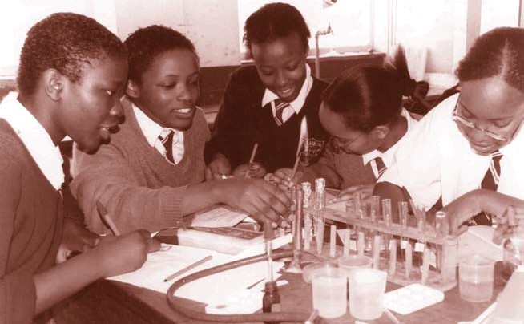

4.0

Indicators of School Safety

9 SAFETY STANDARDS MANUAL For Schools in Kenya

A safe school should have the following indicators:

    - High retention rate of enrolled learners.

    - Strong focus on teaching and learning, reflected by better academic performance and all round character development amongst its learners.

    - Visible strategies in promoting the rights of children as provided in the Convention on the Rights of the Child and in Children’s Act.

    - High levels of interaction between school administrators, teachers, learners, sponsors parents/guardians and the community, among others.

    - Active participation of community in school programmes.

    - Visible presence of key stakeholders such as relevant Government officials, private sector representatives, religious leaders, and representatives of NGOs in providing material, psychological and spiritual needs of the learners and staff.

    - Adequate and well maintained facilities such as toilets and sanitation facilities.

    - Clearly demarcated school grounds with proper fencing and secure gates/boundaries.

    - An environment free from drug and substance abuse, trafficking and illegal hawking.

    - Low incidences of indiscipline.

SAFETY STANDARDS MANUAL For Schools in Kenya I0

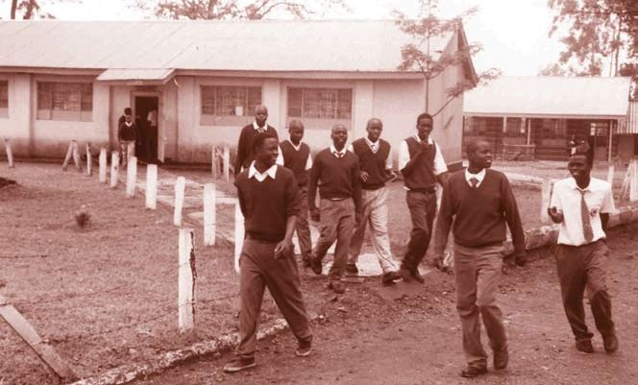

5.0

Organisation of the School Safety Programme

II SAFETY STANDARDS MANUAL For Schools in Kenya

The safety of the school depends to a large extent on measures taken to organise and manage such safety. In this respect, School Management Committee/Board of Governors members, the head teacher, teachers, learners, parents and other stakeholders have important roles to play in facilitating and enhancing safety in schools. Nonetheless, the direct responsibility of overseeing school safety should fall within a specific School Safety Committee. The duties and responsibilities of the School Safety Committee should be as outlined below:

Duties and Responsibilities of School Safety Sub-Committee
Each School Management Committee/Board of Governors shall constitute a sub-committee to deal with School Safety.

Membership*
The Sub-Committee shall consist of the following members:

i) Chair, School Management Committee/Board of Governors..Chairperson ii) Head teacher Secretary
- The deputy head teacher Member

- Teacher in charge of School Safety Member

- Guidance and counselling teacher Member

- Teacher union representative (in the School) Member

- An Ex-officio from AEO’s Office Member

- A representative of the Crisis Response Team (CRT)

- Two other members of the School Management Committee/Board of Governors**

* Attention should be paid to fair gender representation in the sub-committee
** One of these members must be a representative of the school sponsor

SAFETY STANDARDS MANUAL For Schools in Kenya Ih

Functions of the School Safety Sub- Committee
The specific functions of this Committee shall be to:
    - identify the safety needs of the school with a view to taking the necessary action.
    - mobilise resources required by the school to ensure a safe, secure
and caring environment for learners, staff and parents.
    - monitor and evaluate the various aspects of School Safety with a view to enhancing school safety.
    - form sustainable networks with all stakeholders to foster and sustain School Safety.
    - keep learners, parents and other stakeholders informed about School Safety policies and implementation activities.
    - seek the support of parents and stakeholders and ensure their participation in activities relating to School Safety.

    - constantly review issues of child safety in and around the school.

The specific functions of some of the key members of the school safety sub- committee are outlined in the sections below.

Responsibilities and Functions of a Head Teacher as a Member of the School Safety Sub-Committee
The head teacher will be responsible for:
    - ensuring proper implementation of School Safety policies by coordinating all phases of programme implementation.
    - coordinating the efforts of the School Safety Sub-Committee, teachers, learners and parents in ensuring that the school is safe, secure and caring.
    - ensuring that school resources are efficiently used in fostering a
safe, secure and caring environment in the school.

I) SAFETY STANDARDS MANUAL For Schools in Kenya

    - ensuring that proper and up-to-date records relating, to School Safety are compiled and properly managed.
    - coordinating the monitoring and evaluation of the School Safety Programme.
    - liaising with the teacher in-charge of School Safety, the zonal QASO and the TAC tutor to ensure the implementation of School Safety measures agreed upon.
    - taking necessary corrective measures in accordance with the monitoring and evaluation reports.
    - convening the meetings of the School Safety Committee either on his/ her own or on the chairperson,s request.

Responsibilities of the Teacher in-charge of School Safety
The Teacher in-Charge of School Safety will be responsible to the School Safety Sub-Committee in:
    - liaising with other teachers on matters relating to school safety.
    - identifying the potential safety hazards in the school with a view to taking corrective measures, either directly or through the committee.
    - sensitizing learners, staff, parents and community members regularly on issues relating to Child Safety.
    - keeping accurate and up-to-date records of incidents relating to School Safety.
    - briefing the head teacher periodically on the status of School Safety.
    - ensuring that school safety measures agreed upon are implemented.

SAFETY STANDARDS MANUAL For Schools in Kenya I4

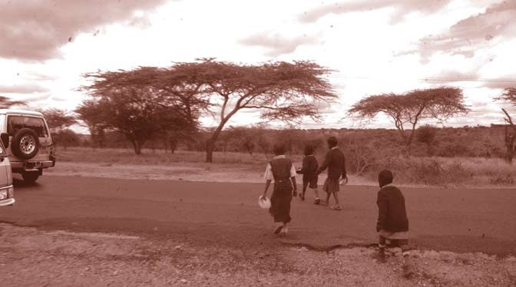

6.0

Safety Standards and Guidelines

I5 SAFETY STANDARDS MANUAL For Schools in Kenya

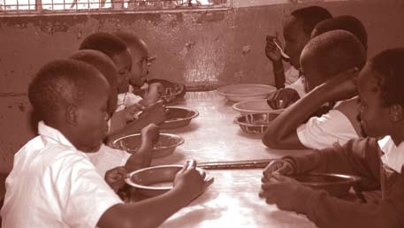This Safety Standards Manual is a document that the school should use to maintain a Safe, Secure and Caring environment that fosters teaching and learning. This manual therefore sets out the Standards and Guidelines that a school should put in place to enhance Child Safety. The Safety Standards Manual incorporates the following key components:
- Safety on School Grounds
- Safety in Physical Infrastructure
- Health and Hygiene Safety
- Safety in School Environment
- Food Safety
- Safety Against Drug and Substance Abuse
- Safe Teaching and Learning Environment
- Socio-cultural Environment of the School
- Safety of Children with Special Needs/Disabilities
- Safety Against Child Abuse
- Transportation Safety
- Disaster Risk Reduction
- School Community Relations.

Each of the 13 areas of School Safety covered in this manual begins with a statement followed by the necessary guidelines which when implemented should facilitate the realization of the Safety Standards. We encourage stakeholders to treat these guidelines as critical inputs to their learner protection efforts.

SAFETY STANDARDS MANUAL For Schools in Kenya I6

Safety on School Grounds
School grounds refer to the entire enclosure designated for

use by the

school for any of its activities such as learning, playing, games or sports. Such grounds should be large to house the required physical infrastructure, including classrooms, offices, latrines, playing grounds and assembly walkways, among others. The school ground must be well managed and the necessary documents of ownership obtained from the Ministry of Lands or the Local Authority, whichever is appropriate.

The following are vital indicators for a safe school ground:

    - Title deeds well kept in a tamper-proof facility and away from any risk or clearly demarcated school compound pending documentation and issuance of title deeds.
    - Registration documents properly kept.
    - Properly fitted and lockable gate or gates with a security office.
    - Good security arrangements with provision for both night and day security personnel (watchmen).
    - Well maintained and clean learning rooms.
    - Well maintained and clean desks and chairs in classrooms, offices and other relevant places.
    - Properly maintained play grounds for various sporting activities and a free area for general play.
    - Properly arranged and maintained walkways, motorways and parking.
    - Properly reinforced fence with appropriate mechanisms for repair and maintenance.

+ School Safety Standard No.1
The school should have properly demarcated and fenced grounds with a secure gate. The grounds should be neat, beautiful and safe for use by learners, staff, parents and community members, at all times.

I7 SAFETY STANDARDS MANUAL For Schools in Kenya

Guidelines
In order to ensure safe school grounds, the following guidelines are necessary:
    - Any school confirmed to have no valid title-deed after verification with Ministry of Lands or any relevant authority should be assisted to secure ownership of the land or be moved to own grounds.
    - The school should post a “NO TRESPASSING” and “VISITORS REPORT TO HEAD TEACHER’S OFFICE“ signs at the main gate entrance.
    - For schools without a gate and a fence, a sign should be posted next to the main passageway into the school with the words“NOTRESPASSING” and “VISITORS REPORT TO THE HEAD TEACHER’S OFFICE”
    - All visitors to the school must sign the visitor’s register and record their IDs at the gate. The gatekeeper must verify that the IDs are valid and keep them safely. The IDs are to be returned on signing out on completion of the visit.
    - School staff as well as community members should have the right to question any stranger found near or within the school grounds.
    - The school should erect sign boards to show directions to various facilities such as the administration offices, staff offices, classrooms, toilets, dining hall, dormitories and staff houses.
    - School grounds should, wherever possible, be located in places with least climatic hazards such as floods, wind effects and similar natural hazards. Similarly, schools should be located away from disruptive land use activities such as industrial facilities, bars, heavy traffic routes, sewage or dump sites etc.
    - The school grounds should be levelled to make them easier for use by learners and teachers.
    - The bare areas of the school grounds should be planted with grass to minimise the effects of dust.
    - Trees in the school should be labelled, indicating their uses and those that may be poisonous.
    - School managements should mobilise resources to ensure that requirements of safe school grounds are met.

SAFETY STANDARDS MANUAL For Schools in Kenya I8

    - Any dispute regarding the ownership of part or whole of the school grounds should be solved within the provision of the Laws of the Republic of Kenya.
    - Playgrounds should reflect the diversity of sport talents in the school. The equipment used for such games should meet the necessary safety requirements. Proper segregation (separation) of these grounds should be ensured.
    - All walkways should be properly demarcated with flowers or shrubs rather than wires, which may cause injuries to learners.
    - In order to maintain safe school grounds, good working relationships should be promoted among all stakeholders namely, learners, the head teacher, teachers, other school staff, parents, School Management Committee/Board of Governors members, community and Government officials.
    - There should be proper and regular supervision and inspection of school grounds to ensure that there are no items such as broken glass, loose sticks, stones or pot-holes that can cause injury to the learners, teachers or other school personnel.
    - Learners and staff should collectively be responsible for playground safety.

Safety in Physical Infrastructure
These facilities include structures such as classrooms, offices, toilets, dormitories, libraries, laboratories, kitchen, water tanks, playground equipment, among others. These facilities can be either permanent or temporary structures. Such physical structures should be appropriate, adequate and properly located, devoid of any risks to users or to those around them.They should also comply with the provisions of the Education Act (Cap 211), Public Health Act (Cap 242) and Ministry of Public Works building regulations/standard.

+School Safety Standard No.2
The school should ensure classrooms, dormitories, offices, kitchens, toilets, and other physical structures are clean, well maintained, safe and properly utilised.

I9 SAFETY STANDARDS MANUAL For Schools in Kenya

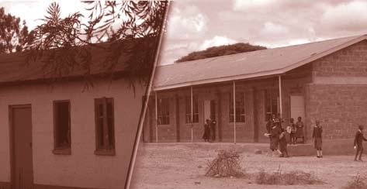

Guidelines
It is important to observe the following with regard to the various types of school buildings:

Classrooms
Classrooms are important infrastructures in a school setting since learners spend most of their time in these facilities. It is important to observe the following:
    - The size of the classroom, in terms of length and width, should be as specified in the Ministry of Education building specifications i.e. 7.5m x 5.85m or 7.5m x 6.0m. Such classrooms should accommodate a maximum of 30 learners in one-seater desks or 40 learners in two- seater desks in line with the provisions of the Ministry of Education circular on Health and Safety Standards in Educational Institutions (2001).

    - The doorways should be adequate for emergency purposes, open outwards and should not be locked from outside at any time when learners are inside.
    - For storeyed buildings, the stairways should be wide enough and located at both ends of the building and should be clear of any obstructions at all times. The construction of stairways should give provision for learners with special needs/disabilities. The handrails in the stairs should be strong and firmly fixed.

SAFETY STANDARDS MANUAL For Schools in Kenya h0

    - The corridors should be both well ventilated and lit. The width should be wide enough for the learners to walk along without bumping into each other.
    - Classroom windows must be without grills and should be easy to open.
    - The classrooms should be properly lit and ventilated.
    - The floors should be level and kept clean always. For cemented floors, any cracks should be repaired in good time. Similarly, for mud walls and floors teachers should ensure that they are regularly smeared with fresh mud and floors smeared with cow dung to prevent the development of cracks and the generation of dust that can pose risks to the health of both teachers and learners. In all cases, efforts should be made to cement all the classroom floors.
    - Each block should be fitted with serviced fire extinguishers.
    - Regular inspection of classroom buildings, halls and stairways should be carried out and immediate measures taken to correct any problems noticed.
    - The furniture in classrooms, especially the desks, should be appropriate for use by both male and female learners. Poorly constructed or inappropriate desks can lead to physical deformities such as curvature of spine, contraction of chest, roundness of shoulders or a confirmed stoop. They can also create tension and fatigue among learners.
    - The class teacher should ensure that the desks are arranged in a manner that facilitates easy and orderly movement of learners in the classroom—ideally each desk should have no more than 3 learners and the space between any two desks should be at least 2 feet.

    - The positioning of electrical sockets should be beyond the reach of young learners in order to avoid tampering.
    - All buildings and facilities should be accessible by special needs learners.

Dormitories
In boarding schools, dormitories are the single most used physical infrastructure, where learners spend the longest continuous period of time in a day. It is therefore important to keep these structures clean and properly ventilated. In every school, care should be taken to observe the following:

hI SAFETY STANDARDS MANUAL For Schools in Kenya

    - The space between the beds should be at least 1.2 metres while the corridor or pathway space should not be less than 2 metres.
    - Since sharing of beds is prohibited in schools, admissions should be tied to bed capacity at all times.
    - All doorways should be wide enough, at least 5 feet wide, and they should open outwards. They must not at any time be locked from outside when learners are inside.
    - Each dormitory should have a door at each end and an additional emergency exit at the middle. It should be clearly labelled “Emergency Exit”.
    - Dormitory doors should be locked at all times when learners are in class or on the playing fields. The keys to the doors should be kept by the Dormitory Master/Mistress or the Dormitory Prefect.
    - Dormitory windows must be without grills and should be easy to open outwards.
    - Fire extinguishing equipment should be functioning and placed at each exit with fire alarms fitted at easily accessible points.
    - Regular spot checks by the teachers and the administration should be undertaken before learners retire to bed.
    - An accurate roll call should be taken every day and records well maintained.
    - There should be regular patrols by the school security personnel or any other authorised security personnel. No visitor should be allowed in the dormitory.
    - There should be inspection of hygiene standards of the dormitories and the learners on alternate days of the week.
    - Bunk beds should be strong and firm and fitted with side-grills to protect young learners against falling off.

Sanitation Infrastructure
Sanitation infrastructure includes all the structures constructed for the purposes of disposal of human waste and for cleanliness. A safe school must have sanitation facilities built up to the required standards and kept clean with high standards of hygiene. In order to enhance safety, the following must be observed:

SAFETY STANDARDS MANUAL For Schools in Kenya hh

    - In cases where pit toilets are used these structures should be built at least 10 metres away from tuition and boarding facilities and on the downwind side.
    - Where ablution block is attached to the dormitory, a high degree of cleanliness must be maintained.
    - Pit latrines should not be less than 6 metres (20ft) deep, and should be regularly well disinfected.
    - Pit latrines should be at least 15 metres (50 ft) away from a borehole or well or water supply point.
    - Where there are boreholes or shallow wells in places with difficult soil types or land forms, the school management should seek the advice of the water department before the digging of a pit latrine.
    - In mixed schools, girls’ sanitation areas must be separate and offer complete privacy.
    - Each school should ensure safe and effective disposal of sanitary wear.
    - In the construction of sanitary facilities, the following must be observed in relation to numbers:
      - The first 30 learners: 4 closets (holes).
      - The next 270 learners: one extra closet for every 30 learners.
      - Every additional learner over 270 learners: 1 closet per 50 learners.

    - All closets must be clean, well-ventilated and properly maintained.
    - At least one third of the fittings for boys should be closets and the rest urinals. If a urinal is a trough, then 0.6m (2 ft.) of the trough is equivalent to one fitting.
    - In all schools, appropriate provisions should be given to learners with special needs and very young learners in pre-unit and lower primary. For example, passageways should be accessible and toilet facilities should be suitable for use by special needs learners and very young school children.
    - Proper consideration should be given for staff sanitation, with at least one closet for 12 persons and with separate provision for ladies and gentlemen.
    - All sanitary facilities and equipment should be in the best state of repair, serviceable and inspected regularly.

h) SAFETY STANDARDS MANUAL For Schools in Kenya

    - If learners are responsible for cleaning their sanitation facilities, proper protective measures (e.g. provision of gloves) must be taken.
    - Soap and tap water or water cans fitted with taps should be set outside the toilets for washing hands after use of these facilities.
    - For girls, tap water/washing places should be behind a screen or wall.

Libraries
The library is the centre of academic life of the school. It is the designated place for storing, lending and reading of books in a school. A library that meets safety standards should be rightly located in a quiet place and should have sufficient space in addition to being well ventilated and safe from invasion by destructive insects and pests. In the construction of libraries, ensure:
- Adequate ventilation and lighting.
- Wide alleys of passageways to facilitate evacuation.
- Spacious room for easy movement.
- Dusting books regularly, preferably every three days.
- Properly reinforced and well spaced bookshelves.

Administration Block
The administration block is an important structure in the school. It is the first station of call for all visitors to the school. It is also the storehouse of all the vital school records and equipment. An ideal school administration block should put into consideration the prevailing security situation of the school environment and the needs of the school. The following should be observed in constructing a school’s administration structure:
- There should be provisions of offices for key school personnel such as the head teacher and deputy head teacher, senior teacher, bursar and the supporting secretarial staff. In addition, the school should have a staff room and registry.
- It should be centrally located and not far from classrooms.
- The doors and windows should be burglar proof.
- Each administration block, like any other block, should have a fire extinguisher.
- Provisions should be made to acquire fire-proof cabinets for the storage of essential office materials and documents.

SAFETY STANDARDS MANUAL For Schools in Kenya h4

- There should be provisions for easy access to legal and administrative documents such as the Educational Act, the Children’s Act, Sexual Offences Act, the Public Health Act, Code of Regulations, school rules and any other documents accorded importance by the school authorities.

Overall, the achievement of the right infrastructure in schools requires the collective efforts of different stakeholders. Nonetheless, the following guidelines would be necessary:
    - No physical infrastructure should be constructed or occupied without consultations with and approval of the Ministry of Public Works, Ministry of Education, and Ministry of Health (Public Health Department).
    - There should be close and cordial working relationship between the school, parents, sponsors and members of the community with regard to construction, utilisation and maintenance of the school buildings.
    - A school site plan should be developed and be available at all times.

Health and Hygiene Safety
The health of learners and their learning achievements are closely related. Good health and nutrition are indispensable for effective learning. Learners can reap maximum benefits from teaching/learning process if they are healthy. The school health programme is an important component of the total school programme. The school organisation has a legal and moral responsibility to ensure learners have a safe sanitary and healthful environment.

According to the World Health Organisation, “Health is a state of complete physical, mental and social well-being and not merely the absence of disease.” A school health programme can be viewed as the school procedures that contribute to the maintenance and improvement of the health of learners and school personnel. The school health programme should be a shared responsibility involving the school, sponsors, parents and the community.

The role of the school health in education is justified on the following grounds:

- Good health facilitates and enhance teaching and learning.
- Unlike adults, children respond better and positively to health education.

h5 SAFETY STANDARDS MANUAL For Schools in Kenya

- Teachers are better placed to impart proper and accurate knowledge, attitudes and skills to learners on health matters than their peers or parents.

- Learners tend to have a lot of faith in and hold in high esteem their teachers and will therefore readily internalise health education messages from teachers.

- It is easier to sustain in adult life the health knowledge, attitudes and skills learnt earlier in school as compared to obtaining the same later on from health practitioners.

The overall objective of the school health programme is to promote, maintain and contribute to the knowledge of learners and staff about health living. Specifically, the school health programme seeks to:
- Impart knowledge, skills, practices and proper attitudes to learners in relation to health.

- Promote and maintain good health practices among the learners.

- Monitor and appraise the health status of the learners through health screening and examinations.

- To provide first line emergency services to learners and teachers injured or taken ill.

- To collaborate with health agencies, parents and communities on issues relating to learners’ health.

- To counsel and give guidance to learners and parents on matters relating to health.

School and home-based factors are responsible for determining the status of learners’ health. The school factors that affect learners’ health include:
- The state and condition of physical infrastructure such as the classrooms, dormitories, toilets, playgrounds; the care of floors, walls; the placement of furniture, use of toilets, the state of the playgrounds, corridors, driveways, and walkways have implications on the health of learners. For example, a dusty, unclean floor can result in respiratory problems for learners.

SAFETY STANDARDS MANUAL For Schools in Kenya h6

- The lighting, ventilation and acoustics also affect learners’ health. Poor lighting can, for example, lead to eye problems. When the rooms are not properly ventilated, respiratory problems can occur. Poorly ventilated rooms can also lead to the spread of communicable diseases. Poor acoustics not only lead to learning distractions but also to hearing problems.
- Water supply and disposal. It is important for learners to have access to clean and safe drinking water and water for cleanliness. Contaminated water can lead to a number of health problems, among them, typhoid, cholera and dysentery. In addition, poor disposal of liquid- and solid-waste can also result in health problems.
- Food Safety. School learners eat food prepared by the school or brought to them by parents or purchased from food vendors in the neighbourhood. The nutritional status, preparation of foodstuffs and the health of those preparing food have far- reaching implications on the health of the learners.
- The emotional health of the learners is equally affected by the length of the school day, school rules and regulations, and ways of handling learner behaviour.

Furthermore, home and community based factors have implications for the health of learners, particularly the school children. These factors include environmental sanitation, nutrition, emotional care, and the physical condition of the home.

There are ways teachers can tell when learners are in good health. A teacher can look out for the following signs:
- Whether the learner is able to carry out routine learning activities in school and in homework assignments without undue fatigue or emotional upset.
- Is he/she able to participate regularly in physical education and other physical activities in the school curriculum?
- Does he/she demonstrates skills in games and basic body movements appropriate for his/her age, sex, body type and motor learning experiences?
- Whether the learner shows progressive gains in weight and height without unusually wide variations.

h7 SAFETY STANDARDS MANUAL For Schools in Kenya

- Whether the learner has enough energy to do the things that most children of his/her age and sex want to do.
- Whether he/she has smooth clear skin,without discolouration, eruptions, or excessive dryness or oiliness.
- Whether the learner has good appetite.
- Whether he/she has frequent illness or accidents that are typical of his/her age and sex group.
- Whether he/she is interested in and enthusiastic about most activities that are popular with classmates.
- Whether the learner is able to control emotions like other children.

+School Safety Standard No.3 The school should provide an environment that nurtures positive health in order to protect, promote and improve health for all.

Guidelines
Health Instruction
    - Health issues constitute part of the syllabi of various subjects. The integrated teaching approach should be used to effectively aid learning about health.

    - In teaching health-related issues, the teacher should use learner-centred methods through the non-directive processes that allow greater learner participation
    - Health instruction should be adapted to learners’ abilities by employing methods like problem-solving, demonstrations, discussions, dramatisation, excursions and field trips.
    - Health instruction should be enriched through use of up-to-date information and materials from relevant authorities such as Ministry of

SAFETY STANDARDS MANUAL For Schools in Kenya h8

Health, National Environmental Management Authority and National Aids Council.

    - All teachers should be trained in first aid skills.

Healthful School Environment
To promote good health and hygiene among the learners, the school should:

    - provide skills-based education on prevention of endemic conditions as well as care of the affected and infected. This is to ensure that children learn the knowledge, attitudes and practices necessary to prevent exposure to the risk of STIs or HIV/AIDS.
    - collect and keep (accurate and up-to-date) comprehensive medical data on every learner in the school.
    - intensify campaign against HIV/AIDS and design special interventions to support those affected and infected by the scourge. For example, peer support and HIV/AIDS counselling would enhance care to prevent discrimination and stigmatisation.
    - establish health policies to provide guidelines regarding what takes place in case of health-related incidences. Clearly stipulate the conduct of learners and other members of staff during such occurrences.
    - put in place a mechanism, such as regular medical check-ups of learners, for early detection and management of infectious diseases/ outbreaks in collaboration with health service providers and local authorities. During outbreaks of contagious diseases, the school administration should inform the local medical officer or health personnel immediately.
    - have an adequately trained teacher in health education. Boarding schools should have sanatora (sick bays) equipped with first line treatment drugs.
    - promote environmental sanitation and hygiene practices in school through regular health practices.
    - ensure working and adequate First Aid Kit and facilities to provide emergency care in schools.
    - undertake remedial emergency action in case of sudden illness or accidents and thereafter inform the parents or guardians.

h9 SAFETY STANDARDS MANUAL For Schools in Kenya

    - promote and encourage the adoption of health-promoting habits, such as healthy eating, reducing risk-taking behaviour associated with HIV/STD infections, and avoidance of unplanned pregnancy, drug and substance abuse, violence and injury.

    - manage the environment to keep away insects and other vectors in order to reduce contacts with such organisms and create conditions less conducive for the transmission of malaria, typhoid, cholera and other diseases.

    - reinforce provision of safe water and sanitation with health and hygiene promoting education materials.

    - provide adequate and safe water for drinking and use by learners and staff. Ensure that MOH and MOE do regular inspection and certification for all water sources for school use.

    - provide adequate latrines and/or sanitation facilities, which are sensitive to gender and culture. In terms of official guidelines this translates into:
The first 30 learners: 4 closets (holes).
The next 270 learners: one extra closet for every 30 learners.
Every additional learner over 270 learners: 1 closet per 50 learners.

    - There should be regular inspection of sanitation facilities to ensure compliance with standard hygiene requirements, including proper learner: toilet ratio and providing sanitary materials and facilities where necessary.

    - protect children with special needs with regard to their health and hygiene, by working closely with parents.

    - undertake immediate steps to close the school when there is a threat of an epidemic outbreak.

    - implement measures, such as isolation, quarantine and vaccination, to protect those not yet infected from those who already show symptoms of infections of contagious diseases such as mumps, measles and tuberculosis. Also ensure that all the young learners have received the mandatory vaccinations and are regularly dewormed.

SAFETY STANDARDS MANUAL For Schools in Kenya )0

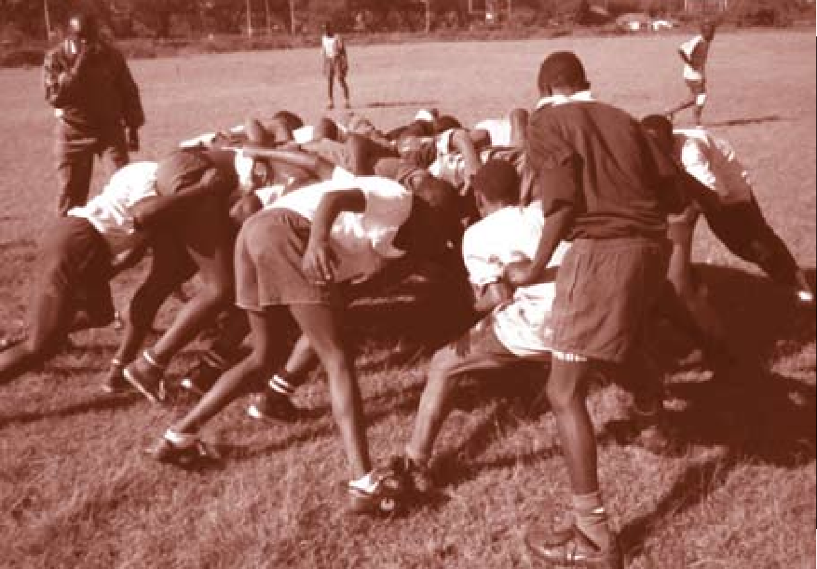Safety in School Environment
Environmental safety refers to the proper and sustainable management of the physical surroundings of the school. Proper management of the school environment entails appropriate mechanisms of waste management, orderly use and replenishment of plants and animals within the school compound and enhancing a sustainable balance of biodiversity.

+School Safety Standard No.4

A School environment should be safe to promote learners’ concentration on learning and to facilitate the development of their social skills without compromising, in anyway, sustainable biodiversity.

Guidelines
The Physical Environment
The school should strive for indoor and outdoor air quality by ensuring
the following:
    - Ventilation equipment/air ducts are regularly inspected and replaced as needed.

)I SAFETY STANDARDS MANUAL For Schools in Kenya

    - Whenever possible, the exterior and interior lighting should be of appropriate standards so as to make it difficult for intruders to go undetected, while classrooms and occupied buildings should be well-lit to ensure that the learners do not strain while undertaking learning activities.
    - Solid waste is properly disposed to avoid the spread of communicable diseases, discourage the presence of pests and other vectors and prevent human contact with hazardous materials.
    - A regular schedule for inspecting school facilities, including roofs, ceilings, walls, and floors for water leakage, stains or discolouration, and mould growth or odours should be developed.
    - Good sanitation practises and proper maintenance of structures and grounds to seal structural cracks through which pests and rodents can enter.
    - Adequate tuition and boarding facilities such as classrooms, dormitories, dining halls, toilets and bathrooms.
    - Classrooms with mud floors are regularly smeared with fresh mud and watered as necessary to minimise a dusty environment.
    - Appropriate colours are used in painting the inside and outside of classroom and other physical structures.

Waste Disposal
In the school, waste materials can be generated from the kitchen, classrooms, laboratory, construction sites, or from daily routine compound cleaning or mowing. Each school should have rules for the management of its waste materials and should make provision for orderly segregation and proper method of destruction. Thus, in order to ensure proper disposal of waste, the following measures should be implemented:
    - The waste disposal sites should be located in isolated places within the school compound, away from any site where learners are active– such as the classrooms, play grounds, toilets, water points and gates.
    - There should be adequate provision for separation of different wastes depending on their types. For example, a site for kitchen waste and waste from the school compound as well as segregation of biodegradable (natural wastes) and non-biodegradable waste.
    - All the waste disposal sites should be well fenced and access denied to any unauthorised persons.

SAFETY STANDARDS MANUAL For Schools in Kenya )h

    - Accumulated waste should be disposed of using safe and effective methods such as burning, fenced pit or burying it in a deep protected pit.
    - Each classroom, office, library or laboratory should have waste buckets with provisions for proper segregation.
    - Buckets for disposal of non-infectious waste should be placed in strategic places outside the buildings, especially in common walkways, to reduce littering of the school compound.
    - The school should instill a culture of appropriate waste disposal in learners and staff through coordinated programmes in class and assemblies.
    - The school administration should seek an effective and efficient working relationship among the learners, staff, parents and school management in waste disposal.
    - Assistance in emptying of latrines and septic tanks (where applicable) should be sought from the local authority whenever such an activity is planned for.
    - The school should take measures to ensure external waste, such as open sewer waste from the neighbourhood, is not disposed of within the school compound. This calls for appropriate locating of schools away from possible pollution.

Food Safety
The concept of food safety refers to access and consumption of wholesome food that promotes good health and optimal body functioning. Access and consumption of safe food by learners is important because safe and wholesome food promotes health and, in turn, effective learning. Research has shown that learners who have access to wholesome (safe) food have more enjoyable and successful learning experience.

+School Safety Standard No.5
Learners in the school should have access to safe and wholesome food for their proper physical and intellectual development.

)) SAFETY STANDARDS MANUAL For Schools in Kenya

Guidelines
There are a number of measures that ensure school learners’ access to safe food. Some of the important measures are:
    - The Ministry of Education, the Public Health Department and the school community will ensure that schools have adequate safe storage facility for food items.
    - The School Management Committee/Board of Governors should ensure that illegal hawking/vending of food to schoolchildren in the school compound or its vicinity is prohibited since the safety of such food cannot be guaranteed. Where the school has a feeding programme provide by an outsider, the quality of food must be inspected on a regular basis.
    - School administrators should ensure that food purchased for children is in good condition, fresh and safe for human consumption.
    - School administrators should undertake measures to protect food from rodents, insects and bacterial contamination.
    - School administrators should ensure that the areas where food is prepared, including tables where food is chopped or cut as well as the utensils used for such purposes, are cleaned at all times.
    - School administration should ensure that all food sellers in schools have medical certificates and relevant trade licences.
    - Teachers should encourage learners to observe basic hygiene, especially the washing of hands, before and after meals.
    - Personnel mandated to serve food to learners should be sensitised to practise basic hygiene such as washing of hands and observing personal cleanliness.
    - The school authorities in collaboration with parents and members of the community as well as other well-wishers should be encouraged to ensure that learners are provided with a hot meal per day. This will not only enhance retention but also improve learning.
    - School should make efforts to ensure that learners with special needs are properly catered for in relation to their dietary needs.
    - Children displaying regular/frequent discomforts after eating food should be referred to medical personnel for tests on allergies.

SAFETY STANDARDS MANUAL For Schools in Kenya )4

Safety Against Drug and Substance Abuse
A drug is any chemical that changes or modifies one or more of body functions. Drug use, misuse and abuse have major implications on the health of individuals. Drug use means using a drug for its intended purpose. Drug misuse refers to using a drug for a purpose for which it is not intended, for example, using aspirin or paracetamols for treatment of malaria.

Drug abuse is the chronic habit of using a drug for a reason other than for what it is intended. Frequent drug abuse can lead to drug dependency or addiction.

Of major concern to schools is the increasing problem of drug abuse among learners. The main reasons why learners abuse drugs include the urge to act grown up, to have a good time or to conform to others. Other than these reasons, learners also abuse drugs as a result of influence of family members, media and peers.

There are many types of drugs that learners are prone to taking.

The most common type is the drug or substance that modifies or changes behaviour and moods. These drugs substances include heroin, opium, cocaine, marijuana, hashish, mandrax and alcohol and cigarettes. Some of these drugs are injected, inhaled, smoked or taken orally.

Drug abuse can have major effects on the learners. Some of these effects include poor mental health, violence, withdrawal symptoms, hallucinations, anxiety and suicidal tendencies. Ultimately, academic performance of learners abusing drugs will be adversely affected.

Categories of Drugs
Drugs can generally be categorised into three:
- Narcotics
- Tobacco
- Alcohol

Narcotics
Narcotic drugs come in three main forms:
- Depressants

)5 SAFETY STANDARDS MANUAL For Schools in Kenya

- Stimulants
- Hallucinogens

Depressants
Under this category are drugs that slow down body processes or decrease functional activity. When taken in small doses, calmness or relaxed state of the body is experienced. When consumed in large doses, a person experiences slurred speech, altered perceptions and staggering gait. Dependency on this type of drug can lead to respiratory problems and even death.

The most common depressant drugs include heroin, opium, cocaine, barbiturates and tranquillisers.

Stimulants
Unlike the depressant drugs, stimulants increase functional activity. Some of the effects of this type of drug include alertness, incessant sweating, headache, dizziness, blurred vision, and sleeplessness. Abuse of stimulants can lead to irregular heartbeat, tremors, loss of co-ordination and physical collapses. Stimulant drugs include cocaine and amphetamines.

Hallucinogens
These types of drugs induce hallucinations such as smells, physical feelings, sights and sounds. Use of these drugs can lead to self inflicted injuries, violence, convulsions, heart and lung failure and rupture of blood vessels in the brain. The common drugs under this category include marijuana, hashish, and LSD (Lysergic Acid Diethylamide).

It is important for the school, and particularly the teachers not only to be knowledgeable but to also have the ability to identify drug abuse among learners. he common signs of the presence of drug abuse include:
- Possession of drug related objects such as rolling paper and pipes.
- Possession of the actual drugs.
- Smell of drugs or odour on clothing and breath.
- Drug related magazines and clothing.
- Hostility in discussing drugs.

SAFETY STANDARDS MANUAL For Schools in Kenya )6

- Memory loss, lapses, short attention span or difficulty in concentration in class.
- Conversation mainly focusing on drugs.
- Good knowledge about various types of drugs.
- Unhealthy appearance, indifference to hygiene and grooming.
- Blood shot eyes or dilated learners.
- Deteriorating performance in class.
- Increased absenteeism and tardiness.
- Chronic dishonesty.
- Possession of large amounts of money.
- Increasing and inappropriate anger, hostility and irritability.
- Reduced motivation, energy, self-discipline.
- Insomnia.
- Tremors in hands.
- Staggering, physical disorientation.
- Abrupt emotional change.

Tobacco
The most common use of tobacco is cigarette smoking. In this country, cigarette smoking is endemic, especially among the youth. The National Campaign Against Drug Abuse (NACADA) estimates that close to one million school children smoke cigarettes. This figure is alarming in view of the young age of the smokers involved and the serious health problems they expose themselves to at such a tender age.

Cigarette smoking poses severe health problems to the users, some of which are painful. It is widely acknowledged that cigarette smoking can result in cancer of the mouth, throat, larynx or lungs, heart attacks and stroke. Medical practitioners point out that the most common diseases attributed to continuous consumption of cigarettes are emphysema and Buergers diseases. Emphysema affects mainly the lungs. The lungs are slowly and progressively destroyed and this leads to suffocation and continuous chesty coughs. Buergers is characterised by clogging and inflammation of blood capillaries.This leads to deterioration in blood supply, which can culminate in gangrene in the fingers and toes.

)7 SAFETY STANDARDS MANUAL For Schools in Kenya

Other conditions attributed to cigarette smoking include weakening of bones, hair graying, skin wrinkling, and loss of vision. Treatment of cigarette smoking related diseases, such as cancer, is not only painful but also costly.

Alcohol
Alcohol is one of the most used and abused drug. Under age drinking is on the rise and the risk of developing alcoholism at an early stage is high.

The youth who are involved in alcohol consumption are more likely to engage in unprotected sex (and therefore become susceptible to HIV/AIDS infection or other sexually transmitted diseases and unwanted pregnancy), dangerous pranks, violence and destruction of property, among others. Of major concern, however, are the health hazards that the youth expose themselves to through alcohol abuse. These include:
- Alteration and death of brain cells.
- Increase in the risk of hypertension, stroke and damage to the heart muscle.
- Weakening of the immune system thereby increasing the probability of one contracting diseases and developing cancer, especially cancer of the liver.
- Increase in chances of injury, disability or even death.
- Reduced mental performance in relation to judgement, moral reasoning and abstract thinking.

The indicators that a learner is using or abusing alcohol include:
- Smell of alcohol in breath.
- Abrupt mood swings.
- Isolation, depression, fatigue.
- Decline in school attendance.
- Sudden resistance to punishment.
- Unusual temper flare-up.
- Unusual aggression at the slightest provocation.

SAFETY STANDARDS MANUAL For Schools in Kenya )8

- Loss of interest in hobbies and sports.
- Secrecy about actions and possessions.

+School Safety Standard No.6
The school must endeavour to create a safe and caring environment where learners and staff know the dangers of drug abuse, and strive to make the school a drug free environment.

Guidelines
Drug Instruction
    - The teachers should, in the subjects they teach, enlighten the learners about drugs and dangers of drug abuse.

    - Instruction on drugs should be enriched through use of up-to-date information that is made available by official agencies, such as NACADA, and other voluntary agencies.

    - Instruction on drugs should be enriched through use of various methods and techniques such as:
- Advertisement – Learners should bring drug related advertisement for analysis in class.
- Brainstorming – Learners should discuss and suggest ways that can contribute to creating a drug free school environment.
- Bulletin board – Learners should display magazine and newspaper articles on drug abuse.
- Learners should display their own articles regarding dangers of drug abuse.
- School should display posters promoting campaign against abuse.
- Learners should narrate their experiences of what they see in their neighbourhood.

)9 SAFETY STANDARDS MANUAL For Schools in Kenya

Creating a Drug-Free Environment

    - The teachers should acquire knowledge and understanding about drugs and signs of drug abuse, identify and note the symptoms and take the necessary remedial actions.

    - The school should sensitise learners about the dangers of drug misuse and abuse and ways of resisting peer pressure to try drugs. Teachers should help learners to resist peer pressure to use drugs by closely monitoring their activities and advising on the company they should avoid.

    - The schools should elicit the assistance of the parents and the larger community by, for example, providing schools with expertise and the necessary resources and support in preventing drug use among learners in school and in the community. Parents and community members should closely monitor the activities of kiosks/small businesses situated near the school with a view to taking any necessary remedial intervention. Similarly, parents and community members should not allow their children to visit tourist hotels or befriend tourists. Some tourists have ill intentions.

    - The school should cooperate with law enforcement agencies, social services and health professionals to talk to the learners and staff on issues relating to drug abuse, the legal implications and rehabilitation activities.

    - The school, through the Guidance and Counseling team/section, should endeavour to provide counselling and pastoral advice to learners and make referrals to local treatment programme for the learners with drug problems.

    - Where cases of use or missuse of drugs gets detected, the community, including school management, needs to show care and concern through couselling. Teachers, in particular, need to appreciate that the best way to fight drug abuse is to counsel those caught engaging in this vice.

SAFETY STANDARDS MANUAL For Schools in Kenya 40

Teaching and Learning Environment
Teaching and learning environment refers to the conditions within the school under which teaching and learning take place. While much of the learning takes place within the classroom, learning also occurs in other areas of the school compound – such as the library, the workshops and the playing fields. In this respect, the way learners relate with fellow learners and with teachers and, similarly, the way teachers relate with fellow teachers in the school compound, are critical to the teaching and learning processes.

The interaction among learners in the school should encourage them to be actively involved in learning and studying. Similarly, the interaction between teachers and learners should encourage the children to be actively involved in the learning process. These conditions are better enhanced when teachers consistently pay attention to promoting child rights as spelt out in the United Nations Convention on the Rights of the Child (CRC). Harshness and rejection are key enemies of the learning process.

+School Safety Standard No.7
The school should provide and sustain a safe and caring environment that promotes quality teaching and learning.

Guidelines
For the learning | school to provide an a number of measures |  | environment need to be put | conducive to teaching in place. Some crucial | and ones
include the following:

    - Development of a school motto or vision focusing on holistic and excellent learner development. Ensure that learners and all school staff internalise the school motto.

    - Promotion of comfortable conditions that facilitate quality learning.

    - Encouraging instructional strategies that actively engage learners in the learning process.

4I SAFETY STANDARDS MANUAL For Schools in Kenya

    - Supporting efforts by teachers to promote child-centred approaches to teaching.

    - School management and teachers should make effort to identify and attend to learners with special learning needs.

    - In-servicing all teachers on issues related to special needs children.

    - School management and, especially teachers, should be sensitised to adopt effective classroom management strategies to reduce learning interruptions.

    - Promotion of interactions with learners to encourage them express themselves freely in class.

    - School management and other school personnel should support colleagues who are prepared to implement new teaching methods.

    - Encouraging learners to participate in co-curricular activities such as sports and educational trips, which enrich learning.

    - Aspiring to ensure that learner-teacher ratio in their respective classrooms remains at the official recommended proportion of 1:50 in order to avoid congested classrooms.

Socio-cultural Environment of the School

School Safety is a process that requires collaborative efforts of all key school stakeholders namely, learners, staff, school administrators and parents, members of communities within the school, Ministry of Education officials, and school sponsors. These stakeholders must be well aware of possible threats to school safety and provide a socio-cultural environment that is supportive of effective learning and the full development of the learners. Such an outcome is better promoted if the relationships between the various stakeholders are cordial and reinforcing. The school needs to feel supported and protected by the members of the communities in its vicinity. The key actors in the building of strong partnerships are school administrators, School Management Committees/Board of Governors, parents and sponsors.

SAFETY STANDARDS MANUAL For Schools in Kenya 4h

Interpersonal Relationships
This term refers to the quality of interactions between two or more groups or people who come together for a common purpose. In the school, it involves the interactions among:
- Learners themselves
- Learners and teachers
- Learners and the head teacher
- Learners and Ministry of Education staff
- Learners and school sponsors
- Teachers themselves
- Teachers and the head teachers
- Teachers and Ministry of Education staff
- Teachers and sponsors of schools
- Teachers and parents/guardians
- Head teachers and Ministry of Education officials
- Head teachers and sponsors of schools
- Head teachers and parents/guardians.

+School Safety Standard No.8 All interpersonal relationships between various stakeholders in and outside the school need to be cordial, cooperative, respectful and focused on promoting a conducive environment for teaching and learning.

Guidelines
The promotion of good interpersonal relations between different stakeholders in schools requires appropriate behavioural responses. Among such responses,
the following are key:

  - SAFETY STANDARDS MANUAL For Schools in Kenya

    - All school personnel and learners should exhibit safe and caring attitudes and behaviour towards one another.

    - Learners should be trained to be respectful towards one another.

    - School administrators must be accessible and supportive to both staff and learners.

    - Schools, and especially headteachers, should promote a culture of compliance with school rules and regulations in order to produce law-abiding citizens.

    - School administrators should encourage learners to report cases of violence for appropriate action.

    - Staff members should identify and support learners with specific learning needs arising from natural limitations and social differences.

    - School administrators should ensure that learners with special needs are made to feel wanted, loved and respected by staff and learners.

    - Parents and teachers should cooperate to promote learning and development of learners.

    - All members of the school community should respect one another’s cultural and religious beliefs and provide pastoral care as needed.

    - School administrators should establish guidance and counselling programmes.

    - School administrators should establish mechanisms, such as committees, for conflict resolution and emergence response.
    - School authorities should endeavour, through PTA and forums such as parents’ day, to sensitise parents/guardians and community members about negative cultural practices such as child marriages, female genital mutilation.
    - School administrators should have a suggestion box where various stakeholders can deposit their views regarding different aspects of social interactions in the school.
    - The school community should act as a good example of acceptance and appreciation of harmony in diversity.

SAFETY STANDARDS MANUAL For Schools in Kenya 44

Safety of Children with Special Needs/ Disabilities
The Government is cognisant of the need to enable children with special needs to access education at all levels, without discrimination. These children include children with challenges such as physical, mental, visual and hearing. The Government’s commitment to the education of special children is clearly outlined in various policy papers developed since 1968. These include Sessional Paper No.5 of Special Education, which articulated policies pertaining to education of children with physical handicaps and established the management structures for Special Education e.g. the creation of Special Education Unit at the Ministry of Education Headquarters. There was also Sessional Paper No 6 of 1988, which promulgated policies that guide implementation of Special Education programmes in the country, and the Sessional Paper No.1 of 2005.

It is the policy of the Government to integrate or mainstream children with mild disabilities into the regular school programmes to enhance their participation in formal education.

+ School Safety Standard No.9
The school should have a learning environment that is safe and caring and caters for the requirements of children with special needs/disabilities.

    - provide access paths to different facilities within the school compound.
Guidelines
The school should:

    - support children with special needs by ensuring that the teaching and learning environment is responsive to their needs, including provision of remedial teaching.
    - sensitise parents/guardians and communities so that children with disabilities are taken to school.

45 SAFETY STANDARDS MANUAL For Schools in Kenya

    - emphasise early identification and referral for troubled learners to prevent situations from escalating into violent incidents.

    - encourage children to develop interests in sport and other activities, regardless of their abilities.

    - strengthen guidance and counselling at the school level by providing teacher counsellors to every public school, facilitating the training and providing the necessary resources to enable them perform these duties effectively.

    - adhere to guidelines to ensure school premises are structurally safe. They should have appropriate runways, ramps and stairways for all those who are physically challenged or have special needs.

    - take appropriate measures, such as sensitisation and counselling, to ensure that the children with special needs are not stigmatised or discriminated against by their peers and teachers.

    - work closely with parents and community in identification and referral of learners with special needs as a means of preventing situations from deteriorating.

    - train children with special needs/disabilities and educators on life skills and protection strategies against sexual harrasment.

SAFETY STANDARDS MANUAL For Schools in Kenya 46

Safety against Child Abuse
Incidents of child abuse are in the increase in the country. In many instances children suffer abuse at the hands of their fellow learners, parents, guardians and teachers. The implications of child abuse are many. Children subjected to physical violence may grow up believing that brute force, violence or aggressive behaviour are acceptable part of normal life, hence many abused children become abusers in their adulthood. More importantly, abused children find it difficult to cope with the learning process.

Child abuse?
Definitions of child abuse are many and vary. However, it can be simply defined as subjecting children to suffering through physical, sexual, emotional or neglectful behaviour. The abuse takes place in families, school and in the community. Abused children are often psychologically traumatised and are unable to concentrate in learning. Teachers play a key role in protecting children from abuse. For this reason, when teachers become the abusers, the implications of their actions are very serious.

The various forms of child abuse and their respective indicators are:

Physical Abuse
This is perhaps the most common and blatant type of child abuse. It mainly involves non accidental injuries resulting from hitting/beating, shaking, throwing, pinching, poisoning, burning or scalding, drowning or suffocating the child. The symptoms of this form of abuse include:
- Unexplained injury or injuries where there are conflicting explanations.
- A repeated pattern of injuries, which seem unlikely to have been caused accidentally, e.g. bruises at different stages of healing.
- Scalds and burns with clear outlines.
- Bite marks.
- Bruising to the face, bruising to the buttocks and torso.
- Fingertip bruising, hand marks, grasp marks and marks of implements.
- Untreated internal injuries or broken bones.

47 SAFETY STANDARDS MANUAL For Schools in Kenya

- Concealment or reluctance to discuss injuries by the child.
- Withdrawn or aggressive behaviour, loss of confidence, social problems or lack of achievement in school.

In addition, some evidence of child abuse may be detected from the behaviour of parents or guardians. The adults may tend to:
- be evasive and contradictory in explaining the child’s injuries.
- be antagonistic, suspicious and fearful of other people.
- have inappropriate or unattainable expectations of their child.

Emotional Abuse
This form of abuse occurs when the child is denied basic needs like love, security, positive regard, warmth, praise, etc.

Emotional abuse can be recognised by:
- Chronic lack of self-esteem and low self-confidence.
- Immature emotional responses, regression and neurotic behaviour.
- Demanding behaviour, attention seeking, in appropriate behaviour towards non-parental adults.
- Withdrawn behaviour, failure to make friends or sustain friendships.
- Fear of new tasks, not wanting to experiment or join in.
- Developmental and learning delays.
- Outburst of anger or distress.
- Indifferent or negative relationships with parents.
- Over-compliant behaviour, excessive desire to please.

Sexual Abuse
Sexual abuse takes the form of forcing or enticing a child into sexual activities. The abuser (more often an adult) has carnal knowledge of the child with or without the child’s consent or the child is used for sexual stimulation. Other forms of this abuse include touching the child’s private parts, sexual threats and intimidation. The use of pornographic materials to stimulate the child also constitutes sexual abuse. The indicators of this form of abuse include:

SAFETY STANDARDS MANUAL For Schools in Kenya 48

- Bruising and/or bite marks around the genitals.
- Unusual bleeding or discharge from the genitals.
- Inappropriate sexual behaviour towards adult, and/or other children.
- Sexual knowledge inappropriate for the child’s age.
- Self harming.
- Eating and sleeping disturbances.
- Depression, low –self-esteem, suicidal behaviour.
- Poor achievement.
- Withdrawal.

Child Neglect
Neglect involves failure to provide a child with basic needs like food, good levels of hygiene and health, clothing, shelter and medical treatment when the child falls ill. The indicators of neglect include:
- Poor growth and development, failure to thrive without an organic cause.
- Learning delays, poor academic performance in school.

- Poor hygiene, inadequate clothing.

- Untreated medical conditions.

- Poor self–esteem.

- Chronic tiredness and hunger, falling asleep in class, voracious eating.
- Sores, poor health condition.
- Lateness to school, frequent non-attendance.
- Poor social relations, indiscriminate attention seeking with adults.
- High levels of accidents.
- The parents more often neglect their own physical health.

49 SAFETY STANDARDS MANUAL For Schools in Kenya

+School Safety Standard No.10
Schools need to ensure that learners are safe from any form of physical, emotional and sexual abuse and neglect by teachers, peers, parents or community members.

Guidelines
Schools, parents and the learners have the responsibility to identify and prevent child abuse. The school, and more specifically the teachers, because
of the long daily contact with learners, should be able to notice forms of abuse. Specifically,
    - Teachers should be able to identify children who have been subjected to child abuse through symptoms that indicate abuse and report suspected cases to the police, Children’s Department or other appropriate authorities.
    - Teachers should sensitise learners to distinguish between an honest parental touch and an ill-intended immoral touch by the parent, a relative or any other person.
    - Teacher should advise learners to report any case where peers, relatives, strangers and parents touch their private parts or utter any seductive words to them. Learners should report similar incidents from peers, relatives, strangers and teachers to their parents/guardians. In the event of such incidences by teachers, the parents should report the abuse to the School Management Committee/Board of Governors for appropriate action.
    - Learners should be warned against accepting any inducements from strangers (sweets, money, gifts etc) and report any such cases to the school authorities and parents.
- The school, through the School Management Committee/Board of Governors, should sensitise parents and community members on issues relating to child abuse and its implications for learning.
    - Teachers should advise learners who walk through secluded places– plantations, bushes, etc–to walk in groups.

SAFETY STANDARDS MANUAL For Schools in Kenya 50

    - 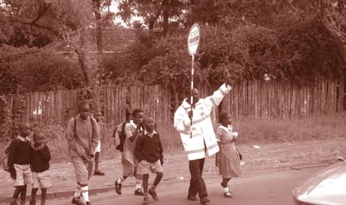Teacher should advise learners to scream, bite or to do anything to attract attention if a stranger attempts to forcibly grab them.
    - Learners should be advised not to talk to strangers who may want, for example, to get information or ask them questions. It is not common for adults to get information from children.

The school should counsel learners who have been subjected to any form of abuse.

Transportation Safety
Nearly all the schools in the country are day schools. Learners have to commute to school using ‘matatus’, buses, and bicycles. Many also walk to schools. There are many instances where learners have been involved in accidents as pedestrians or passengers, some culminating into fatalities due to negligence, ignorance or sheer irresponsibility in observing basic road usage rules.

+School Safety Standard No.11 Schools should ensure that learners are conversant with the basic road safety rules as pedestrians, or passengers in public service vehicles in order to minimise traffic accidents.

5I SAFETY STANDARDS MANUAL For Schools in Kenya

Guidelines
Pedestrian Safety
    - Learners should walk on the sidewalks or a distance away from the
street or road.
    - Learners should always walk in the direction of oncoming traffic.
    - Learners should be trained to obey traffic lights and look in both directions before crossing a road or chasing a ball or any item on the road.
    - Learners should cross the roads only at designated places, such as zebra crossing, footbridges or tunnels.

    - Older learners should assist the younger learners in crossing the road in the absence of a traffic attendant.
    - The school should seek the assistance of the local authorities in erecting bumps on roads near the school to slow down traffic flow.
    - Learners should never play on the roads or close to the roads.

    - Learners should be sensitised to avoid the company of strangers while walking to and from school as this can result in harm, such as kidnapping and rape.
    - Similarly, learners should be instructed not to accept lifts in vehicles driven by strangers.

Bicycle Safety
    - It is the responsibility of every learner using a bicycle to ensure it is in good condition and is well maintained.
    - Parents/guardians need to ensure that their children’s bicycles are in good condition.
    - A bicycle should have reflectors and lights.
    - Learners should never attempt any stunts while riding a bicycle.
    - Learners should obey traffic signs and signals.
    - Bicycles should be ridden in the same direction as the flow of the motor traffic.

SAFETY STANDARDS MANUAL For Schools in Kenya 5h

    - Learners riding bicycles should never hold on to moving motor vehicles for assistance.
    - School Management Committees/Board of Governors should liaise with respective local authorities to vet boda boda riders and motor cyclists who provide transport for children.
    - Learners should follow regular routes to and from school, especially when the mode of transport is a boda boda/motorcycle. Parents should monitor and regularly ensure that this requirement is observed.
    - Parents should know the people who provide their children’s transport.

Safety in Public Transportation

    - Learners should ensure that they are seated and should fasten seat belts when using ‘matatus’ or other public service vehicles.
    - Learners should not stick out their heads or hands when inside a motor vehicle.
    - Learners should not board or alight from a moving public service vehicle.
    - Learners should be advised to avoid boarding any public service vehicle (eg, matatus or buses), with loud music or videos because many of the vehicles play dirty music and videos.
    - Learners should refuse food/drinks, money, gifts or similar inducements from motorists and other strangers.
    - Where learners use trains, they must be cautioned to desist from hanging on the doors.
    - Learners should be advised not to board trains through the windows.
    - Where learners use ferries/canoes, they should observe the mandatory safety measures specified by relevant authorities.
    - The learners should be sensitised and instructed on safety measures to take in the event of an accident.

  - SAFETY STANDARDS MANUAL For Schools in Kenya

Schools with Transport Vehicles
    - The vehicle should be comprehensively insured and regularly serviced and maintained.
    - The driver and his/her assistant must have the necessary PSV qualifications, a valid driving licence, experience and a certificate of good conduct.
    - The school bus/vehicle must be fitted with appropriate seats and seatbelts.
    - The bus/vehicle must have a First Aid kit.

    - The assistant shall be responsible for ensuring proper behaviour of the learners, assist them in boarding and alighting from the bus and ensure proper sitting arrangements.
    - The assistant will also be responsible for helping learners cross the road.
    - The school bus/vehicle shall clearly display on the outside the name, address and telephone number of the school
    - The school bus/vehicle shall at all times be driven at not more than 60kph, hence the mandatory speed governors.
    - No undesirable materials, such as posters depicting cigarette or alcohol advertisements or pornography, should be depicted inside or outside the school bus/vehicle.
    - The speed limit within the school compound for any motorised vehicle should be 5kph.
    - For any school excursions or field trips, the parents should give their consent in writing and an accompanying teacher is mandatory.
    - Where parents pick up their children from school, proper details of the vehicles must be entered in a register at the gate.
    - School administrators should enforce discipline among learners while on school trips or when attending co-curricular activities away from the school.
    - School administrators should ensure that Ministry of Education guidelines on school travel for learners are strictly adhered to.

SAFETY STANDARDS MANUAL For Schools in Kenya 54

Disaster Risk Reduction
Disaster means an emergency event that occurs with little or no warning, causing extensive destruction of prosperity, lives and disruption of normal operations.

Disasters can be divided into two broad categories:
- Natural disasters
- Man-made disasters

Natural disasters are calamities that occur without human involvement. They include earthquakes, floods, drought, landslides and volcanic eruption and wind storms.

The man-made disasters are calamities caused by the actions of human beings either directly or indirectly. They include wild fires, oil spillage, industrial accidents, pollutions and bomb blasts.

Disaster Risk Reduction (DRR) Strategy
Disaster Risk Reduction refers to actions designed to minimise destruction of life, property and disruption of normal operations. There needs to be disaster risk strategy if the effects of disasters are to be minimised. This risk reduction strategy calls for the establishment of a disaster Crisis Response Team with the mandate to prevent, mitigate and effectively prepare against potential disaster hazards. It also includes organising and carrying out rescue and rehabilitation operations during and after a disaster has struck.

Early Warning Mechanisms
It is important to note that not all disasters are rapid or sudden. Some disasters develop over time and there is usually a lead time to receive information and react to early warnings. Careful monitoring and early warning are useful only if they help to avert potentially dangerous events or circumstances that can lead to emergency or disaster or if they lead to actions taken to minimise damage.

The purpose of monitoring and early warning is to enable remedial measures to be initiated and to provide more timely and effective relief through disaster and emergency preparedness actions. Early-warning mechanisms will provide the school community and other stakeholders with relevant information to enable them make informed decisions for evacuation or relocation.

55 SAFETY STANDARDS MANUAL For Schools in Kenya

+School Safety Standard No.12
The School management/board should create mechanisms and procedures that ensure stakeholders are conversant with measures needed to prevent occurrance of disasters and steps required to reduce the impact.
Guidelines
- Every school should post evacuation maps at every entrance and exit to buildings, classrooms, enclosed hallways, stairways and offices.

  - The school should schedule practice drill sessions for fire, earthquake, lockdown,shelter-in-place and other situations that the safety committee determines necessary to practise. Fire drills are required once a month. It is recommended that other drills follow the same format.
  - Every school should develop a telephone tree list including all employees (include e-mail address, pagers, mobile phones numbers as necessary).
  - Every school should maintain school emergency kit(s).
  - School management need to ensure that schools are safe from natural and human made disasters by observing the safety of their operating environments.
Recommended items in the emergency kit will include:
- First aid kit
- Whistles
- Fire blankets
- Flash torchs
- Fire extinguishers
- Blueprints of school buildings

Flood safety
  - During floods, parents should keep in touch with the local authorities to determine whether it is safe for their children to go to floods- prone schools.

SAFETY STANDARDS MANUAL For Schools in Kenya 56

  - In case sections of the route to school are flooded, learners should not attempt to wade through floodwater on their own.
  - After the onset of floods, school authorities should ensure all the electrical lights, sockets and appliances are carefully checked by a qualified electrician before they are used.
  - School authorities should ensure that drinking water is boiled at all times.
  - The school should have all the physical structures like classrooms, toilets, dormitories, and administrative block checked by competent authorities before they are declared safe for use by learners and staff.

Safety during landslides

  - During heavy rains, schools in landslide-prone areas should be on the lookout for signs of unusual land movement.

  - On detection of unusual land movement, alternative learning facilities should be used until the threat ends.

  - Rapid evacuation measures should be implemented when a landslide takes place.

Safety during thunderstorms and lightning
  - During thunderstorms, learners should remain in the school and stay in-doors.

  - During thunderstorms, learners should be seated inside school buildings. No one should take shelter in the verandahs or open places.

  - Learners should be warned that during thunderstorms, they should never take shelter under trees or walk in the rain.

  - In areas prone to thunderstorms and lightning, school authorities should install lightning arresters.

Safety during an Earthquake
  - When learners are inside the classroom and an earthquake occurs, they should take cover under desks or tables. They should not panic or attempt to rush outside or near windows.

57 SAFETY STANDARDS MANUAL For Schools in Kenya

Where evacuation is necessary learners should have clearly stated (standing) procedures on how to move out of the buildings.

  - If learners are in the open and an earthquake occurs, they should move away from buildings because they can be struck by falling building materials and other rubble.

Safety during Strong Winds

  - If learners are inside a classroom, the windows should be closed immediately. They should also stay away from the windows.

  - Learners should be advised to seek shelter under a desk or table.

  - In open grounds, learners should lie flat on the ground or in trenches.

Fire Safety

Fire prevention

  - All kinds of trash should be discarded as they tend to quickly catch fire.

  - Inflammable substances such as petroleum, paint, chemicals etc should be stored in tightly closed cans or containers and away from any source of heat. They should never be stored in classrooms and dormitories.

  - An electrician should regularly check the electrical wiring and replace any that is weak, broken or worn out.

  - Learners should not carry or play with matches as they can result in clothing or other items catching fire.

  - The use of hurricane lamps in the dormitories should be properly regulated.

  - The teachers should sensitise learners about the dangers of fire through the related sections in the curriculum.

  - The school should invite the local fire department to give talks and demonstrations to learners about fire prevention in a school context.

SAFETY STANDARDS MANUAL For Schools in Kenya 58

  - Learners and staff should undertake periodic fire drills, at least twice a term.

  - Fire extinguishers should be located in strategic places in the school.

What to do in case of a fire:

  - The learners should leave the room immediately, without creating any panic rush.

  - Learners should be advised to crawl on the floor when going through a smoky area or room as smoke and heated gases tend to rise and so they will be thinnest near the floor.

  - Doors that feel hot should not be opened as the fire on the other side could be blazing fiercely or one could get killed by the burst of heat and smoke when the door is opened.

  - One should not run in clothes that are on fire. Running helps to fan and spread the flames. Instead, one should roll on the floor to smother the flames.

  - Learners should not return to the classroom or dormitory or any other building. After they have escaped, the Fire Department or the relevant authorities should be called.

Safety during Poisonous Chemical Emissions/Severe Pollution

  - If poisonous gas or chemical leakages/emissions that are likely to pose a threat to learners and staff occur, school authorities should be notified immediately.

  - Once notified, school authorities should immediately contact relevant experts on gas or chemical risks.

  - School authorities should quickly implement evacuation plans for all persons in the school.

  - For affected individuals, school authorities should seek immediate emergency treatment at the nearest medical facility.

59 SAFETY STANDARDS MANUAL For Schools in Kenya

School-Community Relations
School-community relations focus on how school learners and staff are viewed and treated by members of communities within which schools are located and vice versa. Members of the communities include parents/ guardians with children enrolled in the schools and other community members who may not have children enrolled in the catchment schools. The Education Act (CAP. 211) Part III provides for school-community collaboration in the management of schools in Kenya through school committees.

+School Safety Standard No.13 Learners and staff should create a school climate that is conducive for other stakeholders to be involved in a wide- range of school activities.

Guidelines
For learners, school staff, parents and other members of the local communities to share the same vision regarding the role of the school,
certain attitudes and behaviours are expected from each. Some crucial ones include the following:

    - School management should develop linkages with communities around schools.

    - Learners and school staff should have positive attitudes towards members of the local communities.

    - Learners and school staff should behave with respect towards members of the local communities and their culture.

    - Schools should organise regular joint meetings on academic matters with parents or guardians and learners.

- Schools should organise regular joint co-curricular and cultural activities with members of local communities.

SAFETY STANDARDS MANUAL For Schools in Kenya 60

- Schools should participate in some community activities, such as keeping designated areas of the community clean.

- Members of local communities should be encouraged to participate actively in schools’ development efforts.

- Members of local communities should be encouraged to cooperate with schools in ensuring learners’ and staff safety.

- Communities should be encouraged to use its administrative structure and authority to resolve school-community conflicts.

- School curricula, especially Social Studies and pastoral programmes, should reinforce the importance of community moral values and social responsibilities.

- Parents should be wary of the hazards their children are likely to encounter from school.

- Parents should be included in safety programmes regarding children’s movement between the home and the school.

- School authorities should sensitise the communities about catering for the educational needs of children with special needs.

6I SAFETY STANDARDS MANUAL For Schools in Kenya

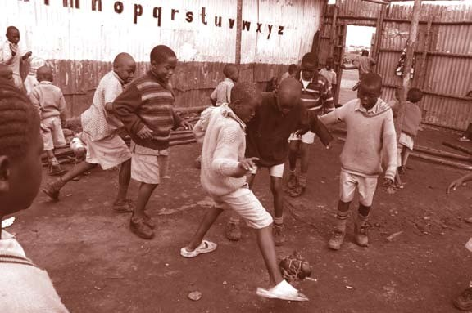

7.0

Monitoring and Evaluation of the School Safety Programme

SAFETY STANDARDS MANUAL For Schools in Kenya 6h

Monitoring and evaluation are essential components of the School Safety Programme. Each school must establish a monitoring and evaluation system.

There should be a processes of determining the progress the school is making towards the achievement of the predetermined objectives relating to School Safety. Monitoring and Evaluation is, therefore, a continuous process in which learners, staff and parents participate in assessing the achievements they have made. The evaluation process is continuous. It involves both day-to- day assessment of various components of the safety programme by teachers through observation, planned and organised efforts to gather objective information using predetermined data collection tools such as checklists, questionnaires, scales and tests.

What is to be evaluated?
A comprehensive and meaningful evaluation should encompass all the components of the school safety programme, which are:

- Safety on School Grounds

- Safety in School Infrastructure

- Health and Hygiene Safety

- Environmental Safety

- Food Safety

- Safety Against Drugs and Substance Abuse

- Teaching Environment Safety

- Safety Against Child Abuse

- Transportation Safety

- Socio-Cultural Environment/Settings

- School-community Relations

- Disaster and Emergency Preparedness.

  - SAFETY STANDARDS MANUAL For Schools in Kenya

Methods Used in Evaluation
The main techniques that can be used to evaluate the school safety programme are:

- Teacher Observation: Teachers should continuously evaluate components of the School Safety Programme on day-to-day basis using an observation checklist/schedule designed for the purpose.

- Monitoring instruments: Various data collection instruments that cover all components of the School Safety Programme can be used in assessing knowledge, attitudes and practices relating to school safety. More importantly such instruments can be used in determining process outcomes.

- School safety assessment can also be undertaken by designated education officers but should also be monitored by Quality Assurance and Standards Officers (QASOs) as part of their routine advisory visits to schools.

The process of monitoring and evaluation should be based on the following principles:
  - Monitoring and evaluation is a continuous process.

  - Monitoring and evaluation focuses on all components of the School Safety Programme.
  - Monitoring and evaluation process is participatory, i.e. it involves all beneficiaries of the programme namely, learners, teachers, other staff, parents and community members.
  - Monitoring and evaluation focuses on values underlying the whole concept of School Safety and expressed in the objectives of the programme.
  - Monitoring and evaluation should be simple and clear to be understood by everyone.
  - Evaluation results should form the basis for taking the necessary remedial actions.

Based on the principles outlined above, the purpose for monitoring and evaluation include:

SAFETY STANDARDS MANUAL For Schools in Kenya 64

  - 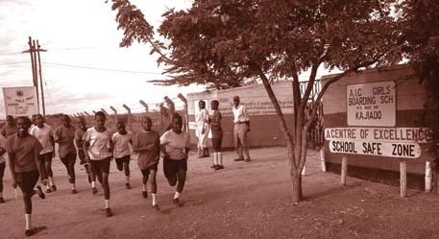Diagnosis, i.e. assessing prior knowledge of learners regarding safety issues and determining what else they need to know.
  - Determination of objective attainment – determining whether or not safety objectives are being achieved.
  - Motivation of learners by creating awareness and stimulating their curiosity about various school safety components.
  - Guidance and Counselling – empowering learners to avoid harmful habits such as drug abuse.
  - Continuous review of the school safety programme using results from the evaluation.
  - Using data collected during evaluation to sensitise parents and community members on issues and challenges relating to school safety.

Conclusion
This manual has provided the necessary information guidelines and instruments needed in design, implementation and evaluation of a School Safety Programme. However, all those concerned must use the manual bearing in mind local circumstances. For this reason, school managements and their stakeholders must constantly examine and re-examine the local circumstances and decide on what they need to do to ensure safety of children in and out of schools. However, in all the situation teachers and school managements need to remember that School safety is a collective responsibility of all stakeholders. Let us all work together to build strong partnerships for sustainable safety.

65 SAFETY STANDARDS MANUAL For Schools in Kenya

References

Achola, P.P.W and Pillai V. (2000) Challenges of Primary School Education in Developing Countries: Insights from Kenya. Ashgate Aldershot, U.S.A.

Alberta Learning Special Eduation Board (1999) ‘School Climate’, in ‘Supporting Safe, Secure and Caring Schools in Alberta’. Edmonton.

Cornacchia, H.J. Olsen, L.K., & Nickerson, C.J (1984), Health in Elementary Schools.
Times Mirror/Mosby, St. Louis.

International Save the Children Alliance(2005). Practice Standards in Children’s Participation. Save the Children(UK).
Kay,J.(2003) Teachers Guide to Protecting Children. Continuum, London. Kilander, H.F. (1972) School Health Education; A Study of Content Methods and
Materials. Macmillan Co. New York.

Ministry of Education(2001). ‘Health and Safety Standards in Educational Institutions’. (Circular Ref no.G9/1/169).

Ministry of Education (2005). Kenya Education Sector Support Programme (KESSP)
2005-2010. Nairobi.

Ministry of Education, Science and Technology (1999). School Action for Better Health(PSABH). Nairobi.

Redican, K. Olsen, L. & Baffi, C (1993) Organisation of School Health Programs.
Brown & Benchmark, Madison.

Republic of Kenya(1980) Education Act. Govenment Printers.
.................................(2001) Childrens Act. Government Printers.
.................................(2006) Sexual Offenses Act. Government Printers.
.................................(2005) Sessional Paper No.1 of 2005 on Policy Framework for
Education,Training and Research.
..................................(2006) National Early Childhood Development Policy.
..................................(2006) Early Childhood Development Service Standard Guideline
for Kenya.

UNESCO (2005) Challenges of Implementing Free Primary Education in Kenya.
Assessment Report. UNESCO, Nairobi.
UNESCO (2006) Fact Book on Education For All (EFA)2006. UNESCO, Nairobi. UNESCO (2006) Strong Foundations; Early Childhood Education and Care. UNESCO,
Paris.

SAFETY STANDARDS MANUAL For Schools in Kenya 66

67 SAFETY STANDARDS MANUAL For Schools in Kenya

SAFETY STANDARDS MANUAL For Schools in Kenya 68

