School Safety
Exterior Facilities

After a school building is constructed, it is important school district administra- tors keep a close eye on the quality of the buildings. New buildings tend to deteriorate quickly because of poor weather conditions and routine wear and tear. If administrators make maintenance a priority from the beginning, it could reduce large and expensive fixes in the future. This course takes a closer look at the building and athletic field maintenance as well as providing ways to keep both students and staff safe both in parking lots and school buildings.

This page intentionally blank

OSHAcademy Course 571 Study Guide
School Safety: Exterior Facilities
Copyright © 2017 Geigle Safety Group, Inc.
No portion of this text may be reprinted for other than personal use. Any commercial use of this document is strictly forbidden.
Contact OSHAcademy to arrange for use as a training document.

This study guide is designed to be reviewed off‐line as a tool for preparation to complete OSHAcademy Course 571.
Read each module, answer the quiz questions, and submit the quiz questions online through the course webpage. You can print the post‐quiz response screen which will contain the correct answers to the questions.
The final exam will consist of questions developed from the course content and module quizzes. We hope you enjoy the course and if you have any questions, feel free to email or call: OSHAcademy
15220 NW Greenbrier Pkwy, Ste. 230
Beaverton, OR 97006 www.oshatrain.org instructor@oshatrain.org
+1 (888) 668‐9079

Disclaimer

This document does not constitute legal advice. Consult with your own company counsel for advice on compliance with all applicable state and federal regulations. Neither Geigle Safety Group, Inc., nor any of its employees, subcontractors, consultants, committees, or other assignees make any warranty or representation, either express or implied, with respect to the accuracy, completeness, or usefulness of the information contained herein, or assume any liability or responsibility for any use, or the results of such use, of any information or process disclosed in this publication. GEIGLE SAFETY GROUP, INC., DISCLAIMS ALL OTHER WARRANTIES EXPRESS OR IMPLIED INCLUDING, WITHOUT LIMITATION, ANY
WARRANTIES OF MERCHANTABILITY OR FITNESS FOR A PARTICULAR PURPOSE. Taking actions suggested in this document does not guarantee that an employer, employee, operator or contractor will be in compliance with applicable regulations. Ultimately every company is responsible for determining the applicability of the information in this document to its own operations. Each employer’s safety management system will be different. Mapping safety and environmental management policies, procedures, or operations using this document does not guarantee compliance regulatory requirements.

Revised: November 26, 2018

This page intentionally blank

Contents

Course Introduction 1
Course Components 1
Module 1: Parking Lot Safety 2
Student Drop‐off and Pick‐up Safety 2
Curb Striping and Other Pavement Markings 2
Signs 3
Education 3
Monitoring and Enforcement 4
Site Design 4
Module 1 Quiz 6
Module 2: External Building Safety 8
Portable Classroom Safety 8
Portables and Health Issues 8
Sports Field Maintenance 8
Improving Playing Surface 9
Watering Fields 9
Field Renovation 9
Bleacher Safety 10
Bleacher Hazards 10
Action Plan 11
Module 2 Quiz 12
Module 3: Building Maintenance 14
Inspection Areas 14
Monthly Maintenance Checks 15
Annual Maintenance Checks 16
Module 3 Quiz 18
Module 4: Roof Maintenance 20
Gutters 20
Clay Tiled Roofs 20
Corrugated Steel Roofs 21
Fiber‐Cement Roofs 22
Roof Structures 22
Steel Structures 23
Roof Fascias, Bargeboards, and Exposed Roof Timbers 23
Module 4 Quiz 24
Endnotes 25

Course Introduction
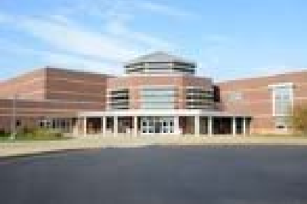After a school building is constructed, it is important school district administrators keep a close eye on the quality of the buildings. New buildings tend to deteriorate quickly because of poor weather conditions and routine wear and tear. If administrators make maintenance a priority from the beginning, it could reduce large and expensive fixes in the future.
This course takes a closer look at the building and athletic field maintenance as well as providing ways to keep both students and staff safe both in parking lots and school buildings.
Course Components

Once you complete this training, you will have extensive knowledge on the following components:

- parking lot safety and maintenance

- athletic field bleacher maintenance

- safety in portable classrooms

- required roof maintenance

- gutter improvements

Module 1: Parking Lot Safety
One of the most dangerous spots at school is the parking lot. In fact, the National Highway Safety Administration listed parking lots as the most common area for injuries for pedestrians under the age of 12 in the report “Traffic Safety Facts 2008: Pedestrians.”
Student Drop‐off and Pick‐up Safety

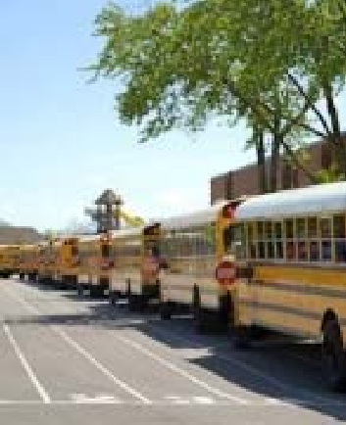As you can imagine, there are many ways a drop‐off and pick‐ up zone can become dangerous for children. There are several ways to make the process much safer, such as striping, safety cones, signs, supervision, and enforcement.
There are many other tools that can be used to improve the safety and efficiency of this process at schools including:

- Encourage walking, bicycling, and carpooling.

- Separate motor vehicles from pedestrians and bicyclists.

- Add a drop‐off lane and pick‐up lane.

- Offer assistance for students who are both exiting and entering motor vehicles.

Curb Striping and Other Pavement Markings

This method can be very beneficial to protect students in the school parking lot. Curb striping or painting can be used in drop‐off and pick‐up zones to clarify parking and other curb rules. Let’s take a closer look at what each color means.
White (or no color)

Parking allowed unless restricted or limited by signs.

Blue

Parking for the disabled only. Drivers must have a disabled parking permit visible, either hanging from the rear view mirror or on the license plate.

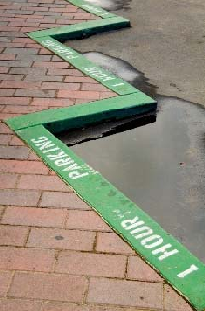Green

Parking is allowed for a short time. This time is usually shown on a sign next to the green zone, or it may be painted on the curb.
Yellow

Stop only long enough to load or unload passengers. Drivers are usually required to stay with their vehicle.
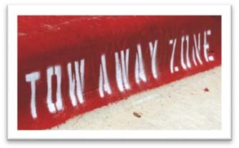
Red

No parking. Red curb may also be used in NO STOPPING or NO STANDING zones. A bus may stop at a red zone marked for buses. Red is also used to designate fire lanes at schools.
In some instances, it may be beneficial to stripe out the
loading area, both for the driver and for waiting students. Some schools choose to stripe the path the drivers are supposed to follow. Other schools tend to use pavement arrows and stencils to designate circulation patterns and where loading should happen.
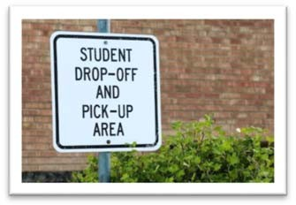
Signs

Signs help define areas in drop‐off and pick‐up zones and explain their proper use. Signs should be standard, highly visible, properly installed, and well‐maintained.
Remember, some signs can be confusing if improperly placed or poorly worded. Signs with fewer words are easier to read and understand. Standard signs should be
used on school property and in the surrounding area for regulating and guiding traffic. A local traffic engineer can recommend appropriate signs and their placement.
Education

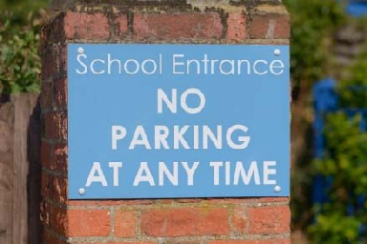Educating parents and students about the proper drop‐off and pick‐up procedure at your school is necessary to develop both a safe and efficient system.
There are several ways to educate about the procedure. For example, regular reminders of the procedure from school officials to parents is just one way to keep them

informed. Maps of the drop‐off and pick‐up area with traffic flow patterns is very helpful as well.
Some schools hold traffic safety days to provide students and parents with useful information. Drivers are reminded of traffic safety principles and the policies and procedures at drop‐off and pick‐up.
Monitoring and Enforcement

Enforcement of drop‐off and pick‐up rules is important to create a safe drop‐off and pick‐up environment. A variety of people should enforce the drop‐off and pick‐up policies, such as law enforcement officers, school personnel or parent volunteers. When new drop‐off and pick‐up plans are implemented, administrators can ask for help from law enforcement officers. They can ensure traffic flows smoothly during the first few days. Implementing a new plan may also require more volunteers or monitors to regulate parent activity in the first few days. A new drop‐off plan should start either at the start of the school year or after a break. Administrators need to give sufficient notice to parents and students before a new plan starts.
In conclusion, improving the drop‐off and pick‐up process at your school will constantly keep students safer. Let’s take a look at parking lot design.
Site Design

It is important to create a space that is a safe area for vehicles and students during pick‐up and drop‐off. Parking lots should be created to handle the high traffic during the busiest times of unloading and loading at the beginning and end of each day. During other times, these areas may be empty and unsupervised.
The safety and security of the parking lot area are dependant on the following components:

- Parking lots should not be separated from the school, but near visual surveillance from classrooms and administration areas.

- Classrooms should have windows that overlook the vehicular routes.

- External access to parking areas should be restricted to a limited number of controlled entrances.

- Parking and vehicular routes should be lit with vandal proof lighting.

The entry drive should also have sufficient space for lanes coming in and out. If possible, it should be separated by a landscaped median. Issues of security and safety will also affect the

design and configuration of a school parking lot. Try and avoid using loose gravel or crushed rock for surfacing because spinning tires will toss projectiles and can damage other vehicles and potentially injure pedestrians.
One entry is preferred to maintain control over vehicles entering and leaving the parking lot. This is especially true for school events that may restrict parking to certain people. However, if two entries are necessary, they should be close enough so one person can monitor both entrances. If not, two people will be needed.

Module 1 Quiz

Use this quiz to self‐check your understanding of the module content. You can also go online and take this quiz within the module. The online quiz provides the correct answer once submitted.

- This curb striping color means you can park there unless it is restricted or limited by signs.

  - Blue
  - White
  - Green
  - Purple

- A stripe on the curb means parking is allowed for a short time.

  - green
  - yellow
  - blue
  - red

- When should you use more volunteers to monitor and regulate pickup/drop‐off locations?

  - After a vacation
  - After a weekend
  - When a new plan is implemented
  - You should always use the same amount of volunteers in this area

- How many entries should there be in a pickup/drop‐off lane?

  - 3
  - 2
  - 1
  - 4

- When the curb is , you are only allowed to stop only long enough to load or unload passengers.

  - white
  - green
  - yellow
  - red

Module 2: External Building Safety
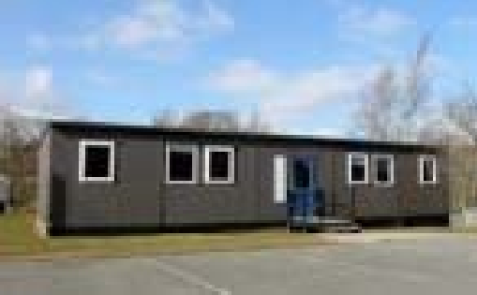Portable Classroom Safety

An estimated 385,000 portable classrooms are in use at schools across the country, and that number is sure to grow, as school districts across the nation are dealing with overcrowding issues. Portable classrooms should be a temporary fix for overcrowding, but more often than not, they are becoming permanent fixtures on school campuses.
Portables and Health Issues
Portables should be only used as short‐term fixes as they can lead to chronic problems, such as the following:

- exposing students and teachers to mold and mildew

- poor ventilation

- potential for dangerous gases from cheap building materials

Experts say outdoor air should be supplied on a continuous basis when students and/or teachers are in the portable classroom to improve the ventilation. If students or teachers experience eye or respiratory irritation, neurologic symptoms or difficulty concentrating while in the portable classrooms, they should immediately reduce exposure and get medical help.
Poor lighting, extreme temperatures and noisy heating, and air condition can compromise the learning experience in portables. The structures often are placed in soggy fields or parking lots, near noise and vehicle exhaust.
Sports Field Maintenance

Coaches may be more concerned with injuries, personnel problems, and opponents rather than the condition of their playing turf. However, this may be detrimental to their athletes. An acceptable playing field should be resilient, uniform, and wear‐resistant. It

should be soft enough to prevent cuts when players fall, yet firm enough to allow for good footing.
Recent reports show that as many as half of the serious knee and ankle injuries are related to poor field maintenance, such as:

- poor grass cover

- rough surfaces

- slick, muddy conditions

Fields that are mowed regularly, fertilized properly, and watered on a timely basis tend to stand up to normal use.
Improving Playing Surface
If the field is hard due to poor soil conditions or even heavy use, you may want to aerate to help the problem. A hollow‐spoon aerator will reduce soil compaction, increase water penetration, and promote grass recovery. For best results, you need to aerate fields when the soil is moist, not wet, for maximum penetration of the spoons. After you complete the aeration, drag the field with a heavy mat to break up the soil and smooth the surface.
Watering Fields
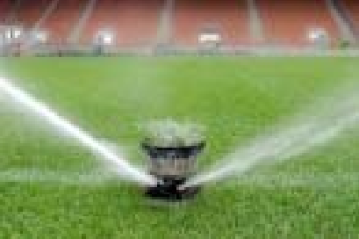Wet conditions only add to the deterioration of turf on an athletic field. Coordinate watering practices with the scheduled use of the playing field to minimize problems. The field surface must be dry when the field is in use to prevent injuries.
Therefore, when supplemental watering is needed, schedule it for at least 24 hours before the field will be used. As water is needed, wet the soil to a depth of 4 to 6 inches on a weekly basis. You can follow with some light watering as needed.
Field Renovation
Renovation of athletic fields are necessary, especially for
the fields are used quite a bit, to help reduce injuries. The renovation of an extensively used football field, for example, is an annual requirement. This would involve aeration, weed control, fertilization, and, in extreme cases, replanting. The first step in renovation is to correct the conditions that caused the field to deteriorate in the first place, such as poor drainage, weeds or excessive use.

Bleacher Safety

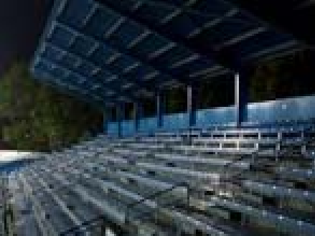Many athletic fields have bleachers, and they can pose serious safety risks if they are not properly taken care of. The United States Consumer
Product Safety Commission (CPSC) says there were an estimated 22,100 bleacher‐associated injuries treated in emergency rooms in 1999. Approximately 6,100 of these injuries were a result of the person falling from, or through, bleachers, onto the surface below.
Approximately 4,910 of these falls involved children under the age of 15.
Bleacher Hazards
Millions of spectators watch sporting events from many
types of bleachers each year. School administrators need to be aware of the following hazards:

- Large Gaps: Gaps of more than four inches between seatboards and footboards are considered unsafe. That is because small children can slip through them. The CPSC suggests using rigid materials to close the opening between these surfaces.

- Unsafe Guardrails: If guardrails do not properly prevent falls, they need to be replaced. Also, guardrails are often fun climbing targets for children. If the bleacher guardrails are so tall that a child can pass under it, it is not safe.

  - Guardrails should be used on any bleacher where the top row is 30 or more inches off the ground.

  - The top surface of the guardrails should be no less than 42 inches from the highest point of the bleachers.

  - Nowhere in the guardrails should a four‐inch diameter sphere be able to pass through.

  - Guardrails should discourage climbing in one of three ways:

    - Only use vertical fill‐ins between the top and bottom rails.

    - If there are openings in the fill‐ins that could provide a foothold for climbing, the widest measurement of the opening should be limited to 1.75 inches. Opening patterns that provide a ladder effect should be avoided.

    - Use solid surfaces to fill in spaces, but only use this if the visibility would not be significantly impaired.

- 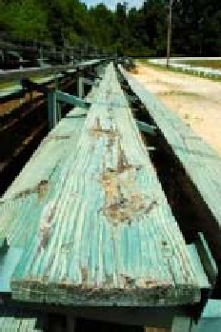Structural Problems: Older bleachers that have not been maintained correctly or have aged due to weather, overuse, or misuse may become structurally unsafe. Bleachers should be strong enough to handle a maximum load and be mechanically operational.

- Entrance & Exit: Spectators must be able to enter and leave the bleachers in a safe manner. Aisles and walkways should have non‐skid surfaces and be wide enough for spectators to reach exits in an emergency.

The area underneath the bleachers can be dangerous as well. For this reason, it is important to block off completely the space underneath them. If your facility has larger rows of outdoor bleachers that cannot be closed off completely, you may want to consider having someone supervise the area to keep kids away.
Action Plan
You need to inspect the bleachers on a regular basis. The CSPC guidelines recommend you inspect bleachers no less than four times a year. Take a closer look at the amount and type of use the bleachers experience before creating an exact inspection schedule. Along with the regular inspections, each school should hire an engineer to conduct a full structural inspection at least once a year.
During an inspection, you should identify any structural damage or issues that could make them unsafe. It often works well to create a checklist for inspections and then carry it out in a systematic manner.

Module 2 Quiz

Use this quiz to self‐check your understanding of the module content. You can also go online and take this quiz within the module. The online quiz provides the correct answer once submitted.

- The following health issue(s) can happen if portable classrooms are not maintained.

  - Mold and mildew
  - Potential dangerous gases
  - Hospitalization and/or death
  - Both A and C are correct

- of the serious knee and ankle injuries are related to poor field maintenance.

a. 3/4
b. 1/2
c. 75%
d. 25%

- When supplemental watering is needed on a playing field, schedule it at least
before the field will be used.

  - 48 hours
  - 36 hours
  - 24 hours
  - 8 hours

- As watering is needed, wet the athletic field soil .

  - 4‐6 inches
  - 12 inches
  - 9 inches
  - 1 inch

- Guardrails should be used on any bleacher where the top row is inches high.

  - 30
  - 10
  - 20
  - 15

Module 3: Building Maintenance
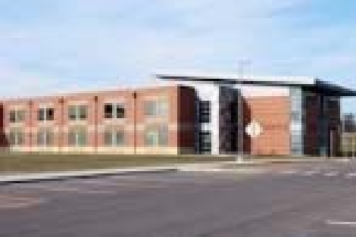It is important to keep school buildings in good condition by performing routine inspections and maintenance to make sure the building and structures are safe for students and staff members. Regular inspection processes are the basis of good building maintenance practice because it helps identify necessary repairs at an early stage to minimize the risk of bigger and costly problems in the future. Experts say engineers and surveyors should
provide a visual inspection of the structures on an annual basis.

Inspection Areas

Key areas of inspection should include the following:

- Roof level: covering, flashings, gutters, gulleys and downpipes, and chimney stacks

- External walls: cladding, rendering, windows and doors, and damp proof course

- Roof space: roof structure, insulation, and ventilation

- Internal rooms: ceiling, walls and floors, windows, and doors

- Stairs: tread, risers, and handrails

- Services: electrical, heating, plumbing, ventilation, water supply, fire, alarms, intruder prevention, and lightning protection systems

When the inspection is complete, make sure to draw up an action plan and identify what work is required to distinguish between both essential and desired work. It is also necessary to keep the inspection information, such as photographs or measurements that were taken during the inspection. Let’s take a closer look at some things you need to remember.
Know where to look for information. Buildings can change hands and it can be difficult to secure all the necessary and important inspection information. When deciding with whom to

place the information, you should consider management staff, third party suppliers and contractors, design teams, inspection authorities, health and safety departments, building surveyors, and structural engineers.
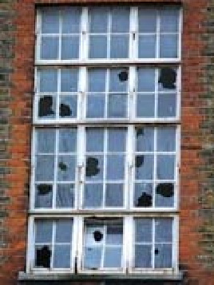Check existing documentation for basic construction details. It is worth looking at existing building condition surveys. They may have been completed previously to determine funding needs of the building or even as part of refurbishment efforts in the past. You should also identify other documentation, such as local authority records, education authority records, and alteration documents over the building’s lifetime.
Look at the fabric of the building both as a whole and its individual components. Are window frames properly secured to the building or are window openings showing any signs of cracking? Look for signs of wear and tear in general, such as cracking, movement or leaning of ceiling tiles. These can cause potential instability issues. Make sure to review the accident log to figure out any accident or injury patterns.
Secure any potential hazards. Building maintenance should include both the overall actions required to complete maintenance work and provide temporary arrangements.
It may be necessary to cordon off an area of the building to mitigate accident or injury. Make sure to take into account all necessary measures, such as adequate signposting indicating the area is off‐limits.
Monthly Maintenance Checks

As mentioned earlier, it is necessary to do maintenance checks throughout the school building on a regular basis. Every month, a more detailed inspection should occur.
On the Grounds

- Trim any trees or shrubs that are close to the building.

- Collect any garbage around the buildings. Burn and bury it.

- Check for termite tunnels and remove them. Make sure you dig out any termite nests you find around the buildings.

- Remove all garbage and debris from storm drains and check outlets for blockage as well.

- Check main water supply pipes and outside pipes and taps for leaks. Make sure you repair them, as needed.

- Check to make sure all electric pumps are operating correctly.

- Weed and tidy up any flowerbeds.

Outside the Buildings

- Remove any leaves or garbage from the rooftops.

- Check tiled roofs for loose tiles and fix if needed.

- Check external ceilings for damp patches that indicate leaks.

- Remove any leaves or garbage from the gutters and down‐pipes, especially during the wet season.

- Check external gas piping, heating/cooling, and electrical installations.

- Make sure external light fittings and switches are working correctly, and switch covers are properly fixed and not damaged. Clean light fittings, if necessary.

Annual Maintenance Checks

Every year, a member of the school maintenance team needs to inspect the school grounds and buildings.
On the Grounds

- Trim back any trees or shrubs that are too close to the buildings.

- Check for termite nests and dig out any that are found.

- Check storm drains and outlets for cracks. Make sure to repair, if necessary.

- Check that electrical pumps are working. Follow maintenance procedures and instructions in the handbook or call an electrician to make any needed repairs.

- 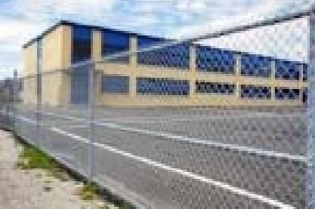Check paving around buildings.

- Check paths and roads within the site.

- Check walls or fences and gates for damage. Repair them, if necessary.

Outside the Buildings

- Replace any loose or damaged tiles or ridge pieces on tiled roofs.

- Check corrugated steel or fiber‐cement roofs for loose nails or screws and damaged sheets. Paint or replace any damaged sheets or flashings.

- Check any gutters or down‐pipes for blockages, damage, and rust. Repair or replace, if necessary.

- Check external ceilings for indications of roof leaks, and sagging or broken panels and repair or replace, if necessary. Repair any leaks as well.

- Check external electrical installations.

- Steel‐framed buildings: Check steel wall, veranda, and roof frames for rust and repair. Re‐paint or replace, if necessary.

- Timber‐framed buildings: Check timber cladding for rot or termite damage. Repair, replace, or re‐paint, if necessary.

In conclusion, remember that regular inspections on the site can help identify necessary repairs BEFORE they cause larger problems in the future.

Module 3 Quiz

Use this quiz to self‐check your understanding of the module content. You can also go online and take this quiz within the module. The online quiz provides the correct answer once submitted.

- Why it is important to have a regular inspection process in your school buildings?

  - Reduces chance of costly problems
  - Helps identify necessary repairs early
  - Keeps maintenance staff busy
  - Both A and B are correct

- Engineers and surveyors should provide a visual inspection of the structures every
.

  - week
  - year
  - month
  - 2 weeks

- How often should you remove all garbage and debris from storm drains?

  - Yearly
  - Daily
  - Monthly
  - Weekly

- How often should you check to make sure all electrical pumps are working?

  - Yearly
  - Daily
  - Monthly
  - Weekly

- Check external ceilings for indications of leaks, and sagging or broken parts every
.

  - day
  - week
  - year
  - day

Module 4: Roof Maintenance
A roof needs to protect the school building from all types of weather, such as rain, sun, and wind. Another important function of the roof is to keep water from getting into the school building. It is a key part of the school building’s waterproofing system. Therefore, the roof and gutters should be kept in good shape.
Gutters

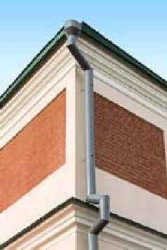Gutters need to be kept clean to function properly. Make sure someone regularly cleans out leaves, debris, plant or tree droppings. Clogged gutters or down‐spouts will cause water problems if they are left untreated. An inspector should also look at the gutters for pinhole leaks or rusted sections. These can cause them to leak water. Gutter brackets should not be broken or rusted. Down‐spout pipes, called leaders, should be intact, with no rust, holes, or broken sections. The rainwater should freely flow through the gutters and into the down‐spouts. If not, the gutters may not be aligned correctly. They should slope toward the down‐spout.
Improper alignment should be corrected quickly. If not, it defeats the purpose of the gutter system. Never allow water from down‐spout to pour directly on a roof below. Connect upper storey down spouts to lower level gutters.
Let’s take a closer look at the different types of roofs that are common on school buildings.

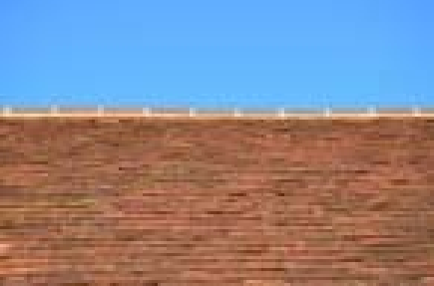Clay Tiled Roofs

There are many issues and common problems that can exist with clay tiled roofs. Here is a look:

- Tiles cracked or broken by stones or balls thrown up on the roof

- Tiles that have become loose or fallen out because they were not laid properly or the timber has moved

- Tiles that have deteriorated because they were either under‐burned or poorly made

If any of these issues occur, the tiles should be replaced as soon as possible. You will need to have a maintenance worker get on the roof and lift the surrounding tiles and replace the loose or damaged ones.
Another common problem with clay tiled roofs is the ridge or hip tiles that are set in motor become loose, causing leaks. To correct this problem, you will need to have a tiler re‐lay the loose tiles and set them in place using a 1:1 cement/sand mortar.
These operations can be dangerous, and you must be careful not to damage the other tiles. Make sure you use proper fall protection to prevent drastic falls from the roof as well. Always use ladders to access the roof and crawl boards. The ladders must be fixed over the ridge of the roof to spread the weight of the tiler.
Corrugated Steel Roofs

There are many issues and common problems that can exist with corrugated steel roofs. Here is a look:

- Fixing screws or nails that have become loose and can cause leaks

- Ridge or hip flashings becoming loose

- Flashings to verges becoming loose

- Roof sheets rusting

Many things can indicate roof fixings that have become loose. First, there will be damp patches on the ceiling panels. Try tightening or replacing the roofing screws or nails as soon as possible to avoid extensive and costly damage to the ceilings.
There will also be similar indications if ridge, hip, or verge flashings become loose. Tighten or replace the roof screws and nails as soon as possible. Also, if roof nails do have to be removed, use a claw hammer supported on a piece of timber that is shaped to fit into the sheet corrugations. This will spread out the load and stop the sheet damage.
Always make sure to secure fixings to roof sheets through the top of the corrugations. Also, always use roofing screws and plastic washers if they are available. If plastic washers are not available, you can always use roofing nails with a twisted shank and a felt washer under a metal washer.

If corrugated sheet roofs start to rust, their life can be extended by painting them. Before painting, brush off any loose dirt and rust using a steel brush. When galvanized roof sheets are in good condition are painted, use a special self‐etching primer to make sure the paint does not peel off over time. However, if the sheets have rusted, make sure you use a red‐oxide metal primer with two coats of gloss paint. Using a light‐colored paint will reflect the heat.
Fiber‐Cement Roofs

The problems associated with fiber‐cement roofs are similar to those of the corrugated steel sheet roofs, but there are a few differences.
Replace cracked or broken sheets as soon as possible. To do this, carefully remove the fixings to adjacent sheets before you remove the cracked or broken sheet. When inserting a new sheet, the top corner under the side lap (this will depend on which way the original roof sheets were laid) will have to be joined at the seam before the sheet is laid. Drill new fixing holes in the new sheet below the existing holes in the adjoining sheets.
Roof Structures

You should inspect the roof and ceiling timbers at least once a year. There should be an access panel in each ceiling to allow access into the roof space for inspections and any required repairs.
If you find any timber damaged due to termites, insect attack, or rot caused by roof leaks, take action as soon as possible.
If insects or termites have attacked the timber, but the damage is not extensive, then you will need to clean off the timber and treat it to prevent future insect attacks. Used engine oil is a free or very cheap and effective form of treatment.
If the damage is more extensive, then more drastic measures will need to be taken. It will be somewhat difficult to remove damaged structural timbers, such as rafters or ceiling supports, without removing the roof covering.
This would also be very expensive. It might be possible to remove the roof covering just over the damaged timbers, but if not, you will need to deal with the damage exclusively. To do that, prop up the roof or ceiling and either cut the damage parts to one or both sides. Ceiling timbers might require you to fix additional hangers from the roof timbers. Check all fixings of roof trusses or rafters at the tops of walls or columns. Re‐fix them, if necessary.

Steel Structures

Many existing school buildings have a roof and supporting structures made of steel beams and columns. For safety reasons, make sure to inspect the steel structures for rust at least once a year. Rub down any rusty sections with carborundum paper, prime the exposed metal with metal primer, and then re‐paint with two coats of gloss paint.
Make sure you pay close attention to areas exposed to the rain, such as the ends of beams. Re‐ paint the entire steel structure every four years.
Roof Fascias, Bargeboards, and Exposed Roof Timbers

There are many external roof timbers that require regular maintenance. These include fascias to the eaves at the bottom of the roof, bargeboards at the ends of the roof, and any exposed structural roof timbers.
These eaves and verge fascias protect the ends of the rafters from the rain and sun and other weather‐related damage. Therefore, it is very important to keep them in good shape.
Paint all fascias at intervals not more than every four years. Rub down the timbers with sandpaper and paint them with at least one coat of glossy paint. Punch any protruding nails from the timber and fill the holes with wood filler before painting. Also, prime any timber that is exposed during sanding. You can use good quality wood primer and then re‐paint it with two coats of oil paint.
If during the annual inspection, you find rotten timbers, they should be removed and replaced as soon as possible. If only a short section is affected, cut it out and replace it. Treat structural roof timbers with wood preservative.

Module 4 Quiz

Use this quiz to self‐check your understanding of the module content. You can also go online and take this quiz within the module. The online quiz provides the correct answer once submitted.

- Who should look at the gutters for pinhole leaks or rusted sections?

  - Students
  - Inspector
  - Maitenance supervisor
  - Teachers

- On a corrugated steel roof, why should you use a light‐colored paint?

  - Reflects the heat better
  - Look more professional
  - The paint never peels
  - The roof rusts more slowly

- How often should someone fully inspect the roof and ceiling timbers?

  - Once a week
  - Once a month
  - Every 30 days
  - Once a year

- Using can prevent future insect or termite attacks on the roof timbers.

  - cooking oil
  - engine oil
  - grease
  - dish soap

- Re‐point the entire steel structure every .

  - 2 years
  - 10 years
  - 4 years
  - 5 years

Endnotes
- Safe Routes to School. (2007). Student Drop‐off and Pick‐up. Retrieved from: http://guide.saferoutesinfo.org/pdf/SRTS‐Guide_Dropoff‐Pickup.pdf

- Safe Schools Design Guidelines. (1993). Vehicular Routes & Parking Areas. Retrieved from: http://www.fccdr.usf.edu/upload/Projects/safeschool/safesc/site11.htm

- Sports Field Maintenance. (1995). Texas Agricultural Extensive Service. Retrieved from: http://publications.tamu.edu/TURF_LANDSCAPE/PUB_turf_Sports%20Field%20Maintenance.p df

