Equipment Name & Number: |  | 1-BACKHOE LOADER (JCB) &
Note: Please write Yes or No in the given box and if some comments write in remarks column.
SN. | Description |  |  | Yes/No | Remarks
1. | Machine should be physically good & certified by competent authority. |  | #
2. | No damage in tire (Bolts, crack, cuts & air pressure, etc.). |  | #
3. | Head & tail light and indicators are in working condition. |  | #
4. | Side mirror should be in good condition. |  | #
5. | Wind shield/glass should be in proper condition. |  | #
6. | Wiper should be in running condition.
7. | Operator cabin and driver seat should be made by good  & sound quality of material. |  | #
8. | Hydraulic cylinders and hoses are in good condition and free from leakage. |  | #
9. | Outrigger should be free from damages. |  | #
10. | Red triangle/reflective tape should be fixed in front of vehicle.
11. | Front & reverse horn. |  | #
12. | Fire extinguisher in operator cabin. |  | #
13. | First aid box in operator cabin.
14. | Operator have valid and suitable license. |  | #
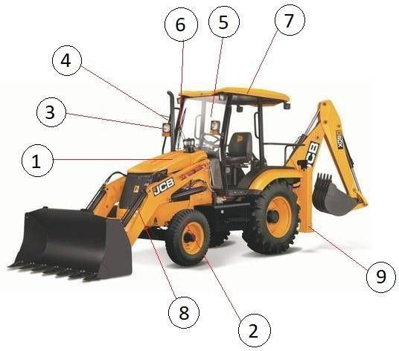

Equipment Name & Number: |  | 2-EXCAVATOR &
Note: Please write Yes or No in the given box and if some comments write in remarks column.
SN. | Description |  |  | Yes/No | Remarks
1. | Engine and rotating part should be properly covered. |  | #
2. | Track frame should be in good and working condition. |  | #
3. | Crawler belt and shoes should be in good condition. |  | #
4. | Boom and arm should be free from defects like corrosion, bend, etc. |  | #
5. | Hydraulic cylinder and hoses should be in good condition.
6. | Bucket, cutter pins should be free from defects, e.g., damage, corrosion, bend, etc. |  | #
7. | Teeth should be free from defects, e.g., damage,  corrosion, bend, etc. |  | #
8. | Side mirror should be in good condition. |  | #
9. | Head & tail light and indicators are in working condition. |  | #
10. | Wind shield/glass should be in proper condition. |  | #
11. | Wiper should be in running condition.
12. | Swing horn should be in good condition.
13. | Fire extinguisher in operator cabin.
14. | Operator have suitable licence/experience certificate. |  | #

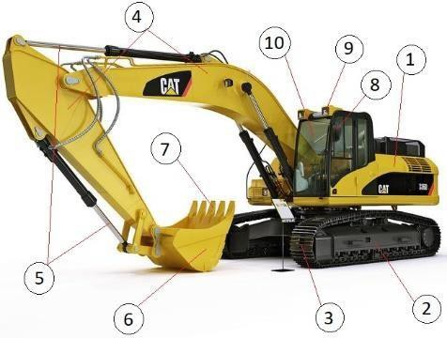

Equipment Name & Number: |  | 3-DUMPER &
Note: Please write Yes or No in the given box and if some comments write in remarks column.
SN. | Description |  |  | Yes/No | Remarks
1. | Operator cabin should be fully covered and made by sound quality of material. |  | #
2. | Carrier should be in good condition. |  | #
3. | No damage in tire (Bolts, crack, cuts & air pressure, etc.). |  | #
4. | Side mirror should be in good condition. |  | #
5. | Head & tail light and indicators are in working condition. |  | #
6. | Wiper should be in running condition.
7. | Wind shield/glass should be in proper condition. |  | #
8. | Seatbelt should be available. |  | #
9. | Red triangle/reflective tape should be fixed in front of vehicle.
10. | Hydraulic cylinder and hoses should be in good condition and free from leakage. |  | #
11. | Registration number should be written. |  | #
12. | Front & reverse horn. |  | #
13. | Fire extinguisher in operator cabin. |  | #
14. | Operator have valid and suitable license. |  | #
15. | First aid kit should be available.
16. | Normal break & emergency (hand) break should be in functional & operational condition. |  | #
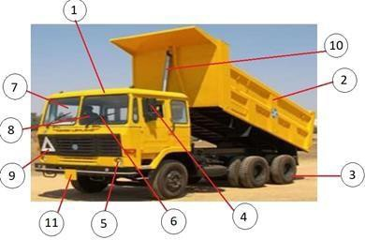

Equipment Name & Number: |  | 4-EARTH COMPACTOR (ROLLER) &
Note: Please write Yes or No in the given box and if some comments write in remarks column.
SN. | Description |  |  | Yes/No | Remarks
1. | Earth compactor should be physically in good condition. |  | #
2. | No damage in tire (Bolts, crack, cuts & air pressure, etc.). |  | #
3. | No damage in compacting roller.
4. | Dangerous and moving part should be covered with fix guard. |  | #
5. | Head & tail light and indicators are in working condition. |  | #
6. | Side mirror should be in good condition. |  | #
7. | Wind shield/glass should be in proper condition. |  | #
8. | Wiper should be in running condition.
9. | Front & reverse horn. |  | #
10. | Fire extinguisher in operator cabin. |  | #
11. | Operator have valid and suitable license. |  | #

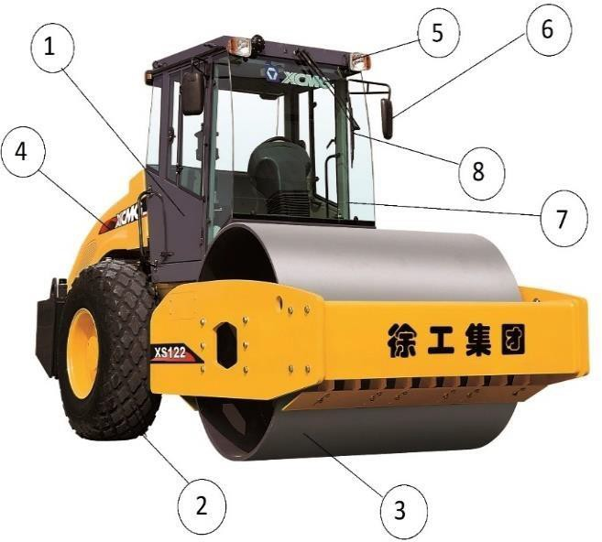

Equipment Name & Number: |  | 5-CONCRETE MIXER &
Note: Please write Yes or No in the given box and if some comments write in remarks column.
SN. | Description |  |  | Yes/No | Remarks
1. | Mixer machine should be physically fit. |  | #
2. | Rotating part & IC engine should be covered with fix guard. |  | #
3. | No damage in tire (crack, cuts & air pressure, etc.). |  | #
4. | Rotating part of gear should be covered. |  | #
5. | Proper handle lock should be available. |  | #
6. | Handle should be free from defect.
7. | Mixer machine should be with proper handle to control the movement. |  | #
8. | Spark arrestor should be installed, if machine is operating in flammable atmosphere.

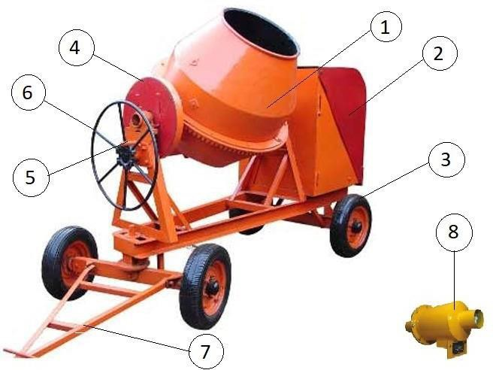

Equipment Name & Number: |  | 6-TRANSIT MIXER &
Note: Please write Yes or No in the given box and if some comments write in remarks column.
SN. | Description |  |  | Yes/No | Remarks
1. | Transit mixer should be physically in good condition. |  | #
2. | No damage in tire (Bolts, crack, cuts & air pressure, etc.). |  | #
3. | Registration number should be written. |  | #
4. | Head & tail light and indicators are in working condition. |  | #
5. | Side mirror should be in good condition. |  | #
6. | Wind shield/glass should be in proper condition. |  | #
7. | Wiper should be in running condition.
8. | Red triangle/reflective tape should be fixed in front of vehicle.
9. | Rotatory part of secondary engine should be covered with fix guard. |  | #
10. | Rotating part of gear box should be covered by fixed guard. |  | #
11. | Inbuilt ladder should be proper with suitable guard. |  | #
12. | Front & reverse horn. |  | #
13. | Fire extinguisher in operator cabin. |  | #
14. | Operator have valid and suitable license. |  | #
15. | First aid kit should be available.
16. | Normal break & emergency (hand) break should be in functional & operational condition. |  | #
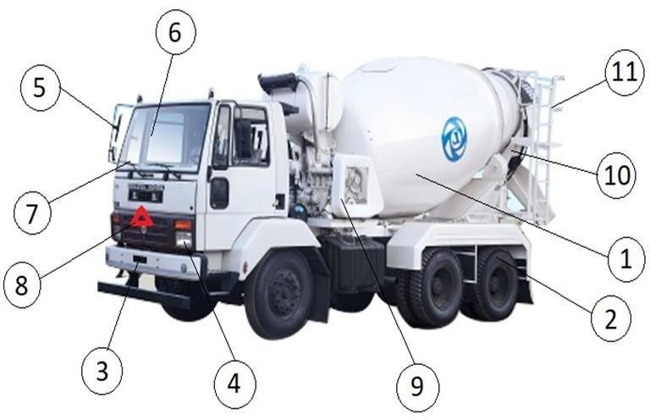

Equipment Name & Number: |  | 7-CONCRETE PUMP &
Note: Please write Yes or No in the given box and if some comments write in remarks column.
SN. | Description |  |  | Yes/No | Remarks
1. | Concrete pump should be physically in good condition. |  | #
2. | No damage in tire (Bolts, crack, cuts & air pressure, etc.). |  | #
3. | Outrigger should be free from damages. |  | #
4. | Dangerous or moving part should be covered with fix guard. |  | #
5. | Panel/switch board should be covered properly.
6. | Emergency stop button should be mushroom headed with red colour. |  | #
7. | Concrete hopper should be in good condition.
8. | Suitable mesh should be kept on hopper to avoid getting in touch with moving part. |  | #
9. | Clamp should be proper for tight joint of pipe. |  | #
10. | Hook should have sufficient strength to carry self-load during shifting.
11. | In case of electrically operated, electrical connection should  be taken in proper manner. |  | #
12. | In case of electrically operated, machine should be grounded as per IS 3043:1987. |  | #
13. | Concrete pump should be operated by competent person. |  | #
14. | Concrete pipe should be free from damages. |  | #
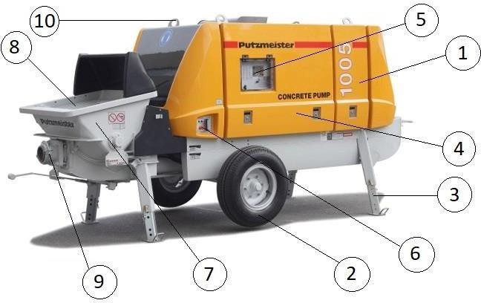

Equipment Name & Number: |  | 8-BOOM PLACER &
Note: Please write Yes or No in the given box and if some comments write in remarks column.
SN. | Description |  |  | Yes/No | Remarks
1. | Boom placer should be physically good. |  | #
2. | No damage in tire (Bolts, crack, cuts & air pressure, etc.). |  | #
3. | Head & tail light and indicators are in working condition. |  | #
4. | Outrigger should be free from damages. |  | #
5. | Wind shield/glass should be in proper condition. |  | #
6. | Wiper should be in running condition.
7. | Side mirror should be in good condition. |  | #
8. | Boom should be free from defects. |  | #
9. | Hydraulic cylinder and hoses should be in good condition and free from leakage. |  | #
10. | Pipe should be free from defects e.g. bend, crack, etc. |  | #
11. | Red triangle/reflective tape should be fixed in front of vehicle.
12. | Rotatory part of secondary engine should be covered with fix guard. |  | #
13. | Front & reverse horn. |  | #
14. | Fire extinguisher in operator cabin. |  | #
15. | Operator have suitable license/experience certificate. |  | #
16. | First aid kit should be available.
17. | Normal break & emergency (hand) break should be in functional & operational condition. |  | #
18. | Concrete hopper should be covered with mesh. |  | #
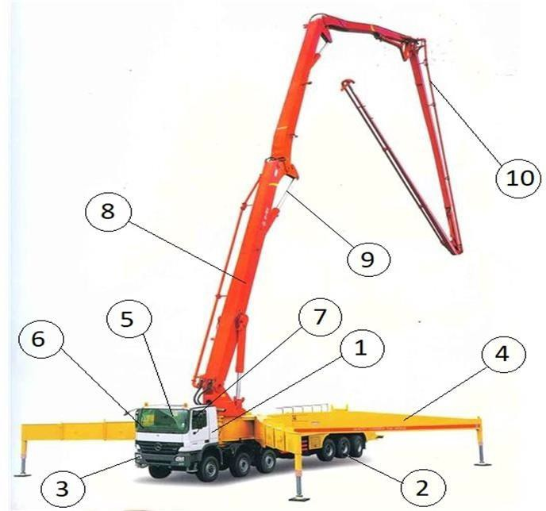

Equipment Name & Number: |  | 9-ELECTRICAL VIBRATOR &
Note: Please write Yes or No in the given box and if some comments write in remarks column.
SN. | Description |  |  | Yes/No | Remarks
1. | Physical condition of body should be good & sound. |  | #
2. | Power cable should be free from damages and connection taken through industrial plug. |  | #
3. | Junction box of motor should be free from defects. |  | #
4. | On/off switch should be properly insulated. |  | #
5. | Rotating part of machine should be covered by fixed guard. |  | #
6. | Needle should be tightly connected with motor.
7. | Needle should be free from damages.
8. | Machine should be grounded as per IS 3043:1987. |  | #

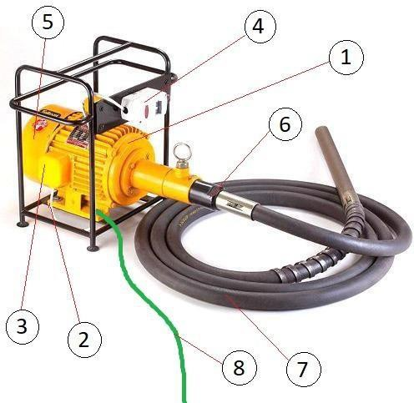

Equipment Name & Number: |  | 10-BAR CUTTING MACHINE &
Note: Please write Yes or No in the given box and if some comments write in remarks column.
SN. | Description |  |  | Yes/No | Remarks
1. | Physical condition of body should be good & sound. |  | #
2. | Junction box of motor should be full packed. |  | #
3. | Rotating part of machine should be covered by fixed guard. |  | #
4. | Operating leaver should be insulated with nonconductive material. |  | #
5. | Bar guard should be fixed with machine. |  | #
6. | Machine should be grounded as per IS 3043:1987. |  | #
7. | Power cable should be free from damages and connection taken through industrial plug. |  | #
8. | Machine should be operated by competent person.. |  | #

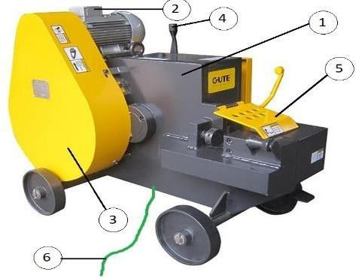

Equipment Name & Number: |  | 11-BAR BENDING MACHINE &
Note: Please write Yes or No in the given box and if some comments write in remarks column.
SN. | Description |  |  | Yes/No | Remarks
1. | Physical condition of body should be good & sound. |  | #
2. | Electrical connection should be taken through industrial plug in proper manner. |  | #
3. | Power cable should be free from damages. |  | #
4. | Operating switch should be free from defects, e.g., uninsulated & broken, etc. |  | #
5. | On/off or other switches should free from defects, e.g., uninsulated & broken, etc. |  | #
6. | Emergency stop button should be mushroom headed with red colour. |  | #
7. | Bar support should be properly fitted with machine. |  | #
8. | Pins should be free from loose fitting. |  | #
9. | Machine should be grounded as per IS 3043:1987. |  | #
10. | Machine should be operated by competent person. |  | #

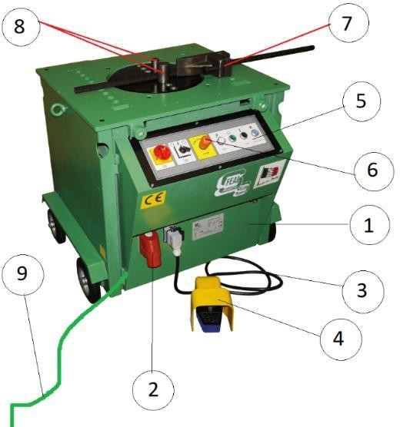

Equipment Name & Number: |  | 12-BREAKER &
Note: Please write Yes or No in the given box and if some comments write in remarks column.
SN. | Description |  |  | Yes/No | Remarks
1. | Breaker should be in good and working condition. |  | #
2. | Power cable should be free from damages and connection taken through industrial plug. |  | #
3. | A flexible cord should be provided to keep cable free from damage.
4. | Handle should be provided for better control.
5. | Bit should be in good condition and free from defect.
6. | Breaker should be double insulated otherwise grounded.
7. | Machine operated by competent person. |  | #

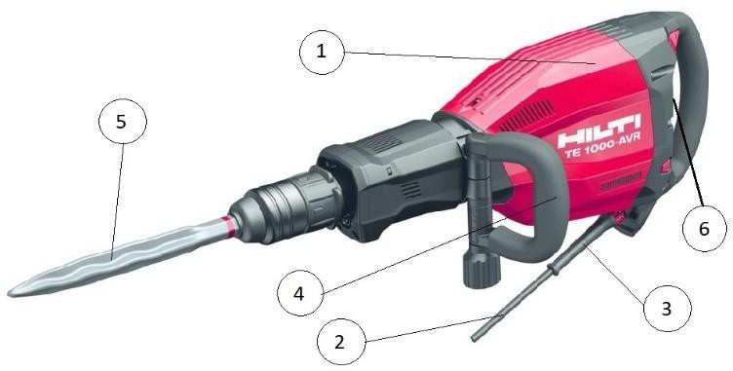

Equipment Name & Number: |  | 13-DRILL MACHINE &
Note: Please write Yes or No in the given box and if some comments write in remarks column.
SN. | Description |  |  | Yes/No | Remarks
1. | Drill machine should be in good and working condition. |  | #
2. | Power cable should be free from damages and connection taken through industrial plug. |  | #
3. | A flexible cord should be provided to keep cable free from damage.
4. | Dead man switch should be in working condition. |  | #
5. | Handle should be provided for better control.
6. | Drill bit should be in good condition and free from defect.
7. | Always use designated key for removing and changing drill bit.
8. | Drill machine should be double insulated otherwise grounded.
9. | Machine operated by competent person. |  | #

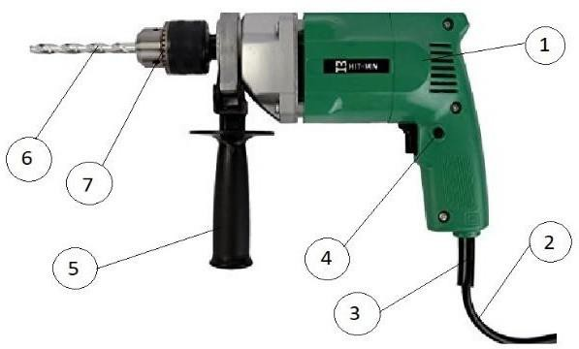

Equipment Name & Number: |  | 14-HYDRA &
Note: Please write Yes or No in the given box and if some comments write in remarks column.
SN. | Description |  |  | Yes/No | Remarks
1. | Hydra should be physically good & certified by TPI. |  | #
2. | No damage in tire (Bolts, crack, cuts & air pressure, etc.). |  | #
3. | Registration number should be written. |  | #
4. | Head & tail light and indicators are in working condition. |  | #
5. | No oil leakage in hydraulic part. |  | #
6. | Safe work load (SWL) marked. |  | #
7. | Sling drum should be in good condition. |  | #
8. | Boom condition while full extension (free from damage, crack & jamming, etc.). |  | #
9. | Wire rope free from damage. |  | #
10. | Hoist limit switch. |  | #
11. | Safety latch in hook. |  | #
12. | Safe load indicator should be in working condition. |  | #
13. | Front & reverse horn. |  | #
14. | Fire extinguisher in operator cabin. |  | #
15. | Operator should have valid license (heavy duty). |  | #
16. | Load chart available in operator cabin.

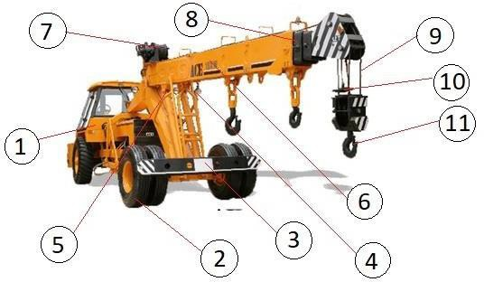

Equipment Name & Number: |  | 15-MOBILE CRANE &
Note: Please write Yes or No in the given box and if some comments write in remarks column.
SN. | Description |  |  | Yes/No | Remarks
1. | Physical condition of body should be in sound manner. |  | #
2. | No damage in tire (Bolts, crack, cuts & air pressure, etc.). |  | #
3. | Head & tail light and indicators are in working condition. |  | #
4. | Side mirror should be in good condition. |  | #
5. | Safe work load (SWL) marked. |  | #
6. | Hoist limit switch. |  | #
7. | Wire rope free from damage. |  | #
8. | Safety latch in hook. |  | #
9. | Outrigger with spreader mat should be in good and working condition. |  | #
10. | Sprit level should be installed. |  | #
11. | Boom condition while full extension (free from damage, crack & jamming, etc.). |  | #
12. | No oil leakage in hydraulic part. |  | #
13. | Safe load indicator should be in working state. |  | #
14. | Front, reverse and swing horn. |  | #
15. | Fire extinguisher in operator cabin. |  | #
16. | Operator should have valid and suitable license. |  | #
17. | Crane simulator should be in working condition. |  | #
18. | First aid kit should be available.
19. | Crane should be physically good & should have valid TPI. |  | `#
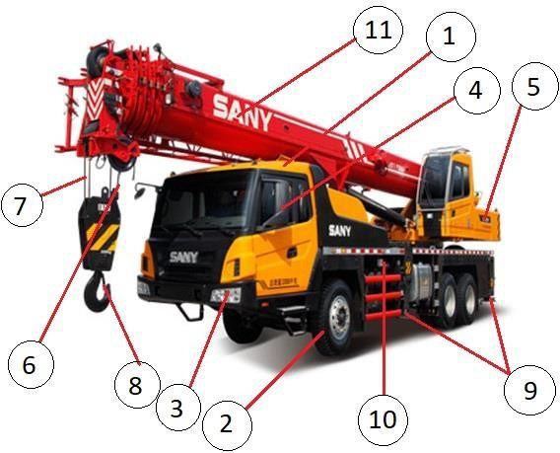

Equipment Name & Number: |  | 16-TOWER CRANE &
Note: Please write Yes or No in the given box and if some comments write in remarks column.
SN. | Description |  |  | Yes/No | Remarks
1. | Tower crane should be physically in good condition, free from defects. |  | #
2. | Foundation should be provided as per design. |  | #
3. | Operator cabin should be in good condition, equipped with wind glasses and wireless communication. |  | #
4. | Safe working load should be marked. |  | #
5. | Counter weight should be properly fixed. |  | #
6. | Hydraulic cylinder, hoses should be in good condition and free from leakage. |  | #
7. | Trolley condition should be good. |  | #
8. | Over hoist limit switch should be in working state. |  | #
9. | Limit switch should be provided for trolley motor. |  | #
10. | Sling should be free from defects. |  | #
11. | Safety latch should be in hook. |  | #
12. | Power cable should be free from damages and connection taken through industrial plug. |  | #
13. | Tower crane should be grounded as per IS 3043:1987. |  | #
14. | Safe load indicator should be in working condition. |  | #
15. | Fire extinguisher in operator cabin.
16. | Operator have suitable license/experience certificate. |  | #
17. | First aid kit should be available.
18. | Tower crane should be physically good & should have valid TPI. |  | #
19. | Anemometer should be in working condition.
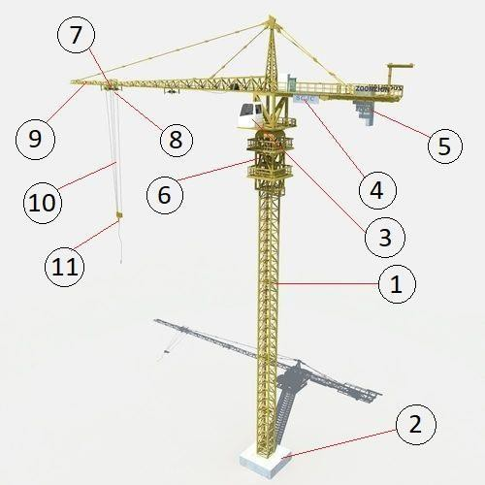

Equipment Name & Number: |  | 17-DIESEL GENERATOR &
Note: Please write Yes or No in the given box and if some comments write in remarks column.
SN. | Description |  |  | Yes/No | Remarks
1. | Physical condition of DG should be good. |  | #
2. | Door of DG should be in good condition, so that rotatory part of machine could cover. |  | #
3. | Display panel should be in good condition.
4. | Emergency stop button should be mushroom headed with red colour. |  | #
5. | DG should be grounded as per IS 3043:1987. |  | #
6. | Power supply panel provided with ELCB/RCCB/MCB. |  | #
7. | Spark arrestor should be installed, if DG is operating in flammable atmosphere.
8. | Diesel tank should free from leakage. |  | #
9. | DG should be keep on aggregate/gravel stone.
10. | Keep CO2, BCP fire extinguisher/sand bucket near DG. |  | #
11. | Fitness and pollution certificate should be taken from  competent authority.
12. | DG operated by competent person. |  | #
13. | Spill observant kit or drip tray available.
14. | Insulated rubber mat available. |  | #`

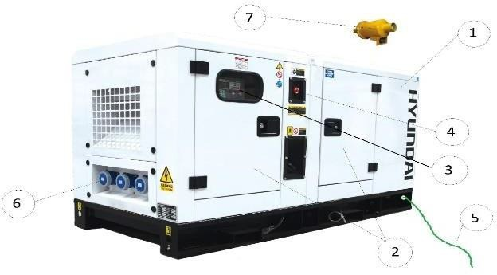

Equipment Name & Number: |  | 18-POWER/SUB DISTRIBUTION PANEL &
Note: Please write Yes or No in the given box and if some comments write in remarks column.
SN. | Description |  |  | Yes/No | Remarks
1. | Physical condition of panel should be good & sound. |  | #
2. | Panel should be kept on suitable stand. |  | #
3. | Junction boxes should be free from defects. |  | #
4. | All connection should be taken through ELCB/RCCB/MCB. |  | #
5. | Connection socket should be covered with auto lock.
6. | Switches and display should be properly covered.
7. | A danger signage should be marked.
8. | Panel should be grounded as per IS 3043:1987. |  | #
9. | Further connection for extension of cable should be taken through male-female connector. |  | #
10. | In case of flammable atmosphere single length cable shall be use.
11. | Canopy should be provided to avoid water getting entered due to rain or any other means. |  | #
12. | Rubber mat should be provided to stand during operation. |  | #
13. | Input power cable should be free from defects.
14. | Power input and output cable should be passes through glands. |  | #
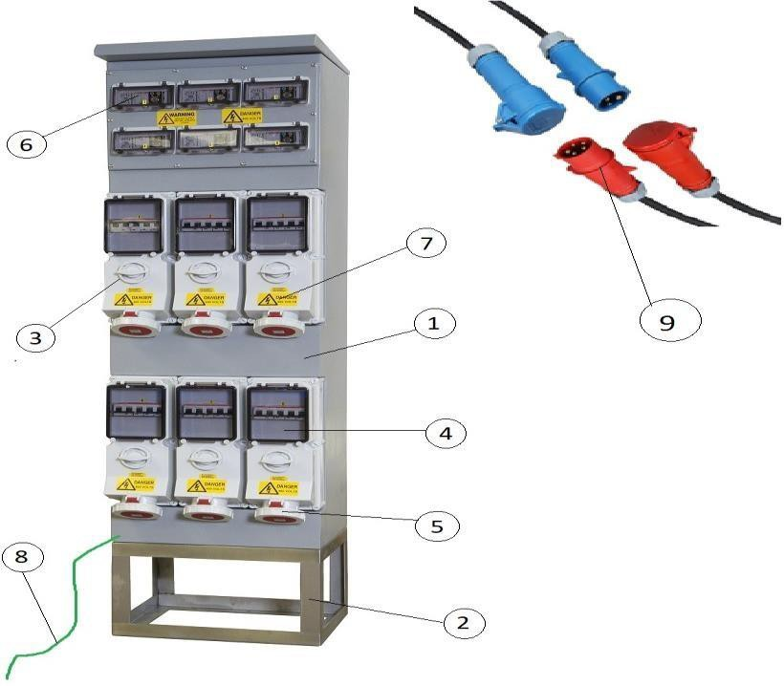

Equipment Name & Number: |  | 19-GAS CUTTING SET &
Note: Please write Yes or No in the given box and if some comments write in remarks column.
SN. | Description |  |  | Yes/No | Remarks
1. | Cylinder should be kept in trolley. |  | #
2. | Always keep in upright position. |  | #
3. | Properly secured. |  | #
4. | Valve protection cap. |  | #
5. | Regulator should be free from any defect. |  | #
6. | Pressure gauge should be in proper condition. |  | #
7. | Provide flash back arrestor. |  | #
8. | Provide industrial clip.
9. | Hose condition should be good with colour coded. |  | #
10. | Joint should be firm and free from defect, e.g., oily, rust & leakage, etc. |  | #
11. | Torch should be in good condition. |  | #
12. | Use proper PPEs for the Job, e.g., Leather hand gloves & safety goggles, etc. |  | #
13. | Keep fire extinguisher at working place. |  | #
14. | Provide booth, made by fire retardant material (if required).
15. | Work carried out by competent person. |  | #
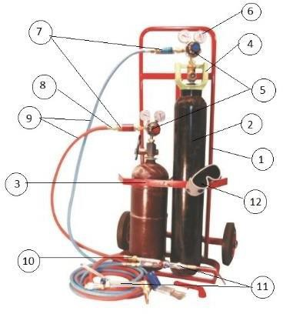

Equipment Name & Number: |  | 20-PORTABLE GRINDER &
Note: Please write Yes or No in the given box and if some comments write in remarks column.
SN. | Description |  |  | Yes/No | Remarks
1. | Grinding machine should be in good and working condition. |  | #
2. | Power cable should be free from damages and connection taken through industrial plug. |  | #
3. | A flexible cord should be provided to keep cable free from damage.
4. | Motor capacity should be marked in RPM.
5. | Dead man switch should be in working condition. |  | #
6. | Handle should be provided for better control.
7. | Wheel guard should be properly installed with  machine, so that gap between guard and wheel should not be more than 3mm. |  | #
8. | Grinding/cutting wheel should free from defect and rotating capacity should be marked. |  | #
9. | Grinding machine should be double insulated otherwise grounded.
10. | Always use designated key for removing and changing wheel.
11. | Machine operated by competent person. |  | #
12. | RPM of wheel should be more than RPM of motor. |  | #
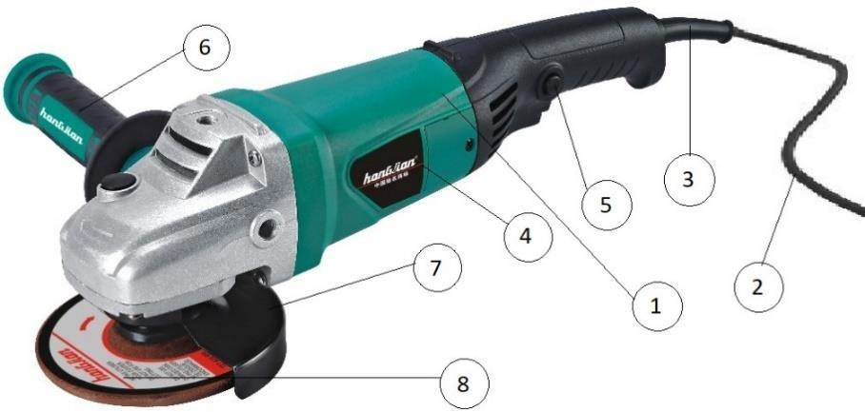

Equipment Name & Number: |  | 21-WELDING MACHINE &
Note: Please write Yes or No in the given box and if some comments write in remarks column.
SN. | Description |  |  | Yes/No | Remarks
1. | Welding machine should be in good and working condition. |  | #
2. | Power cable should be free from damages and connection taken through industrial plug and . |  | #
3. | Switches should be free from defects, e.g., uninsulated & damages, etc. |  | #
4. | Welding led & return led connection should be tightly by means of lugs/socket. |  | #
5. | Welding led & return led should be free from damages, e.g., cuts, naked, too many joint, etc. |  | #
6. | Welding holder should be in good condition and free from metal contact. |  | #
7. | Earthing holder should be in good condition and free from rust. |  | #
8. | Welding machine should be grounded as per IS 3043:1987. |  | #
9. | Keep fire extinguisher at working place. |  | #
10. | Provide booth, made by fire retardant material (if required).
11. | Work carried out by competent person. |  | #
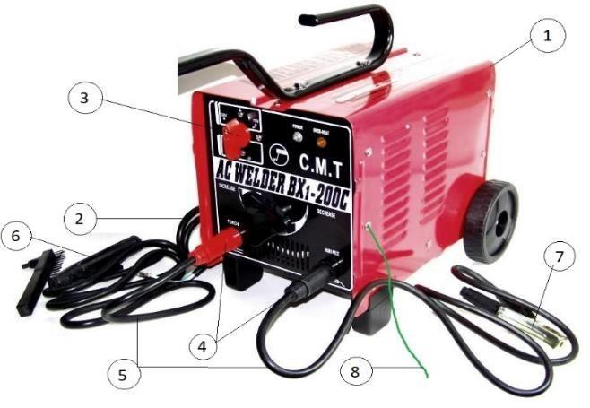

Equipment Name & Number: |  | 22-ELECTRICAL PUMP/MOTOR &
Note: Please write Yes or No in the given box and if some comments write in remarks column.
SN. | Description |  |  | Yes/No | Remarks
1. | Physical condition of pump should be good. |  | #
2. | Power cable should be free from damages and connection taken through industrial plug. |  | #
3. | Cable entry point should be fully packed, so that water can’t enter. |  | #
4. | Junction box of motor should be free from defects. |  | #
5. | On/off switch should be properly insulated. |  | #
6. | Rotating part of machine should be covered by fixed guard. |  | #
7. | Machine should be grounded as per IS 3043:1987. |  | #

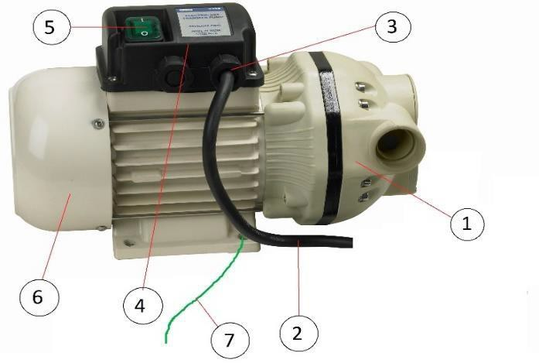

Equipment Name & Number: |  | 23-WINCH MACHINE &
Note: Please write Yes or No in the given box and if some comments write in remarks column.
SN. | Description |  |  | Yes/No | Remarks
1. | Winch should be in good and working condition and certified by TPI. |  | #
2. | Rotating part should be covered with fixed guard. |  | #
3. | Operating liver should be free from defects. |  | #
4. | Rope drum should have sufficient space to roll-in full slings. |  | #
5. | Wire sling should be free from damages. |  | #
6. | Sling should be knotted in proper manner. |  | #
7. | Safety latch should be in hook. |  | #
8. | Winch should be grounded as per IS 3043:1987. |  | #
9. | Winch machine should be properly fixed with hard structure. |  | #
10. | Power cable should be free from damages and connection taken through industrial plug. |  | #
11. | SWL should be written. |  | #

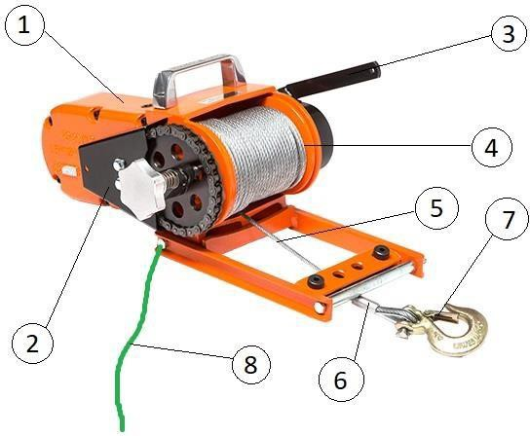

Equipment Name & Number: |  | 24-CHAIN PULLEY BLOCK &
Note: Please write Yes or No in the given box and if some comments write in remarks column.
SN. | Description |  |  | Yes/No | Remarks
1. | Chain pulley block should be in good and working condition and certified by TPI. |  | #
2. | Chain should be free from defects, e.g., crack, corrosion, etc. |  | #
3. | Hook should be in good condition, not stretched more than 15% of its original shape. |  | #
4. | Safety latch should be in hook. |  | #
5. | Safe working load should be marked and visible. |  | #
6. | Rotating part should be covered. |  | #

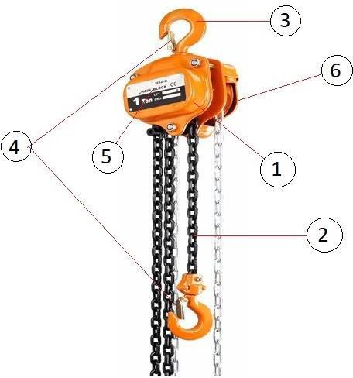

Equipment Name & Number: |  | 25-LIFTING TOOLS & TACKLES &
Note: Please write Yes or No in the given box and if some comments write in remarks column.
SN. | Description |  |  | Yes/No | Remarks
1. | Wire sling should be free from defects, e.g., corrosion, crack, cuts & oily, etc. |  | #
2. | Use thimble for making I-shape.
3. | Wire rope should be knotted with proper clamp. |  | #
4. | Web sling should be free from defects, e.g., cuts, abrasion, knot, hole & oily, etc. |  | #
5. | I-shape should be free from damages. |  | #
6. | D-shackle should be in good condition and its face should not expand more than 15% of its original  shape. |  | #
7. | Suitable I-bolt should be used. |  | #
8. | Lifting tools & tackles should be used having suitable strength & capacity. |  | #
9. | Lifting tools & tackles should be handle and store in safe manner. |  | #

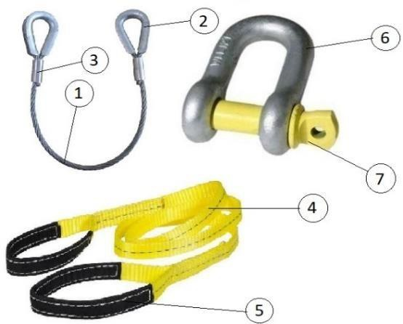

Equipment Name & Number: |  | 26-AIR COMPRESSOR &
Note: Please write Yes or No in the given box and if some comments write in remarks column.
SN. | Description |  |  | Yes/No | Remarks
1. | Physical condition of compressor tank should be good and certified by TPI. |  | #
2. | Piston should be in good condition. |  | #
3. | Motor should be in good and working condition. |  | #
4. | Inspection date and due date should be clearly marked. |  | #
5. | Pressure gauge should be in working state and free from defects. |  | #
6. | Safety valve should be calibrated at regular interval. |  | #
7. | Any other valve should be free from defects and in  working condition. |  | #
8. | Rotating part should be covered with fixed guard. |  | #
9. | All joints should be properly tighten. |  | #
10. | Compressor should be grounded as per IS 3043:1987. |  | #
11. | Power cable should be free from defects and connection taken through industrial plug. |  | #
12. | Whip arrestor is in good condition. |  | #

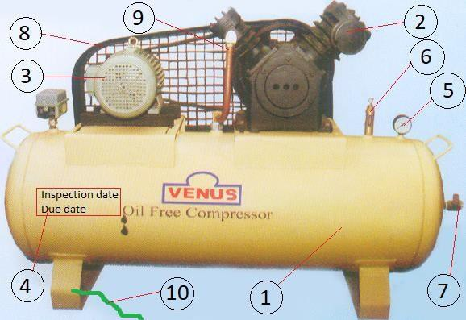

Equipment Name & Number: |  | 27-GRIT/SAND BLASTING SET &
Note: Please write Yes or No in the given box and if some comments write in remarks column.
SN. | Description |  |  | Yes/No | Remarks
1. | Hopper is made by sound quality of material. |  | #
2. | Pressure gauge in working condition. |  | #
3. | All joints should be properly tighten and free from corrosion. |  | #
4. | Inlet and outlet valve should be functional. |  | #
5. | Blasting hose should have adequate strength and free from cuts or damages. |  | #
6. | Nozzle should be in good condition with dead man switch. |  | #
7. | Blasting hood must be provided for blaster with  physical particle filtration. |  | #
8. | Whip arrestor is in good condition. |  | #

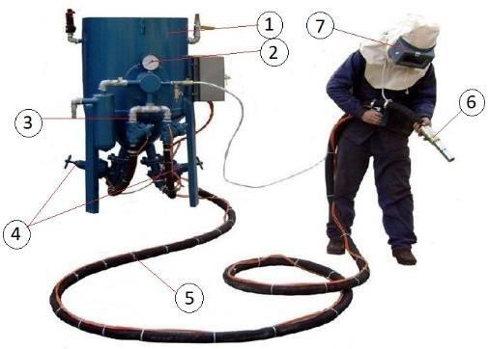

Equipment Name & Number: |  | 28-FIRE EXTINGUISHER &
Note: Please write Yes or No in the given box and if some comments write in remarks column.
SN. | Description |  |  | Yes/No | Remarks
1. | Fire extinguisher always keep on trolley, it will be easy for movement.
2. | Keep Sand bucket. |  | #
3. | Sand bucket should be covered to avoid mixing of foreign material.
4. | Fire extinguisher should be kept at waist level height for quick access.
5. | Fire extinguisher should be free from defects and regularly tested. |  | #
6. | Inspection date and due date should be clearly marked. |  | #
7. | Hose and hose connection are in good condition. |  | #
8. | Check pressure gauge at regular interval for any pressure drop. |  | #

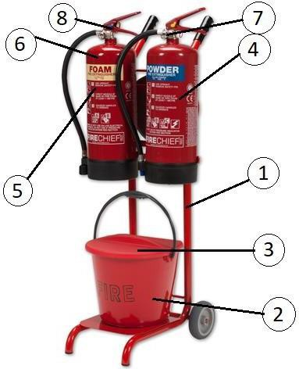

Equipment Name & Number: |  | 29-BENCH CUTTING MACHINE &
Note: Please write Yes or No in the given box and if some comments write in remarks column.
SN. | Description |  |  | Yes/No | Remarks
1. | Physical condition of body should be good & sound. |  | #
2. | On/off switch should be in proper condition. |  | #
3. | Fixed guard should be in good condition. |  | #
4. | Auto adjustable guard should be functional condition. |  | #
5. | Cutting wheel should free from defect and rotating  capacity should be marked, standard quality of cutting wheel used. |  | #
6. | Positioning screw should be in working condition. |  | #
7. | Power cable should be free from damage and connection taken through industrial plug. |  | #
8. | Machine should be double insulated or grounded. |  | #
9. | Always use designated key for changing wheel.
10. | Machine operated by competent person.
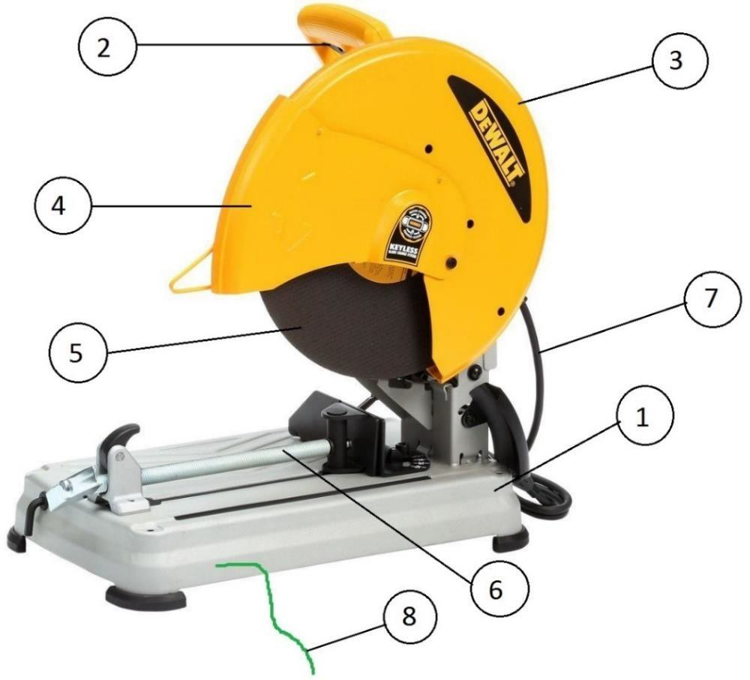

Equipment Name & Number: |  | 30-PEDESTAL GRINDER &
Note: Please write Yes or No in the given box and if some comments write in remarks column.
SN. | Description |  |  | Yes/No | Remarks
1. | Physical condition of body should be good & sound. |  | #
2. | On/off switch should be in proper condition. |  | #
3. | Wheel guard should be in good condition. |  | #
4. | Tool rest should be available at distance of 3 mm from rotating wheel. |  | #
5. | Eye guard and spark deflector should be available. |  | #
6. | Machine should be double insulated or grounded. |  | #
7. | Wheel should free from defect and rotating capacity should be marked. |  | #
8. | Power cable should be free from damage and connection taken through industrial plug. |  | #
9. | Always use designated key for changing wheel.
10. | Machine operated by competent person.

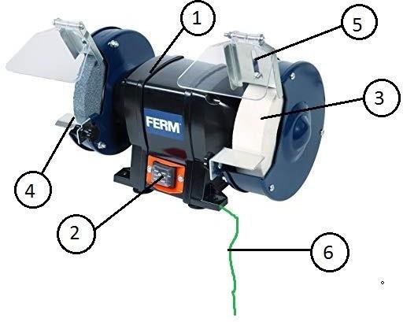

Equipment Name & Number: |  | 31-CIRCULAR SAW &
Note: Please write Yes or No in the given box and if some comments write in remarks column.
SN. | Description |  |  | Yes/No | Remarks
1. | Physical condition of body should be good & sound. |  | #
2. | On/off switch should be in proper condition. |  | #
3. | Fixed guard should be in good condition. |  | #
4. | Auto adjustable guard should be functional condition. |  | #
5. | Wheel should free from defect and rotating capacity should be marked. |  | #
6. | Power cable should be free from damage and connection taken through industrial plug. |  | #
7. | Machine should be double insulated or grounded. |  | #
8. | Always use designated key for changing wheel.
9. | Machine operated by competent person.
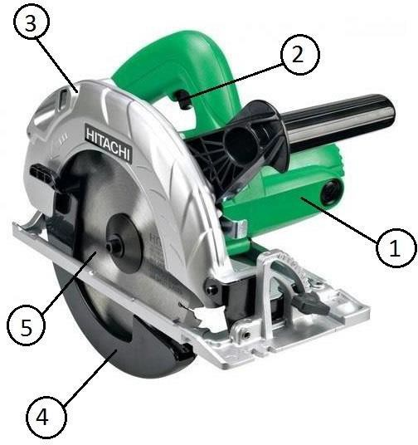

Equipment Name & Number: |  | 32-BATCHING PLANT &
Note: Please write Yes or No in the given box and if some comments write in remarks column.
SN. | Description |  |  | Yes/No | Remarks
1. | Physical condition of body should be good & sound. |  | #
2. | Staircase should be in good condition. |  | #
3. | Operator cabin should be free from dust accumulation. |  | #
4. | Metal mesh should be provided on the aggregate and sand hopper. |  | #
5. | Conveyor belt should be guarded, covered and pull cord should be installed. |  | #
6. | Mixing chamber should be closed. |  | #
7. | Monkey ladder with cage should be available. |  | #
8. | Guardrail system should be in good condition. |  | #
9. | Lightening arrestor should be installed. |  | #
10. | All part of machine should be grounded. |  | #
11. | Power cable should be free from defect and connection taken through MCB and RCCB. |  | #
12. | Fire extinguisher in operator cabin. |  | #
13. | Operated by only authorized operator. |  | #
14. | Emergency switch should be in working condition. |  | #
15. | Aviation light should be in working condition.
16. | Hooter is in working condition.
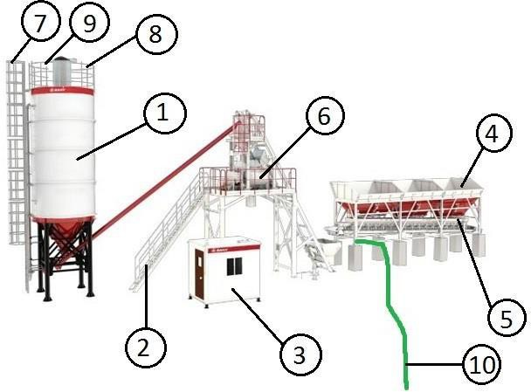

Equipment Name & Number: |  | 33-AMBULANCE &
Note: Please write Yes or No in the given box and if some comments write in remarks column.
SN. | Description |  |  | Yes/No | Remarks
1. | Physical condition of vehicle including brake and clutch. |  | #
2. | Condition of tire and availability of spare/stepney tire. |  | #
3. | Head & tail light and indicators are in working condition. |  | #
4. | Side mirror. |  | #
5. | Functional condition of emergency light and audible siren are in working condition. |  | #
6. | Emergency contact number displayed. |  | #
7. | Availability and condition of stretcher. |  | #
8. | Availability of first aid kit with suitable medicine. |  | #
9. | Portable fire extinguisher. |  | #
10. | Medical oxygen cylinder with pressure gauge and availability of key to open the cylinder. |  | #
11. | Condition of canister mask. |  | #
12. | Availability and condition of fan for ventilation. |  | #
13. | Driver has valid license for operating ambulance. |  | #

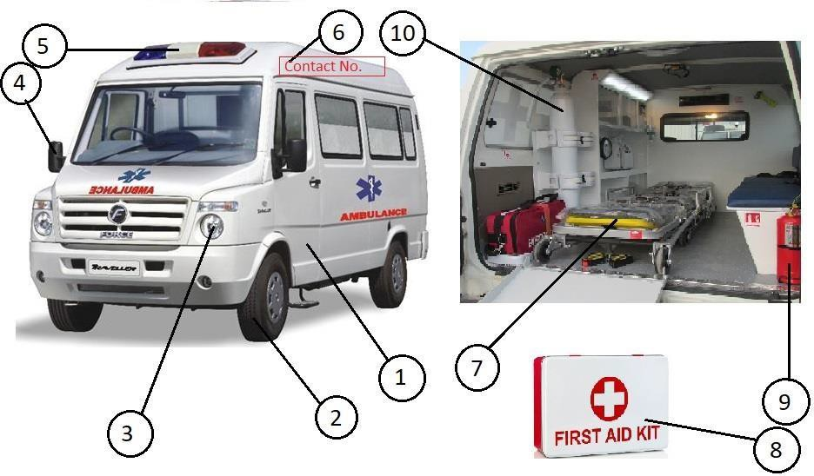

Equipment Name & Number: |  | 34-SKID STEER LOADER &
Note: Please write Yes or No in the given box and if some comments write in remarks column.
SN. | Description |  |  | Yes/No | Remarks
1. | Machine should be physically good & should have valid TPI certificate. |  | #
2. | No damage in tire (Bolts, crack, cuts & air pressure, etc.). |  | #
3. | Head & tail light and indicators are in working condition. |  | #
4. | Side mirror should be in good condition. |  | #
5. | Wind shield/glass should be in proper condition. |  | #
6. | Wiper should be in running condition.
7. | Operator cabin should be made by good & sound quality of material. |  | #
8. | Hydraulic cylinders should be in good condition and free from leakage. |  | #
9. | Foot Step should be free from slip or tip hazard.
10. | Red triangle/reflective tape should be fixed in front of vehicle.
11. | Front & reverse horn. |  | #
12. | Fire extinguisher in operator cabin. |  | #
13. | Operator have suitable license. |  | #

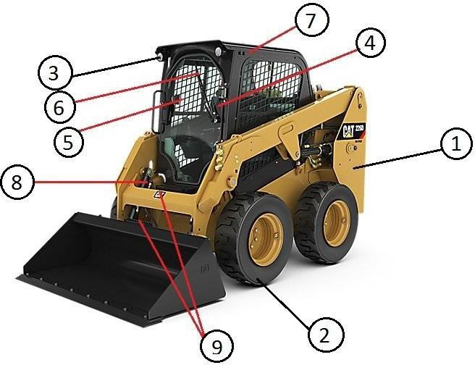

Equipment Name & Number: |  | 35-GRADER &
Note: Please write Yes or No in the given box and if some comments write in remarks column.
SN. | Description |  |  | Yes/No | Remarks
1. | Machine should be physically good & should have valid TPI certificate. |  | #
2. | No damage in tire (Bolts, crack, cuts & air pressure, etc.). |  | #
3. | Head & tail light and indicators are in working condition. |  | #
4. | Side mirror should be in good condition. |  | #
5. | Wind shield/glass should be in proper condition. |  | #
6. | Wiper should be in running condition.
7. | Canopy above driver seat should be made by good & sound quality of material. |  | #
8. | Hydraulic cylinders should be in good condition and free from leakage. |  | #
9. | Red triangle/reflective tape should be fixed in front of vehicle.
10. | Front & revers horn. |  | #
11. | Fire extinguisher in operator cabin. |  | #
12. | Operator have suitable license. |  | #
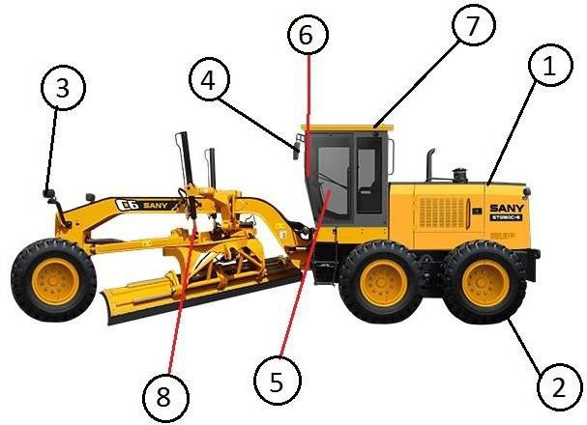

Equipment Name & Number: |  | 36-GANTRY CRANE &
Note: Please write Yes or No in the given box and if some comments write in remarks column.
SN. | Description |  |  | Yes/No | Remarks
1. | Machine should be physically good & Should have valid TPI certificate. |  | #
2. | SWL should be visible on either side. |  | #
3. | Walkaway should be in good condition and free from obstruction.
4. | Access ladder should be provided with cage. |  | #
5. | Proximity sensor should be in working condition. |  | #
6. | Operator cabin should be in good condition and clean. |  | #
7. | Wire sling should be free from damage. |  | #
8. | Hook latch must be installed in hook. |  | #
9. | Guardrail system should be provided. |  | #
10. | Rotating part of motor should be covered. |  | #
11. | Wire sling drum should be under canopy. |  | #
12. | Audible horn should be in working condition. |  | #
13. | Fire extinguisher in operator cabin. |  | #
14. | Operator have suitable license. |  | #
15. | Deflection test should be carried out. |  | #
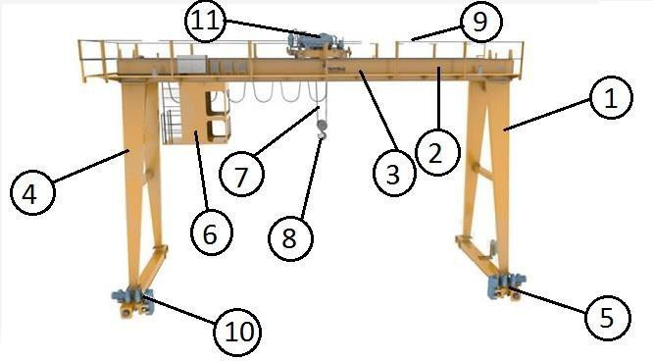

Equipment Name & Number: |  | 37-EOT CRANE &
Note: Please write Yes or No in the given box and if some comments write in remarks column.
SN. | Description |  |  | Yes/No | Remarks
1. | Machine should be physically good & should have valid TPI certificate. |  | #
2. | SWL should be visible on either side. |  | #
3. | Wire sling should be free from damage. |  | #
4. | Hook latch must be installed in hook. |  | #
5. | Power cable should be free from defect. |  | #
6. | Remote should be in good condition. |  | #
7. | Audible horn should be in working condition. |  | #
8. | Operator have suitable license/experience certificate. |  | #
9. | Deflection test should be carried out. |  | #
10. | Safe access and egress should be provided. |  | #

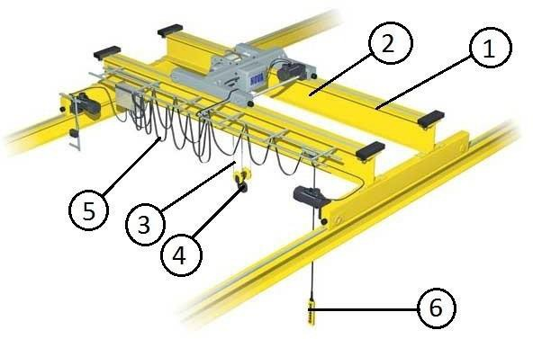

Equipment Name & Number: |  | 39-Trailer &
Note: Please write Yes or No in the given box and if some comments write in remarks column.
SN. | Description |  |  | Yes/No | Remarks
1. | Operator cabin should be fully covered and made by sound quality of material. |  | #
2. | Carrier should be in good condition. |  | #
3. | No damage in tire (Bolts, crack, cuts & air pressure, etc.). |  | #
4. | Side mirror should be in good condition. |  | #
5. | Head & tail light and indicators are in working condition. |  | #
6. | Wiper should be in running condition.
7. | Wind shield/glass should be in proper condition. |  | #
8. | Seatbelt should be available. |  | #
9. | Red triangle/reflective tape should be fixed in front of vehicle.
10. | Registration number should be written. |  | #
11. | Front & reverse horn. |  | #
12. | Fire extinguisher in operator cabin. |  | #
13. | Operator have valid and suitable license. |  | #
14. | First aid kit should be available.
15. | Normal break & emergency (hand) break should be in functional & operational condition. |  | #
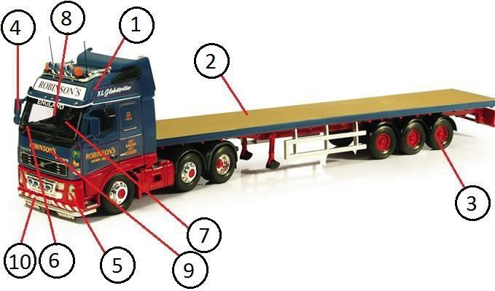

Equipment Name & Number: |  | 40-Four Wheeler &
Note: Please write Yes or No in the given box and if some comments write in remarks column.
SN. | Description |  |  | Yes/No | Remarks
1. | Physical condition of vehicle is good. |  | #
2. | No damage in tire (Bolts, crack, cuts & air pressure, etc.). |  | #
3. | Side mirror should be in good condition. |  | #
4. | Head & tail light and indicators are in working condition. |  | #
5. | Wiper should be in running condition.
6. | Wind shield/glass should be in proper condition. |  | #
7. | Seatbelt should be available. |  | #
8. | Reflective tape should be fixed in front of vehicle.
9. | Registration number should be written. |  | #
10. | Door lock are good condition. |  | #
11. | Front & reverse horn. |  | #
12. | Fire extinguisher in operator cabin. |  | #
13. | Operator have valid and suitable license. |  | #
14. | First aid kit should be available.
15. | Normal break & emergency (hand) break should be in functional & operational condition. |  | #
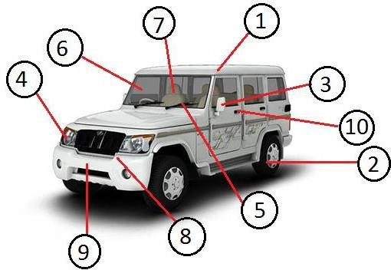

Equipment Name & Number: |  | 41-Bus &
Note: Please write Yes or No in the given box and if some comments write in remarks column.
SN. | Description |  |  | Yes/No | Remarks
1. | Physical condition of vehicle is good. |  | #
2. | No damage in tire (Bolts, crack, cuts & air pressure, etc.). |  | #
3. | Side mirror should be in good condition. |  | #
4. | Head & tail light and indicators are in working condition. |  | #
5. | Wiper should be in running condition.
6. | Wind shield/glass should be in proper condition. |  | #
7. | Seatbelt should be available. |  | #
8. | Reflective tape should be fixed in front of vehicle.
9. | Registration number should be written. |  | #
10. | Door lock are good condition. |  | #
11. | Front & reverse horn. |  | #
12. | Fire extinguisher in operator cabin. |  | #
13. | Operator have valid and suitable license. |  | #
14. | First aid kit should be available.
15. | Normal break & emergency (hand) break should be in functional & operational condition. |  | #
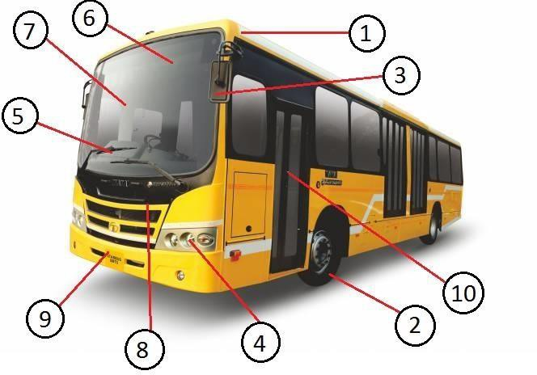

Equipment Name & Number: |  | 42-Diesel Tanker &
Note: Please write Yes or No in the given box and if some comments write in remarks column.
SN. | Description |  |  | Yes/No | Remarks
1. | Physical condition of vehicle is good and free from leakage. |  | #
2. | No damage in tire (Bolts, crack, cuts & air pressure, etc.). |  | #
3. | Side mirror should be in good condition. |  | #
4. | Head & tail light and indicators are in working condition. |  | #
5. | Wiper should be in running condition.
6. | Wind shield/glass should be in proper condition. |  | #
7. | Seatbelt should be available. |  | #
8. | Red triangle/Reflective tape has fixed in front of vehicle.
9. | Registration number should be written. |  | #
10. | HAZCHEM code visibly written. |  | #
11. | NFPA diamond Visibly written. |  | #
12. | Front & reverse horn. |  | #
13. | Fire extinguisher in operator cabin. |  | #
14. | Operator have valid and suitable license. |  | #
15. | First aid kit should be available. |  | #
16. | Spill observant kit/drip tray available. |  | #
17. | TERM card and MSDS available. |  | #
18. | Emergency contact number available. |  | #
19. | Normal break & emergency (hand) break should be in functional & operational condition. |  | #
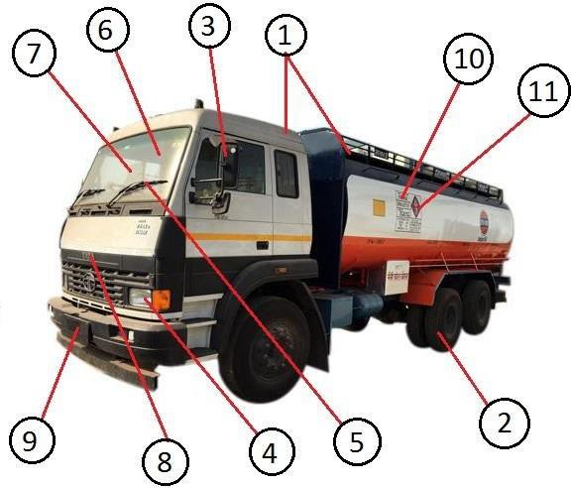

Equipment Name & Number: |  | 43-Water Tanker &
Note: Please write Yes or No in the given box and if some comments write in remarks column.
SN. | Description |  |  | Yes/No | Remarks
1. | Physical condition of vehicle is good and free from leakage. |  | #
2. | No damage in tire (Bolts, crack, cuts & air pressure, etc.). |  | #
3. | Side mirror should be in good condition. |  | #
4. | Head & tail light and indicators are in working condition. |  | #
5. | Wiper should be in running condition.
6. | Wind shield/glass should be in proper condition. |  | #
7. | Seatbelt should be available. |  | #
8. | Red triangle/Reflective tape should be fixed in front of vehicle.
9. | Registration number should be written. |  | #
10. | Front & reverse horn. |  | #
11. | Fire extinguisher in operator cabin. |  | #
12. | Operator have valid and suitable license. |  | #
13. | First aid kit should be available.
14. | Normal break & emergency (hand) break should be in functional & operational condition. |  | #
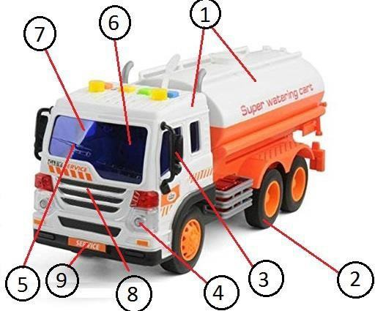

Equipment Name & Number: |  | 71-Bike &
Note: Please write Yes or No in the given box and if some comments write in remarks column.
SN. | Description |  |  | Yes/No | Remarks
1. | Physical condition of vehicle is good. |  | #
2. | No damage in tire (crack, cuts & air pressure, etc.). |  | #
3. | Side mirror should be in good condition. |  | #
4. | Head light and indicators are in working condition. |  | #
5. | Registration number should be written. |  | #
6. | Stand should be in proper condition. |  | #
7. | Horn is in working condition. |  | #
8. | Rider have valid and suitable license. |  | #
9. | Rider is using crash helmet during riding.
10. | First aid kit should be available.
11. | Break should be in functional & operational condition. |  | #

