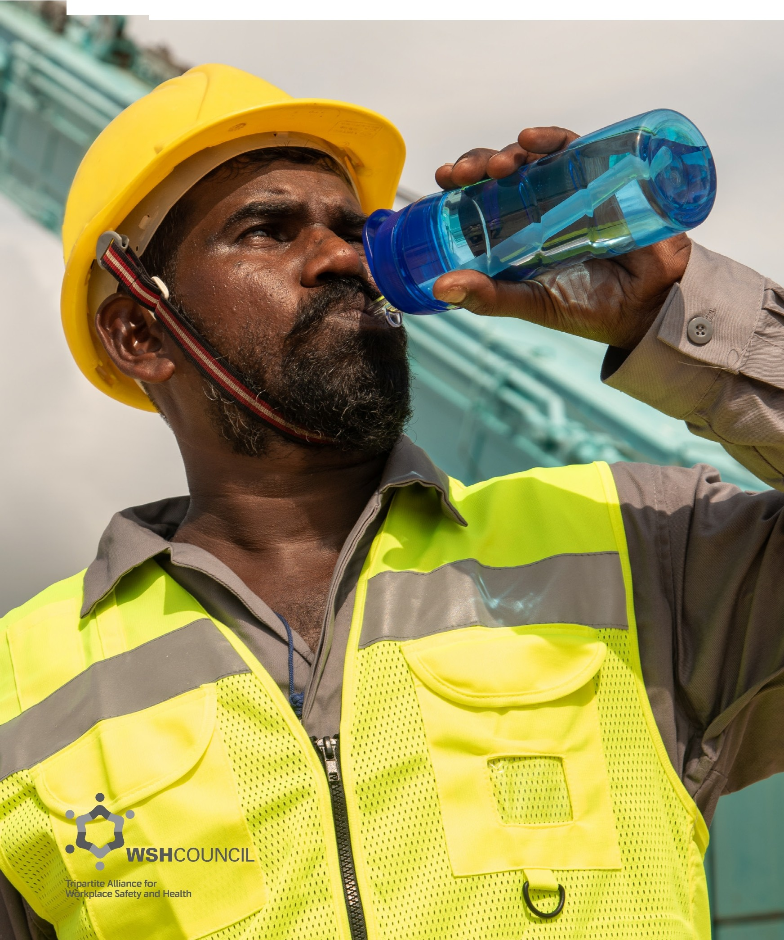
Workplace Safety and Health Guidelines
Managing Heat Stress in the Workplace

Contents
- Introduction 2
- Heat Stress 4
- WSH Act and its Subsidiary Legislations 6
- Risk Assessment 8
  - Factors Contributing to Heat Stress 9
- Measuring Heat Stress 14
- Preventing Heat Stress 16
  - Fitness to Work 16
  - Heat Acclimatisation 16
  - Use of Mechanical Aids 18
  - Work Scheduling 18
  - Shaded Rest Area 19
  - Adequate Water Intake 19
  - Worker Awareness 21
  - Worker Clothing 21
- Management of Heat Illness 23
  - Early Recognition 23
  - First-Aid Treatment 25
- Heat Stress Case Studies 30
  - Case Study 1: Indoor Work Environment 30
  - Case Study 2: Outdoor Work Environment 32
  - Case Study 3: Confined Space Work Environment 34
- Heat Stress Prevention Checklist 37
- References 39
- Acknowledgements 40
- Annexes 41
Annex A: Wet Bulb Globe Temperature Calculations 41
Annex B: Heat Stress Index Calculations 50
- Amendments 53

Introduction

Singapore's climate is becoming warmer (see Table 1). The average ambient temperature has been rising in Singapore and in many countries around the world - a phenomenon attributed to global warming and the urban heat island effect.

Annual mean temperature | + 0.27 °C per decade  (26.6' C in 1972 to 27.7' C in 2014)
Annual number of warm days  (Maximum Temperature ;,: 34.1' C) | + 12.5 days per decade  (10 days in 1972 to 64 days in 2014)
Annual number of cool days  (Maximum Temperature ,; 29.2' C) | - 6.1 days per decade  (56 days in 1972 to 30 days in 2014)
Annual number of warm nights  (Minimum Temperature;,: 26.2' ( ) | + 17.9 days per decade  (Null in 1972 to 69 days in 2014)
Annual number of cool nights  (Minimum Temperature ,; 22.3' ( ) | - 11.1 days per decade  (72 days in 1972 to 26 days in 2014)

Table 1: Long-term changes in Singap ore's ambient temperature extracted from p.19 of Singapore's Second National Climate Change Study- Climate Projections to 2100: Report for Stakeholders ©201 S published by The Centre for Climate Research Singapore, Meteorological Service Singapore.

Working in Singapo re's hot and humid weather puts workers at an increased risk of heat injuries. This publication provides an overview of preventive measures that companies can implement to minimise the risk of heat injuries developing in your workers when working in a hot environment.

Heat acclimatisation, moderation of environmental factors and the regulation of metabolic heat production are important measures to minimise the impact of heat stress. Although heat stress is typically associated with outdoor work, it is important to realise that heat hazard is also present in indoor workplaces such as foundries, commercial kitchens, laundries, boiler rooms, and food and beverage manufacturing factories. Work processes in such environments may emit radiant heat or have inadequate ventilation.

2

Heat stress, if not managed well, can lead to heat stroke and worker fatality. All stakeholders are reminded that they are responsible under the Workplace Safety and Health (WSH) Act to ensure that measures are taken to minimise the risk of heat injuries among workers. Additionally, the WSH (Risk Management) Regulations require all workplaces to conduct risk assessments and take necessary measures to eliminate or reduce workplace risks, including the risk of heat injuries. These measures include ensuring that all workers are properly acclimatised to the local weather conditions before being deployed for full duties at worksites.

A reduction in the exposure to heat stress would mean that workers can be more productive at work, bringing more benefits to employers'. Under heat stress conditions, workers may exhibit poor judgment, making them more prone to accidents 2•

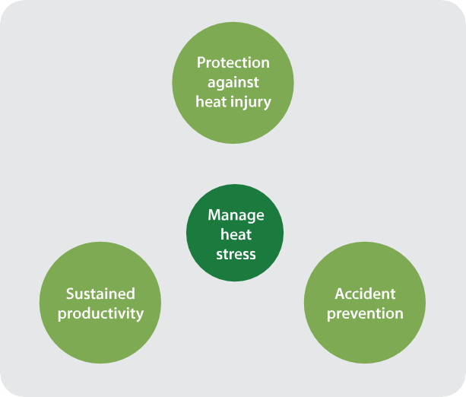
Figure 1: Heat management seeks to protect workers from heat injury, sustain work productivity, and prevent accidents.

Prevention of heat illness is key. Many factors that contribute to heat stress can be managed to reduce the potential for harm.

1 Working on a Warmer Planet - The Impact of Heat Stress on Labour Productivity and Decent Work, International Labour Office (ILO), 2019. 2 "The Impact of Heat Waves on Occurrence and Severity of Construction Accidents" by R. Rameesdeen and A. Elmualim, Int Journal of Environmental Research and Public Health. 2017 Jan; 14(1): 70.

3

Heat Stress

Heat is generated by our body and even more so during heavy physical exertion. Our body also acquires heat from its surrounding environment. When there is an excess of heat, our body tries to lose the excess heat mainly through evaporation of sweat from the surface of the skin.
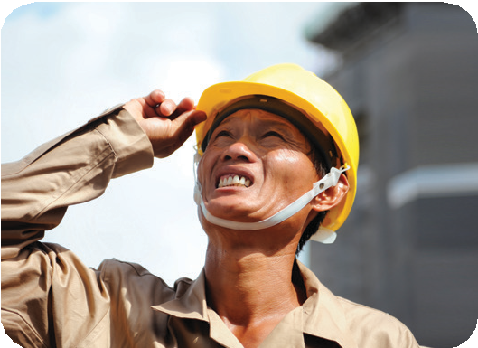
►
Heat gain from
environment
►
►
- - ---►- Heat loss to
environment
►
►
Metabolic heat generated+ Insulation due to clothing

Figure 2: The body gains heat primarily from metabolic heat generation and the environment. Excess heat removal is dependent on the level of insulation due to a worker's clothing and the direction of nett heat exchange with the environment.

Heat stress occurs when the accumulation of heat in the body exceeds the body's ability to remove the excess heat. When the body produces and retains more heat than it loses, one may exhibit signs and symptoms related to heat stress that may progress to heat stroke.

Heat stroke can result in death and is a medical emergency. Should the body core temperature deviate from its normal range for an extended period, vital organs may fail and the affected person can become unconscious and die.

The human body's main mechanism for losing heat is through the evaporation of sweat. When sweat evaporates from the skin, a large amount of heat energy is removed, and this heat loss helps to cool the body. Sweating alone is ineffective as water is lost without much heat loss.

When the surrounding air is humid and has a higher moisture content i.e. high relative humidity, this impedes the process of evaporation. Sweat will evaporate faster when the air is less humid, low relative humidity, and when there is air circulation.

4

Types of Heat Stroke

There are two types of heat strokes:

  - Classical heat stroke- resulting from prolonged passive exposure to extreme environmental heat and occurring mostly during heat waves, affecting mainly infants, toddlers and the elderly

Exertional heat stroke - resulting from physical activity with high rates of metabolic heat production and occurring even in cool environments,affectingpersons undertaking physically strenuous work or activity

The focus of this publication is on exertional heat stroke due to work activities undertaken by workers.

Heat stroke is an injury when a casualty's mental status is altered with high body core temperatures (usually about 40°( or above). This is a medical emergency as high body core temperatures can cause death or permanent disability if not promptly recognised and treated.

Heat stress can induce syncope (fainting), cramps and a feeling of exhaustion.

5

- WSH Act and its Subsidiary Legislations

The intent of the Workplace Safety and Health (WSH) Act is to inculcate good safety habits and practices in all individuals at the workplace - from top management to the front-line worker.

The Act requires every person at work to take reasonably practicable measures to ensure the safety, health or welfare of persons (including himself/herself) at work. In particular:

Occupiers have a duty to take, so far as is reasonably practicable, necessary measures to ensure that the workplace; all means of access to or egress from the workplace; and any machinery, equipment, plant, article or substance kept on the workplace, are safe and without risks to health to every person within those premises, whether or not the person is at work or is an employee of the occupier.

Employers have a duty to take, so far as is reasonably practicable, necessary measures to ensure that the work environment is safe and without risk to their employees' safety and health.

Employees (persons at work) have a duty to take reasonable care of their own safety and health and that of others at the workplace.

Under the WSH (Risk Management) Regulations, the employer, self-employed person and/or principal must conduct a risk assessment in relation to the safety and health risks, and take all reasonably practicable steps to eliminate any foreseeable risk to any person who may be affected by his/her undertaking in the workplace.

In the WSH (General Provisions) Regulations, it is stipulated that it is the duty of the occupier of a workplace to take all reasonably practicable measures to ensure that persons at work in the workplace are protected from excessive heat or cold.

For compressed air environment, e.g. in tunnelling works, the WSH (Construction) Regulations 2007 specifies that the temperature in any working chamber, man-lock or medical lock, in a worksite shall not exceed 29°C and the relative humidity shall not exceed 85%.

6

Examples of workplace incidents that have occurred in Singapore resulting in workers suffering from severe heat-related illness are found in Chapter 8 of this publication. The possible risk control measures (non-exhaustive) that can be taken to prevent similar cases are listed under the recommendations for each case.

Under the WSH (Incident Reporting) Regulations, the employer and the medical doctor diagnosing diseases caused by excessive heat (an occupational disease) must submit an online report to the Ministry of Manpower (MOM) via https://www.mom.gov.sgleserviceslserviceslwsh­ incident-reporting.

For more information on the WSH Act, visit MGM's website at: https://www.mom.gov.sg/workp/ace-safety-and-hea/th/workp/ace-safety-and-hea/th-act

7

- Risk Assessment

Under the WSH (Risk Management) Regulations, risk assessments are to be conducted to address the safety and health risks posed to any person who may be affected by the workplace activity.
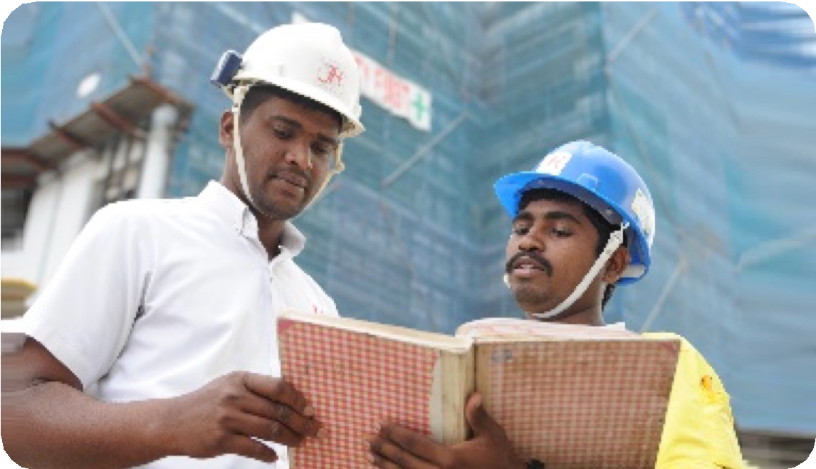
Figure 3: Carrying out risk assessment.

Risk Assessment (RA) is the process of:

- Identifying the safety and health hazards associated with the work
- Evaluating the risks
- Implementing control measures to eliminate or reduce the risks

In a nutshell, RA serves to facilitate hazard identification and the implementation of risk controls to prevent workplace accidents and injuries.

More information on how an RA may be conducted can be found in the Code of Practice on Workplace Safety and Health Risk Management.

RA should cover work activities in a hot environment (outdoor or indoor) and work activities which produce excessive heat as they can severely increase the risk of heat injury.

8

Factors Contributing to Heat Stress

The factors that contribute to heat stress at the workplace can be divided broadly into three categories:

Personal Risk Factors Environmental Risk Factors Job Risk Factors

The above categories of factors should be considered in an RA especially when workers are expected to work in a hot environment.

Personal Risk Factors
Personal risk factors include one's ability to acclimatise to a new environment and one's state of health.

The process in which the human body adapts to a hotter environment is called heat acclimatisation.Employers should provide workers coming from a colder climate with sufficient time for their bodies to acclimatise (adjust) to the hotter climate in Singapore prior to work deployment.

Workers who are unwell and/or on medication, and those who have just recovered from an illness, are at higher risk of developing heat stroke. Placing these workers on light duties for a short period may help them to facilitate their recovery and reacclimatise to the work environment.

Other personal factors that can increase one's susceptibility to heat illness include one's fitness level, medical condition and alcohol consumption.

9

Beyond heat acclimatisation, some key personal risk factors (non-exhaustive) are listed below:

Sleep deprivation | Impaired decision making, and reduced ability to properly regulate body heat when one is tired.
Inadequate nutrition | Poor nutrition generally decreases a person's immunity and may affect his/her heat tolerance.
Dehydration | A worker who is dehydrated will be more likely to experience heat illness. Dehydration may result in less sweating and a corresponding reduction in the worker's ability to lose heat.
Physical condition | A poor level of physical fitness will lower a worker's ability to work in a hot environment. Basically, when one is fitter, the physiological strain is expected to be lower and the body sweating mechanism more  efficient. Also, in general, workers who are acclimatised to a hot work environment will have a lower risk of heat injury compared to a non-acclimatised worker.
Obesity | Being overweight or obese can increase the risk of heat injury due to higher metabolic heat production and a lower rate of heat loss from the body.
Medical condition or illness | A medical condition e.g. heart disease or diabetes, may increase the risk of heat injury. Acute illnesses  e.g. respiratory infection, diarrhoea, may also increase the risk of heat injury.
On medication | Heat tolerance can be affected by medication and stimulants taken for medical conditions such as high blood pressure or common cold. Such medication  or stimulants may interfere with normal hydration, affecting the body's ability to retain water or sweat, thus increasing the risk for heat illness.

10

Alcohol consumption | Alcohol intake may reduce a worker's heat tolerance. Alcohol intake will also cause dehydration, resulting in an increased requirement for water intake.
Inexperienced worker | An inexperienced worker may not know how to adapt his/her pace of work when working in a new or hotter environment.
Highly motivated worker | Highly motivated workers may ignore the early signs of heat stress and continue to work until heat stroke occurs.
History of heat injury | A worker with a history of heat injury may have an enhanced susceptibility for future heat injuries.
Accumulated fatigue | Worker may end up being more vulnerable to illness and cumulative heat strain.
Table 2: Heat stress - personal risk factors and their potential impact on workers.

11

Environmental Risk Factor
Potential Impact on Worker
Ambient temperature higher than body temperature will cause the worker’s body to gain heat from the surroundings. Ambient temperature depends on work location e.g. working directly under the sun or near an engine or hot equipment, will expose workers to a hot work environment.

High humidity in the work environment will lower a worker’s ability to sweat. Loss of heat through evaporative cooling becomes more difficult and the body may quickly overheat.

A high level of ventilation would translate to higher convective currents (wind) in the atmosphere and an enhanced ability for the environment to draw heat away from a worker’s body.

The body may gain heat directly from a radiant heat source e.g. the sun, or a hot engine, if the body is cooler than the radiant heat source.
A worker may also gain heat from a conductive heat source if in direct contact with a hot surface e.g. sitting on the hot ground or
chair that has been out in the sun during a rest break.

Nature of Work | Potential Impact on Worker
 | Work involving strenuous physical activity will increase the metabolic demand of the worker causing his/her body to heat up. Employees performing strenuous work in a hot environment will need more frequent rest breaks than others performing less strenuous tasks in the same environment.
Clothing, including Personal Protective Equipment (PPE), may lower a worker’s ability to lose the metabolic heat generated during the work activity. PPE can range from hard hats, gloves or boots to a fully-encapsulating chemical-protective suit and a self-contained breathing apparatus.
Wearing impermeable PPE, which covers the body or face, limits air movement and the cooling effect of sweating. This will reduce heat loss from the body to the environment and an increased heat load on the body. Note that weight of a worker’s clothing (and the weight of the equipment being carried) can also result in an increase in the worker’s metabolic workload.

- Measuring Heat Stress

The potential for heat injury can be assessed by means of an appropriate heat stress index. Several heat stress indices have been developed and these include the Wet Bulb Globe Temperature (WBGT) and the Heat Stress Index (HSI).

The more commonly used measure for heat stress is the WBGT. The WBGT is based on a measure of environmental conditions that considers air temperature, air humidity, air movement, and level of solar radiation.

To be effective, the WBGT needs to be measured at the work area representative of the environment (in terms of both physical location and time of day) where a worker is expected to work in. In cases where the work area is large, WBGT measurement should be carried out at multiple locations as close as possible to where the workers will be stationed. A good practice would be to monitor the WBGT prior to work commencement and during work; this is especially important in work environments where the ambient temperature changes over time e.g. outdoor work.

More information on the computation of WBGT and the permissible limits for various scenarios can be found in Annex A.

In general, the following criteria can be used for assessment of the level of heat stress based on theWBGT:

Heat Stress Level | WBGT
Low | <31°C
Moderate | 31°C to 31.9°C
High ≥32°C

Table 5: Level of heat stress based on WBGT.

14

The determination of heat stress level is important as part of the risk management process. The level of heat stress that a worker would likely experience will determine the extent of risk control measures to be implemented.

For WBGT, employers can refer to the Threshold Limit Values (TLV®) WBGT for acclimatised workers (Table A1) and Action Limit WBGT for unacclimatised workers (Table A2), and adopt the recommended preventive action(s).

Other than the WBGT, another heat stress index an employer could use is the HSI, which takes into account the metabolic heat generated by the worker during the work activity and the extent of heat loss to the environment (see Annex B).

The heat stress level at workplaces with high heat stress should be measured before work commencement and at regular intervals throughout the workday. Examples of high-risk workplaces include outdoor/open construction sites, bakeries, kitchens, laundries, compressed air tunnels, incineration plants and power plants. Any work carried out near a boiler, furnace, dryer, steaming or pasteurisation machines will also increase the heat stress of the worker.

15

Preventing Heat Stress

Preventive measures can be taken to limit a worker's exposure to heat and/or raise the worker's ability to better cope with the heat. The preventive measures include:

- fitness to work;
- heat acclimatisation;
- use of mechanical aids;
- work scheduling;
- shaded rest area;
- adequate water intake;
- worker awareness; and
- worker clothing.

Fitness to Work
New workers must pass their pre-employment medical examinations and be declared fit to work before being posted to a hot working environment.

Workers returning from prolonged illness should be certified fit to work by a medical doctor or healthcare professional prior to returning to work.

Supervisors should also carry out daily checks for workers who are feeling unwell, e.g. at the start and in the middle of each workday or shift. Such workers should be given administrative or light duties and advised to seek medical attention as appropriate.

Workers should also be encouraged to adopt a healthy and active lifestyle with a well-balanced diet, adequate sleep and regular exercise to improve their aerobic fitness. They should also avoid excessive intake of caffeine or alcohol.

Heat Acclimatisation
Newly assigned workers must be acclimatised to the hot weather or hot working conditions, especially workers who come from colder climates. This will allow the worker to adapt to the new working environment and improve his/her tolerance to heat.

Workers new to Singapore would need at least one to two weeks to adjust to the local weather conditions and workload. They should not start working at full workload in a hot environment upon arrival. Such workers should be put on a heat acclimatisation programme in the first two weeks of employment. Heat acclimatisation can take the form of a gradual increase in daily exposure to the hot working environment for up to 14 days.

16

An example of a heat acclimatisation programme is shown in Figure 4, which shows the number of hours a worker is exposed to heat each day during the acclimatisation period.

 | Day 1 | Day 2 | Day 3 | Day 4 | Day 5 | Sat | Sun | Day 6 | Day 7 | Day 8 | Day 9 | Day 10
 | 6 | 6 | 5 | 4 | 3 |  |  | 4 | 3 | 2 | 1 | 0
 | 2 | 2 | 3 | 4 | 5 |  |  | 4 | 5 | 6 | 7 | 8

In Figure 4, the worker is given two hours of heat exposure on his/her first two days at work. The worker may be assigned light tasks in a cool or shaded environment for the rest of the day. If the worker is working outdoors, he should avoid working under direct sun during the hottest part of the day (typically between 11am to 3pm) during the first two days of work. The amount of heat exposure is then gradually increased by an hour each day from Day 3 onwards.

After a successful acclimatisation for one week, the worker may now begin his/her second week at work with four hours of heat exposure on Day 6. The amount of heat exposure is then gradually increased by an hour each day from Day 7 onwards until the maximum desired daily hours of heat exposure is reached.

Proper heat acclimatisation has a positive impact on endurance capacity 3 and this is expected to translate to greater productivity at the workplace.
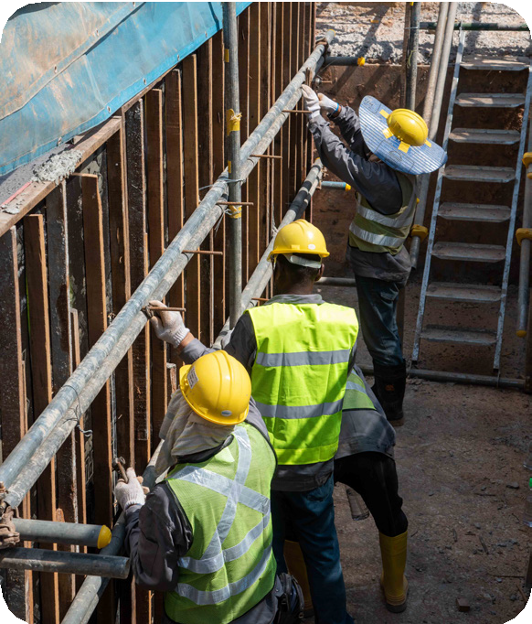
Figure 5: Workers working under direct sun.

During acclimatisation, workers should be supervised and allowed more rest breaks. They should be closely monitored for symptoms of heat injury. Advise the workers to report to their supervisors if they feel unwell. Where practicable, such workers can wear arm bands or helmet tags to allow for easy identification during the acclimatisation period. As the acclimatisation progress may vary from worker to worker, the acclimatisation period may be extended as necessary.

Workers returning from a long vacation or prolonged leave (more than a week) may also need to put on a reacclimatisation programme. Workers returning from prolonged illness will also need to be reacclimatised and should consult a doctor before returning to work.

Use of Mechanical Aids
The use of mechanical aids e.g. lifting equipment, trolleys and power tools, may also be used to reduce the physical workload posed on the worker. This will help to reduce the need for heavy exertion by the worker and decrease his/her metabolic heat generated during the work activity.

Work Scheduling
Where practicable, work tasks should be scheduled to reduce a worker's exposure to high heat stress conditions. This can be achieved by, for example, scheduling heavy physical work or work under direct sun to the cooler parts of the day (early morning or late afternoon).

Under moderate heat exposure conditions, work and rest periods can be alternated, e.g. by scheduling five minutes of rest for every 25 minutes of work. The duration of the rest period should be increased under high heat exposure conditions.

3 "Effects of heat acclimation on endurance capacity and prolactin response to exercise in the heat" by Burk A1 ,
Timpmann 5, Kreegipuu K, Tamm M, Unt E, Oiipik V, Eur J Appl Physiol. 2012 Dec; 112(12):4091-101. doi: 10.1007/ s00421-012-2371-.3Epub 2012 Mar 13.
18

Job rotation e.g. to a low heat stress condition or administrative duties, among workers can also help to reduce a worker's overall exposure to heat and minimise over-exertion. Over-exertion will raise the metabolic heat generated by the worker, contributing to heat stress.

Shaded Rest Area
A shaded area (permanent or temporary) with good airflow should be provided for workers who need to spend a significant amount ohime under the sun. Good airflow may be achieved through mechanical ventilation, e.g. via the installation of fans. Such rest areas can be set up, for example, at or next to a worksite. The shaded rest area will allow workers to have their breaks away from the hot outdoor working environment. Cool drinking water should also be provided at these designated rest areas.

Similarly, a cool rest area should be made available to workers who spend a significant amount of time in a hot indoor working environment.
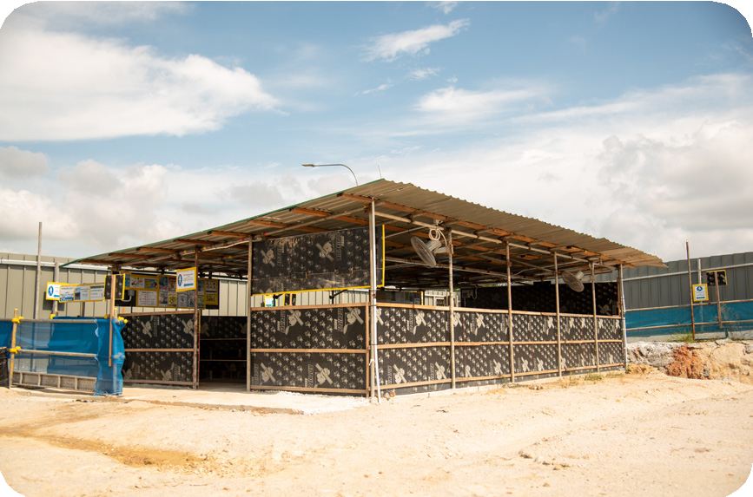
Figure 6: Shaded rest point for workers at a construction site equipped with rotating fans and water coolers. Encourage workers to sponge or rinse themselves with water e.g. during breaks. Body cooling is important especially on days when the weather is hot.

Adequate Water Intake
Workers should start the day well-hydrated by making sure that they are not thirsty and that their urine colour is clear or light yellow. Encourage workers to keep themselves hydrated throughout the day by drinking sufficient water to quench their thirst. Staying hydrated would enable one's body to sweat normally and this will help prevent incidence of heat stress. However, it may not be practicable to monitor urine colour while at work or during physical exertion. Note that urine colour is not a good indicator of hydration during and after exertion.

Urine can be in a variety of colours, in all shades of yellow, ranging from colourless or pale yellow to amber or brown-orange. Normal urine is usually clear in appearance and has a pale straw (light yellow) colour. Early signs of dehydration may cause the urine to be darker yellow than usual. Note that certain types of food and medication may change the colour of urine.

19

Colour | Level of Hydration
 | Good hydration
 | Good hydration/mild dehydration
 | Mild/moderate dehydration
 | Moderate/severe dehydration
 | Severe dehydration

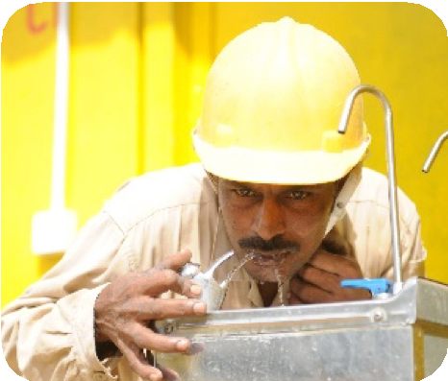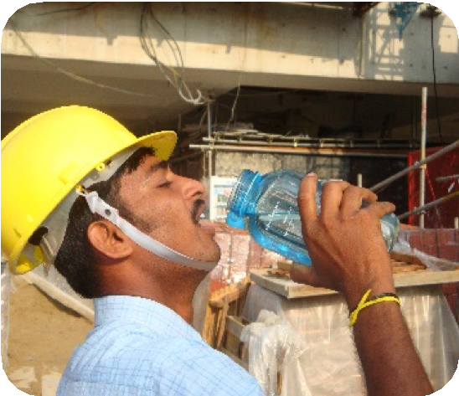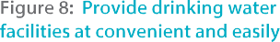

Worker Awareness
All workers should be educated on the hazards of working in a hot environment, the risk factors that can increase the risk of heat injury, the symptoms of heat stress and the possible consequences of heat st roke. The workers should also learn about the preventive measures they can take and the importance of immediately reporting to their supervisors should they or their fellow workers feel unwell.

Workers should look out for one another and know what to do if a fellow worker shows signs of heat injuries. Emergency procedures must be established and made known to all workers so that they can render immediate on-site assistance.

A refresher on heat injury identification and emergency response should then be conducted periodically, e.g. during toolbox meetings.

Worker Clothing
In general, workers should use breathable clothing that is loose-fitting and light-coloured for working in a hot environment. The use of hats or parasols may be used to provide workers with additional shade at the specific work location if appropriate to the work situation.

The use of Personal Protective Equipment (PPE) such as fire-retardant overalls or impermeable chemical-resistant suits will increase the heat stress level experienced by the worker. If such PPE must be used, additional measures should be taken to reduce the worker's physical workload and rest breaks should be longer and/or more frequent.

Employers may consider issuing workers with cooling PPE. It comes in the form of air-cooled, water-cooled, ice-cooled or cooling pack-loaded garments or vests that provide a cool layer (close to the skin) which readily absorbs body heat e.g. via direct cooling or evaporative cooling, thereby helping to keep the body temperature in a safe range. Cooling PPE serves primarily to lower the risk of heat injury and is typically designed to keep the worker comfortable during work.

Insulation and shielding of hot surfaces
Insulation materials can be used to reduce the heat being transferred from the heat source to the work environment. Shielding prevents radiated heat e.g. from a furnace or boiler from reaching workers. Two types of shielding can be used for this purpose:
(i) bright metal surfaces, such as stainless steel and aluminium plates, can be used to reflect heat, and (ii) absorbent shields, such as water-cooled jackets made with black surfaced metal, can be used to absorb and quickly remove the radiant heat.

21

Ventilation and air-conditioning
The movement of air, through mechanical ventilation, can be an effective way to reduce the heat exposure of workers. In hot indoor environments, fans or blowers can be used to bring in cooler air from the external environment and warmer air removed through exhaust fans.

Spot cooling e.g. by using fans, can also be provided to workers if they are required to work near a heat source. Cooled observation booths can also be installed on-site to allow workers to cool down after short periods of exposure to heat while allowing them to monitor the equipment or work process.

Reducing ambient humidity
Humidity can be reduced by installation of dehumidifiers and/or air-conditioning. Reduced humidity increases evaporative cooling via sweating. Local exhaust ventilation may also be used to effectively remove heated vapours at the source. Open hot water baths and drains can be covered to reduce humidity in the work area. Areas with hot open tanks and processes producing large amounts of hot moisture should be situated away from workers.

22

Management of Heat Illness

The two key approaches to the management of heat illnesses are: (a) early recognition and (b) first-aid treatment.

  - Early Recognition
Employers, supervisors and workers should be trained to identify the early signs and symptoms of heat illness so that the affected worker can be promptly treated.

Some of the signs and symptoms associated with heat illness are as follows:

General Appearance
    - Fainting spells, especially after a change in body position e.g. from sitting to standing or after prolonged standing
    - Walking unsteadily or staggering
    - Unconsciousness or experiencing a seizure

Behaviour
Confused, disoriented Irritable, anxious Aggressive

Cardio-respiratory (heart and lung) Hyperventilating (rapid, shallow breathing)

Musculoskeletal (limbs and muscles)

Muscular cramping
General Condition
- Feeling faint or'seeing stars' especially after a change in body position e.g. from sitting to standing or after prolonged standing
- Feeling dizzy or giddy, loss of balance

Feeling weak
- Feels like vomiting (nausea)
- Headache
- Sensitivity to light, blurring of vision

Cardio-respiratory (heart and lung) Shortness of breath
Chest discomfort Palpitations (fast heartbeat)

Musculoskeletal (limbs and muscles)

Cramping in lower limbs
Tingling sensation or numbness in the hands

23

Gastrointestinal (stomach)
- Vomiting
- Sudden loss of bladder or bowel function
Gastrointestinal (stomach) Dry mouth
Vomiting
Abdominal pain
Dermatological (skin)
Dehydrated with dark sunken eyes and/or parched lips
Note: Skin symptoms may deceive. Heat casualties
may appear pale or flushed; their skin may feel cool or hot, and wet or dry to touch

Note: Bold font denotes the more commonly encountered signs and symptoms of heat injury based on data from the SAF Heat Injury Registry (unpublished) .
Table 6: Early signs and symptoms of heat illness.

Note that the signs and symptoms of heat illness may vary between individuals. First-aiders should not use the absence or presence of sweating as a guide to heat injury diagnosis and first­ aid treatment initiation. In general, it is better to err on the side of caution and do everything possible to cool the affected worker's body so long as there has been high heat exposure or there is intense physical work being carried out, and there is the slightest suspicion that the worker is suffering from heat stress.

24

  - First-Aid Treatment
Heat illness can occur quickly. When treating severe heat illness, cooling is the first priority. First-aid for heat illness comprises two key steps: determining a worker's level of consciousness,
e.g. by using the AVPU scale, followed by on-site treatment using the 7R approach.

The AVPU Scale
AVPU is an acronym for "Alert, Verbal response, response to Pain and Unresponsive". The AVPU scale is a tool used by healthcare providers to rapidly assess a worker's level of consciousness. First-aiders may use the AVPU scale to determine the appropriate follow-up action.

The AVPU scale comprises four categories:

The worker is fully awake with spontaneous eye opening.

Eyes do not open spontaneously but the worker responds appropriately when spoken to.

The worker does not respond to verbal stimuli but moves or groans in response to painful stimuli e.g. pinching nail bed.

The worker does not respond to any stimuli.
Table 7: The 4 categories of the AVPU scale.

25

J.
Do you know your name? (Person) Do you know where you are? (Place)
Do you know if it is morning, afternoon or night? (Time)
Not Alert [V, P, U]
Alert [A]
No
Able to answer all 3 questions?
/
Yes

First-aider to assess and treat accordingly
e.g. to proceed with 7R approach to heat injury first-aid treatment
May still require urgent evacuation after initial assessment or if there is deterioration
Proceed with immediate evacuation First-aider to continue providing first-aid
e.g. application of ice packs, CPR

Figure 10: Proposed emergency response/first-aid treatment after AVPU assessment.

Heat stroke must be suspected as a possible cause should a worker collapse at the workplace without signs of external injury. When in doubt, the worker should be treated as having sustained a heat injury and first-aid should be promptly administered.

26

7RApproach
The 7R approach to first-aid treatment for heat stress is as follows:

Recognise symptoms of heat stress and report early.

Get the worker to sit or lie down in a cool shaded area with good ventilation.

Loosen or remove excess clothing as appropriate (while preserving the modesty of the worker).

Reduce body temperature as fast as possible by applying ice packs, wet towels or cool water. Other measures include fanning the casualty (to promote evaporative cooling), the use of cooling blankets and subjecting the worker to cold water immersion.

Rehydrate by providing fluids. If casualty is unconscious, do not provide fluids by mouth as this may result in choking.

If the worker becomes unconscious, call for help immediately and resuscitate using principles of cardiopulmonary resuscitation (CPR) if first-aider is trained to do so.

Rush worker to the nearest hospital if the worker is not alert.

Table 8: First-aid treatment for heat injuries using the 7R approach.

When treating an affected worker with severe heat illness, rapid cooling is priority so as to reduce both the severity of the condition and the risk of possible complications. Take measures to cool the affected worker prior to transfer to the nearest hospital. Emergency response will be improved if workers are familiar with the emergency action plan and drills are regularly conducted.

27

Steps for Cold Water Immersion
Cold water immersion (CWI) is a good way to achieve rapid cooling. This approach is possible in larger worksites with the necessary resources. The following steps may be taken to initiate CWI treatment for workers suspected to be suffering from heat stroke:

Resources for CWI

- Large tub
- Cooler with ice
- Water source
- Towels
- Tent (for shade)
- WBGT measurement device
- Rectal thermometer (if available)
- Lubricating gel (if available)

Table 9: Basic items for cold water immersion.

Step 1
Step 2
Remove excess clothing from the worker.
Cool the heat stroke casualty as quickly as possible via whole-body ice water immersion. This can be achieved by placing the affected worker in a tub filled with ice and water, stirring the water continuously and adding ice throughout the cooling process.

Step 3 Maintain the affected worker's airway, breathing and circulation at all times. Step 4 Once whole-body immersion has been initiated, call SCDF at 995.
Step 5 Monitor the worker's vital signs such as breathing (respiratory) rate, heart rate, blood pressure, and monitor AVPU status.
Step 6 First-aiders as well as medical personnel in facilities where a rectal thermometer is not available, may use the following as a guide: five minutes of CWI for every 1°C desired reduction in body temperature. As an example, for a desired temperature reduction of 3°C, expose the affected worker to approximately 15 to 20 mins of CWI.

A medical practitioner may stop the cooling process when the worker's rectal temperature reaches 38.3°C to 38.9°C.

Do not use an alternate method e.g. thermometers for mouth, ear, armpit, forehead as these devices are not accurate and should not be used on a heat stroke casualty.

28

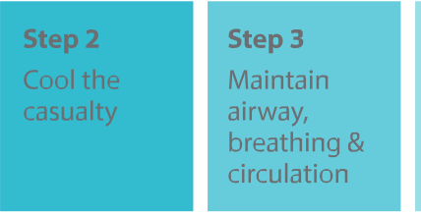
Step4
Call 995
Steps
Monitor vital signs
Step6
Stop the cooling process
No rectal thermometer available Stop cooling after 15 mins
Rectal thermometer available
Stop when temperature reaches 38.3"C to 38.9"C
Step 1 Remove
excess
clothing
Figure 11: Six key steps for Cold Water Immersion (CWI) treatment .

First-aiders must be aware that the heat stroke casualty may exhibit aggressive/combative behaviour e.g. kicking, punching, screaming. There may be a need to call for additional help to restrain the casualty so that the CWI treatment can continue.

Once rapid cooling by CWI is complete, transfer the affected worker to the nearest medical facility or hospital via ambulance.

Note that heat stroke casualties can have a very high survival rate when immediate cooling (via CWI or aggressive whole-body cold water dousing) is initiated within 10 minutes of collapse.

29

- Heat Stress Case Studies

Case Study 1: Indoor Work Environment

Description of Incident
A non-heat acclimatised worker from a colder climate started work in a food processing factory and was exposed to the hot environment inside the factory. He had to move food products via trolleys into the heated drying room. He developed a heat stroke and fainted during work.
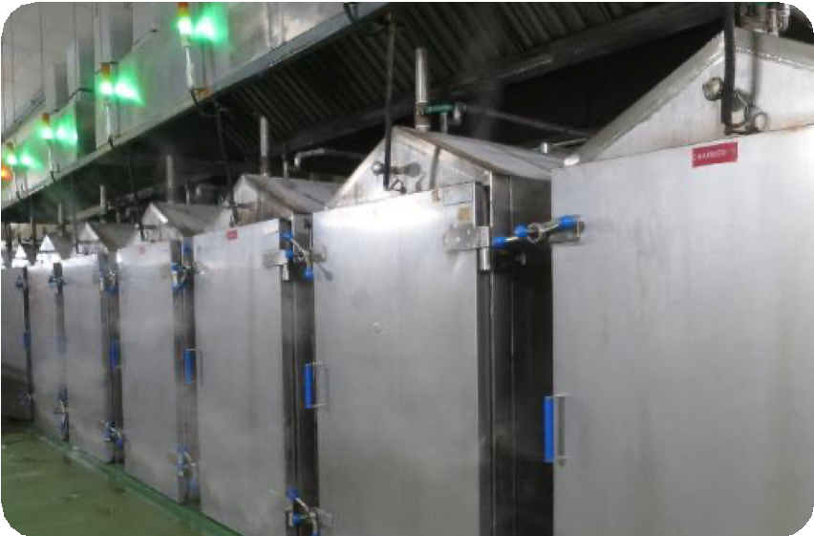
Figure 12: The worker was tasked to work in the vicinity of the above food steamers in the food processing factory.

Risk Factors
- Hot work environment with inadequate ventilation (drying room WBGT was 36.7°()
- Non-heat acclimatised worker

30

Recommendations

- Use of automation or conveyor system for transfer of food products to the drying room.

- Insulate hot equipment surfaces to reduce the heat being transferred to the work environment.
- Increase the workplace general ventilation rate for better heat control.
- Install fans (ceiling or standing) and/or on-site blowers to increase air flow at strategic locations.
- Install local exhaust ventilation near each heat generating machine or process.

- Review the worker's fitness to work and identify those with history of heat-related disorders so that their exposure to heat may be reduced
e.g. through job rotation as appropriate.
- Implement a heat acclimatisation programme for all workers (especially those returning from a cold climate) that need to be exposed to a hot working environment.
- Schedule appropriate work-rest periods for all persons working in the hot environment.
- Provide a cool or air-conditioned area for the workers to rest.
- Provide workers with easy access to cool drinking water and encourage them to drink frequently.
- Highlight the possibility of heat injuries in specific work environments during toolbox meetings, and educate workers on heat illness identification and first-aid treatment.
- Monitor the heat stress index of the hot working environment, keep proper records, highlight peaks and put in place additional heat controls as necessary.

- Provide workers with clothing that is loose­ fitting and light-coloured.
- Consider issuing cooling PPE as appropriate.

31

Case Study 2: Outdoor Work Environment

Description of Incident
A construction worker was erecting formwork for the retention tanks at an open area of a construction site. He was seen by his supervisor and colleagues to be walking unsteadily and sitting down on the ground. His colleagues immediately transferred him to an air-conditioned area where his body was observed to be hot and dry. He was given first-aid and transferred to hospital. The worker was subsequently diagnosed with heat stroke.

Additional Information
The worker had been working in Singapore for some time and was therefore considered to have acclimatised to the local weather. However, he had been feeling unwell with episodes of diarrhoea and gastric discomfort three days prior to the incident but felt that he had recovered sufficiently to resume normal work activities.
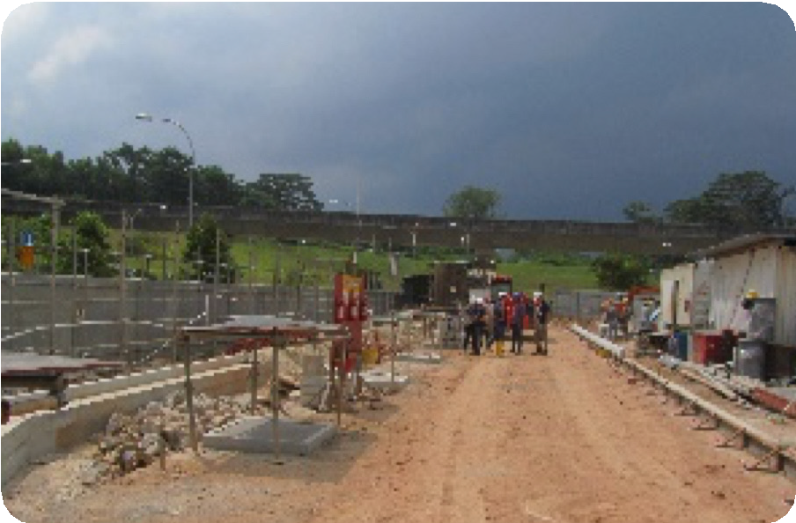
Figure 13: Location where the worker was stationed on the day of the incident.

Risk Factors
- Hot weather (ambient temperature of 35.3°( on incident day)
- Worker just recovered from illness

32

Recommendations

- Provide the worker with a mechanical aid
e.g. a suitable tool or powered equipment, that can reduce the worker's physical workload.

- Check with workers at the start of each workday/ shift to confirm that they are fit for work.
Advise workers to report to their supervisor and/ or colleagues any time they feel unwell.
- Identify workers with history of heat-related disorders and reduce their exposure to heat or incorporate additional risk controls e.g. through job rotation as appropriate.
- Schedule heavy physical work to the cooler parts of the day (early morning or late afternoon).
- Schedule appropriate work-rest periods for all persons working in the hot environment.
- Provide or designate a cool or shady area for the workers to rest.
- Provide workers with water bottles and encourage them to drink frequently.
- Highlight the possibility of heat injuries in specific work environments during toolbox meetings, and educate workers on heat illness identification and first-aid treatment.
- Monitor the heat stress index of the hot working environment, keep proper records, highlight peaks and put in place additional heat controls as necessary.

- Provide workers with clothing that is loose­ fitting and light-coloured.
- Consider issuing cooling PPE as appropriate.

33

Case Study 3: Confined Space Work Environment

Description of Incident
At around 2pm, a worker was descending by rope into a storage tank of a marine vessel when co-workers heard him shouting for help. He was assisted down to the bottom of the tank and immediately conveyed to a hospital, where he passed away two weeks later due to complications arising from heat stroke.
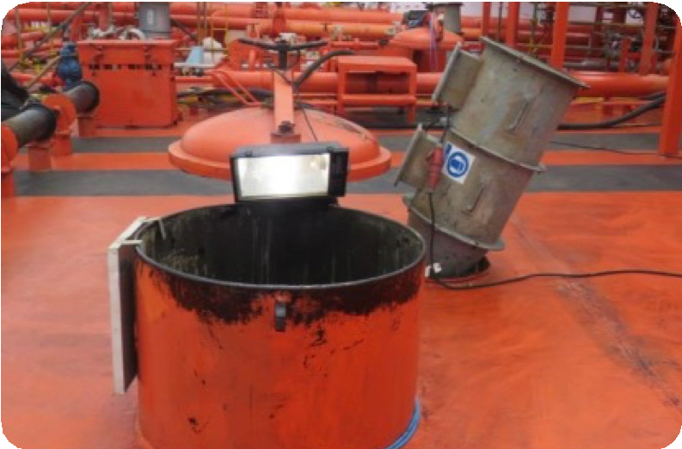
Figure 14: Access point into the tank.

Risk Factors
- Hot work environment in enclosed space (WBGT was 29°()
- Physically strenuous work activity

34

Recommendations

- Ensure that ventilation is adequate when working in an enclosed space (the storage tank in this case). Temperatures in enclosed spaces can be higher than the ambient temperature and this can lead to increased risk of heat injury.
- Instead of rope access, consider if there are other ways to lower the worker into the storage tank to reduce the physical strain on the worker e.g. by means of a mechanical lowering device.

- Check that workers are medically fit and physically able to meet the demands of the assigned work activity. Ensure that workers returning from medical leave are given less strenuous work until they have fully recovered. Advise workers to report to their supervisor and/ or colleagues any time they feel unwell.
- Ensure that foreign workers (especially if they come from a country with a colder climate) have been acclimatised to Singapore's hot and humid climate. Start with a reduced workload, and gradually increase to the full workload over time, to allow workers to get used to the heat.
S. Ensure that the confined space has been checked safe for entry, permit requirements are met
e.g. confined space attendant is in place and rescue team on standby, and the confined space entry permit has been approved, before allowing work to commence.
- Limit strenuous outdoor work during the hottest part of the day. Schedule these activities in early morning, late afternoon or when the weather
is cooler.
- Schedule appropriate work-rest periods for all persons working in the hot environment.
- Provide or designate a cool or shady area for the workers to rest.
- Provide workers with water bottles and encourage them to drink frequently.

35

- Educate workers to recognise the symptoms of heat injuries so that help can be given promptly.
- Monitor the heat stress index of the hot working environment, keep proper records, highlight peaks and put in place additional heat controls as necessary.
- Train and familiarise employees with the emergency and evacuation procedure, so they can respond accordingly and take the appropriate action(s) when an emergency arises.
- Provide workers with clothing that is loose­ fitting and light-coloured.
- Consider issuing cooling PPE as appropriate.

36

The below checklist may be used for both indoor and outdoor hot working environments:

Preventing Heat Stress

Preventive Measures
Risk Assessment
Does your RA cover work in a hot environment?
Has an evaluation of the potential for heat injury been carried out based on a suitable heat stress index?
Have all the heat sources e.g. hot machines, equipment, pipes, in the work area been identified?
Fitness to Work
Have all workers passed their pre-employment medical examination?
Are supervisors checking for workers who are feeling unwell prior to starting work?
Have workers, who have been ill, been certified by a doctor to be fit to return to work?
Heat Acclimatisation
Are new workers acclimatised to work in a hot environment?
Are workers returning from prolonged leave, prolonged illness or returning from a colder climate, reacclimatised to work in a hot environment?
Worker Clothing
Are workers wearing loose-fitting and light-coloured clothing?
Work Scheduling
Is heavy physical work or work under direct sun scheduled to the cooler parts of the day?
Is there work rotation for workers exposed to hot working conditions?
Are workers allowed to take additional rest breaks in very hot weather or after carrying out heavy physical work?
Adequate Water Intake
Do workers have ready access to cool drinking water?
Have the workers been advised to stay hydrated throughout the day?
Rest Area
Is there a cool or shaded area where workers can rest?

Preventive Measures
Use of Mechanical Aids
Are mechanical aids e.g. lifting equipment and power tools used to reduce the worker’s physical workload?
Workplace Ventilation
Is there adequate ventilation (natural or mechanical) in the work area?
Insulation/Shielding of Heat Sources
Are hot machines, equipment and pipes insulated and/or shielded to minimise heat transfer to the work environment?
Worker Awareness
Have the workers been advised to report to their supervisor and/ or see a medical doctor if they are feeling unwell?
Are the workers aware of the heat injury preventive measures they can take before starting work?
Are WSH officers, supervisors, workers and appointed first-aiders able to identify the signs and symptoms of heat injury?
Are emergency procedures established, emergency supplies available and workers trained to render immediate on-site assistance?
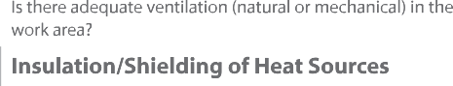

1O. References

Singapore Legislation
- Workplace Safety and Health Act
- Workplace Safety and Health (General Provisions) Regulations
- Workplace Safety and Health (Risk Management) Regulations
- Workplace Safety and Health (Construction) Regulations 2007
- Workplace Safety and Health (Shipbuilding and Ship-Repairing) Regulations 2008
- Workplace Safety and Health (Confined Spaces) Regulations 2009
- Workplace Safety and Health (First-Aid) Regulations
- Workplace Safety and Health (Incident Reporting) Regulations

Guidelines
- MOM Circular on Managing Heat Stress in the Workplace (15 Aug 2012)
- Singapore Armed Forces - Ministry of Health (SAF-MOH) Clinical Practice Guidelines on Management of Heat Injuries (1/201O)
- 2020 TLVs® and BEls® Guidelines by American Conference of Governmental Industrial Hygienists (ACGIH®)
- Workplace Safety and Health Topic on Heat Stress, The National Institute for Occupational Safety and Health (NIOSH)
- Criteria for a Recommended Standard Occupational Exposure to Heat and Hot Environments by US National Institute for Occupational Safety and Health (NIOSH), 2016
- Occupational Safety and Health Administration (OSHA) Technical Manual on Heat Stress, Section Ill: Chapter 4
- ISO 15265: 2004 Ergonomics of the Thermal Environment - Risk Assessment Strategy for the Prevention of Stress or Discomfort in Thermal Working Conditions
- ISO 7243: 2017 Ergonomics of the Thermal Environment - Assessment of Heat Stress using the WBGT (Wet Bulb Globe Temperature) Index
- Risk Assessment for the Prevention of Heat Stroke at Work, Occupational Safety and Health Branch, Labour Dept, Hong Kong
- Workplace Safety and Health Guidelines on Diagnosis and Management of Occupational Diseases
- Workplace Safety and Health Guidelines on Landscape and Horticultural Works
- WSH Council's Activity Based Checklist on Working Safely in Hot Environment

Reports
- Fifth Assessment Report ofThe Intergovernmental Panel on Climate Change
- Working on a Warmer Planet - The Impact of Heat Stress on Labour Productivity and Decent Work, International Labour Office (ILO), 2019
- Singapore's Second National Climate Change Study - Climate Projections to 2100: Report for Stakeholders 2015, The Centre for Climate Research Singapore, Meteorological Service Singapore
- Heat Injury Management in the Singapore Armed Forces - A Report by the External Review Panel on Heat Injury Management, 2018
- Sport Singapore's Sports Safety Committee Report 3rd Ed. (March 2019), Chapter 7: Heat Injuries in Sports
39

Supporting Organisation | Contributor
National University of Singapore | A/Prof Jason Lee (Chairman)
Singapore Armed Forces | COL (DR) Edward Lo Hong Yee LTC (DR) Alexander Gorny
Ministry of Home Affairs | COL (DR) Ng Yih Yng Dr Joshua Wong
National Environment Agency | Mr Cheong Wee Kiong
Singapore Contractors Association Limited | Mr Don Wilson Paua Boon Leng
Singapore Manufacturing Federation | Ms Foo May Ling
Ministry of Manpower | Dr Kenneth Choy Dr Lucy Leong
Workplace Safety and Health Council | Mr Edison J Loh

- Annexes

Annex A: Wet Bulb Globe Temperature Calculations
The environmental conditions which influence the heat equilibrium of the body and its physiological responses are air temperature, humidity, air movement and the temperature of surrounding objects. The physiological effects of these conditions are influenced by the intensity of the work, the health status of the worker, and the clothing worn.

There are various indicators available for assessing thermal environment. The most widely used indicator is the Wet Bulb Globe Temperature (WBGT) index. It is a simple and quick technique of measuring the environmental factors which correlate with deep body temperature and physiological response to heat. It can be performed by semi-skilled personnel.

The WBGT index requires three measurements - the natural wet bulb temperature (Twet bulb), the globe temperature (Tglobe), and the dry bulb air temperature (Tdry bulb). The measurement of these factors is explained in the next section.

For outdoors with a solar load (i.e., radiation from the sun), WBGT is calculated using the following formula:
WBGT = 0.7 Twet bulb + 0.2 Tglobe + 0.1 Tdry bulb

For indoor or outdoor conditions without a solar load, WBGT is calculated as:

WBGT = 0.7 Twet bulb+ 0.3 Tglobe

Example
For an outdoor environment with dry bulb temperature 30°C, globe temperature 40°C, and natural wet bulb temperature 25°C, the WBGT is:
WBGT = 0.7Twetbulb + 0.2Tglobe+ 0.1 Tdrybulb
= 0.7 _{X} (25°() + 0.2 _{X} (40°() + 0.1 _{X} (30°()
= 17.5 + 8 + 3
=28.s°C

How are the environmental factors in WBGT index measured?
Instruments used for measuring environmental factors or for determining the WBGT index should always be located so that the readings obtained will be truly representative of the environmental conditions to which the worker is exposed to. Sensors should, at least, be the same height as the worker. Before obtaining the readings, there must be sufficient time for the instrument to reach equilibrium with the environmental conditions after it has been set up.

41

Dry Bulb Air Temperature
The dry bulb temperature (Tdry bulb) is the temperature of the ambient air as measured with a thermometer. The simplest type of thermometer used for measuring dry bulb temperature is liquid-in-glass thermometer (see Figure A1). Under field (outdoor with solar radiation) conditions, the sensing element should be shielded from direct radiant energy, e.g. by using an aluminium foil.

Natural Wet Bulb Temperature
The natural wet bulb temperature (Twet bulb) is the temperature measured by a thermometer which has its sensor covered by a wet cotton wick and exposed to the natural prevailing air movement unshielded from radiation. One inch or 2.5 cm of wet wick should be exposed to the air above the top of the reservoir. The wick should be wet to the tip at all times with distilled water (see Figure A 1).
Dry bulb (normal thermometer)
Natural wet bulb thermometer
muslin
water
Figure A1: Dry bulb and natural wet bulb thermometers.

42

Globe Temperature
The globe temperature (Tglobe) is the temperature measured by a black globe thermometer. It is a thin-walled, blackened copper sphere, with a thermometer at its centre (see Figure A2).

The temperature attained by the globe thermometer depends on the transfer of radiant heat (solar or infrared radiation) between it and the surrounding, and the convective heat exchange with the ambient air, which in turn depends on ambient temperature and air movement.

The standard 6-inch globe thermometer requires 15 to 20 minutes to be stabilised, whereas small globe thermometers with a 4.2 cm (1.65 inch) diameter require about five minutes.
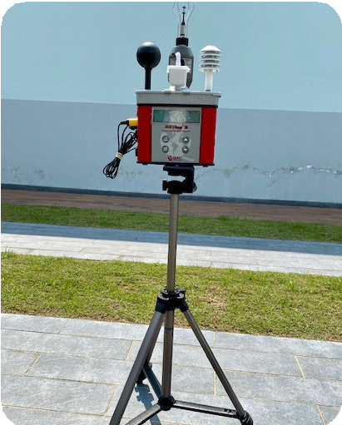
Figure A2: WBGT monitor including a globe thermometer.

Heat Stress Monitoring Device
Portable direct reading heat stress meters or monitors (see Figure A3) are also available for measuring WBGT index. These instruments can calculate both the indoor and outdoor WBGT values according to the WBGT formulas.
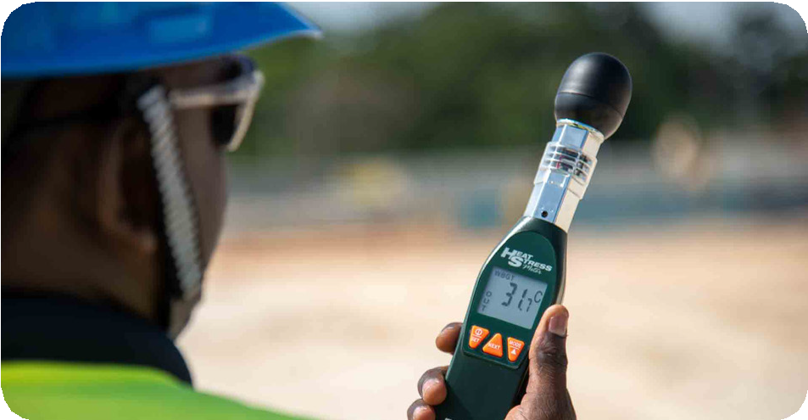
Figure A3: Example of a portable heat index monitor.

43

What are the permissible heat exposure limits?
The risk of heat-related stress depends on the WBGT. In general, the following criteria can be used for risk assessment:
  - WBGT < 31°C: Low risk
  - WBGT 31°C - 31.9°(: Moderate risk
  - WBGT 32°( and above: High risk

There are two sets of permissible WBGT, namely the Threshold Limit Values (TLV®) WBGT for acclimatised workers (Table A1) and Action Limit WBGT for unacclimatised workers (Table A2). The permissible WBGT values depend on two basic parameters: metabolic demands of the task and work-rest cycle (percentage or proportion of work within an hour).

The TLV® WBGT as recommended by the American Conference of Governmental Industrial Hygienists (ACGIH®) represents conditions under which it is believed that nearly all heat acclimatised, adequately hydrated, unmedicated and healthy workers may be repeatedly exposed to without adverse health effects. The goal of the TLV is to maintain the body core temperature within 1°( of normal (37°(), that is, without exceeding 38°C.
Table A1: TLV (WBGT values for acclimatised persons).
Adapted from ' ACGIH ® 2020 TLVs® and BEls ® ©2020. Reprinted with permission.

4 See TLV®/ BEI® Policy Statement and Position Statement.

44

An example of a work-rest cycle for 50% to 75% work is 45 minutes of work followed by 15 minutes of rest.

Acclimatised persons are persons who are adapted to working in the hot environment. Acclimatisation comprises the daily exposure to heat stress for up to 14 days and can take the form of gradual increase in work duration under the hot environment.

The Action Limit WBGT is established to protect unacclimatised workers and represents conditions for which a heat stress management programme should be considered.
Table A2: Action Limit (WBGT values for unacclimatised persons).
Adapted from ' ACGIH® 2020 TLVs® and BEls® ©2020. Reprinted with permission.

Metabolic Rate Demands
To determine the degree of heat stress exposure, the metabolic demands or work rate must be considered. Correct assessment of work rate is as important as environmental assessment in evaluating heat stress. Table A3 provides broad guidance for selecting the work rate to be used in Tables A1 and A2.

45

 |  | Sitting.
Rest | 115
Light | 180 | Sitting with light manual work with hands or hands and arms, and driving.  Standing with some light arm work and occasional walking.
Moderate | 300 | Sustained moderate hand and arm work, moderate arm and leg work, moderate arm and trunk work, or  light pushing and pulling. Normal walking.
Heavy | 415 | Intense arm and trunk work, carrying, shovelling, manual sawing; pushing and pulling heavy loads; and walking at a fast pace.
Very heavy | 520 | Very intense activity at fast to maximum pace.

Table A3: Metabolic Rate categories and representative Metabolic Rate with examples of activities.
Adapted from ' ACGIH ® 2020 TLVs® and BEls ® ©2020. Reprinted with permission.

  - The effect of body weight on the estimated metabolic rate can be accounted for by multiplying the estimated rate by the ratio of actual body weight divided by 70 kg (154 lb).

Unacclimatised persons are those who are not adapted to working in the hot environment and this can include those who come from countries with a colder climate. A person can become unacclimatised during periods when there is no exposure to heat stress, for example, workers returning from a prolonged leave (more than one week). These workers should
be reacclimatised.

46

Clothing Adjustment Factor
The WBGT-based heat exposure assessment was developed for the traditional work uniform
- a long-sleeved shirt and pants. If workers are required to wear non-traditional clothing, an appropriate clothing adjustment factor should be added to the measured WBGT, in accordance with Table A4.

Work clothes (long-sleeved shirt and pants) | 0
Cloth (woven material) coveralls | 0
Double-layer woven clothing | 3
SMS polypropylene coveralls | 0.5
Polyolefin coveralls | 1.0
Limited-use vapour-barrier coveralls | 11.0

Table A4: Clothing adjustment factors for some clothing ensembles*.
Adapted from ACGIH® 2020TLVs® and BEls" ©2020. Reprinted with permission.

* These values must not be used for completely encapsulating suits, often calfed Level A. Clothing Adjustment Factors cannot be added for multiple foyers. The coveralls assume that only modesty clothing is worn underneath, not a second fayer of clothing.

Example
An acclimatised worker performs moderate physical work at a construction worksite from 3pm to 4pm without rest. Polyolefin coveralls are worn. The dry bulb air temperature is 30°(, the globe temperature is 40°(, and the natural wet bulb temperature is 25°C. Hence the WBGTis:
WBGT = 0.7 Twet bulb+ 0.2 Tglobe+ 0.1 Tdry bulb
= 0.7 X ( 25°() + 0.2 X ( 40°() + 0.1 X ( 30°()
=17.5+8+3
= 28.5°(

From Table A4, the clothing adjustment factor for Polyoefin coveralls is l .O°C. The WBGT adjusted for clothing = 28.5 + 1.0 = 29.5°C.
For an acclimatised person, the permissible WBGT from Table A1 is 28°( [for moderate physical work at 100% work-rest cycle i.e., no rest].

As the WBGT is higher than the permissible level, the exposure is excessive.
47

Time-Weighted Average WBGT
When a worker is not continuously exposed in a single hot area but moves between two or more areas with different levels of environmental heat, or when the environmental heat varies substantially at a single hot area, environmental heat exposures should be measured for each area and each level of environmental heat the employees are exposed to. The time­ weighted average (TWA) WBGT index should be calculated as being the mean of the WBGT values for each environment, weighted for the respective duration of exposure.

TWAWBGT=
Where WBGT,, WBGT , ••.WBGTn are measured values of WBGT for the various work and rest intervals during the total time period; T,, T ••• Tn are the duration of the respective intervals
2
2
in minutes.

Heat Stress Evaluation and Control
Based on the metabolic rate category for the work and the appropriate proportion of work within an hour, a WBGT criterion can be found in Table A1 for the TLV WBGT and Table A2 for the Action Limit WBGT.

Low Risk (TWA WBGT < Action Limit)
If the measured TWA WBGT adjusted for clothing is less than the Action Limit in Table A2, there is little risk of excessive exposures to heat stress.

Moderate Risk (TWA WBGT;,: Action Limit, but< Threshold Limit)
If the measured TWA WBGT adjusted for clothing is above the Action Limit in Table A2, but below the TLV in Table A1, the following general controls should be implemented:

General Risk Controls for Preventing Heat Stress
Consider pre-placement medical screening to identify those susceptible to systemic heat injury.
Provide verbal and written instructions, annual training and other information on heat injuries.
Encourage workers to drink a small volume (one glass) of cool water every 20-30 minutes.
Allow self-limitation of heat exposure and encourage co-worker observation to detect
signs and symptoms of heat injury in fellow workers.
Encourage healthy lifestyles and maintenance of ideal body weight. Ensure workers have adequate salt intake from their diets.
Monitor and counsel those who abuse alcohol or other intoxicants, and those who take medications that may compromise normal cardiovascular, blood pressure, body temperature regulation, and renal or sweat gland functions.
Adjust expectations of those returning to work after absence from heat exposure situations.
Monitor the environmental heat stress condition and past reports of heat-related disorders.
48

If there are reports of the symptoms of heat-related disorders such as fatigue, nausea, dizziness, and light-headedness, the analysis should be reconsidered.

High Risk (TWA WBGT;;: Threshold Limit)
If the measured TWA WBGT adjusted for clothing is above the TLV in Table A1, a further analysis is required. This may include monitoring heat strain (physiological responses to heat stress), and the signs and symptoms of heat-related disorders listed below. An individual's exposure to heat stress should be discontinued when any of the following occurs:

sustained (several minutes) heart rate in excess of 180 beats per minute minus the individual's age in years, that is, above (180 - age);
body core temperature is greater than 38.5°C for acclimatised workers; or greater than 38°C for unacclimatised workers;
recovery heart rate at one minute after a peak work effort is greater than 120 beats per minute; and
symptoms of sudden and severe fatigue, nausea, dizziness or light-headedness. For high-risk situations, the following job-specific controls should be implemented:

Job-specific Risk Controls for Preventing Heat Stress
Provide general ventilation e.g. using blowers or stand fans.
Shield radiant heat sources e.g. by erecting temporary shelters to shield against solar radiation.
Consider engineering controls that reduce the metabolic rate e.g. using mechanical devices for material handling.
Consider administrative measures that set acceptable exposure times, allow sufficient recovery time, and limit physiological strain.
Consider personal protection equipment that were demonstrated to be effective for specific work practices and conditions at the location.

By monitoring the environmental factors at the worksite, the level of heat stress that workers are exposed to can be determined. Taking this into consideration and the type of work being performed, heat stress can be effectively managed, thereby preventing heat disorders or heat-related injuries amongst workers.

49

Annex B: Heat Stress Index Calculations

Heat Stress Index (HSI)
The HSI is another useful tool for assessing hot environments and ascertaining the thermal stress on the body. It takes into consideration the environmental heat (radiation Rand convection C) and metabolic heat (M). It is expressed as the ratio of the required evaporation of sweat (E,eq) to stay at thermal equilibrium to the maximum evaporative capacity of the environment (Ema/

An HSI value of 100 represents the maximum heat strain that can be tolerated by fit, acclimatised young men. Should the HSI value be greater than 100 (ACGIH), there is significant heat storage in the body and heat exposure should be time-limited.

E
HSI = x 100
Emax
where Ereq = M ± R ± C

R = 7.7 (Tmea-n
35}

Tmean = Tglobe + 1· BV 0 5 (Tglobe - Tdry bulb )
a·ir
C = 8.1 V j (Td,ybulb - 35) Emax = 122 V i (5.6 - Pa)

and
M = Metabolic heat generated, W R = Radiant heat exchange, W
C = Convective heat exchange, W

V.a,r
=Airspeed, mis

p = Water vapour pressure of air, kPa
a,r

Tmean
= Mean radiant temperature, 0 (

Tdrybulb = Dry bulb air temperature, °C
Tglobe = Globe temperature, 0(

so

Basal Metabolism (8) |  | 70
Posture Metabolism (P) | Sitting | 20
Activity (A) | Standing | 40
 | Walking | 170 | 140 to 210
 | Hand  light heavy | 30  65
 | One arm  light heavy | 70  120 | 50to175
 | Both arms light heavy | 105  175 | 70 to 245
 | Whole body light moderate heavy very heavy | 245  350  490  630 | 175 to 1050
Walking(H) | H = 3.3Hhor  where Hhor = rate of horizontal travel (m/min)
Climbing (V) | V= 3.3Vvert  where Vvert = rate of vertical ascent (m/min)

Table B: Values for estimating Metabolic Heat Generated (M).
[Ref: Fundamentals of Industrial Hygiene, 6'" Edition]

51

Example 1: At Work
Estimated metabolic heat generated
B+P+A+H+V
basal metabolism+ posture metabolism (walking)+ activity (whole body, moderate)
+ walking at 25 m/min + no climbing 70 + 170 + 350 + (3.3 _{X} 25) + 0
672.5 Watts

Example 2: While Resting
Estimated metabolic heat generated

B+P+A+H+V
basal metabolism+ posture metabolism (sitting)+ activity (both arms, light)
+ no walking+ no climbing 70 + 20 + 105 + 0 + 0
195 Watts

52

Amendments

This revised version replaces the WSH Guidelines on Managing Heat Stress in the Workplace published in 2012.

Evidence that Singapore's climate is getting warmer
New emphasis on heat stress in indoor working environments
2 | Focus on Exertional Heat Stroke
4 | Risk assessment to cover hot indoor working environments, taking into account personal, environmental and job risk factors.
5 | Introduction of Heat Stress Index  Guidance on how to measure WBGT for large work areas Criteria for heat stress level assessment based on WBGT
6 | Updated heat acclimatisation schedule example; urine colour chart; cooling PPE; preventive actions for hot indoor working environments.
7 | Management of heat illness - early recognition and first-aid treatment including cold water immersion; use of AVPU Scale and 7R approach.
8 | Heat stress case studies
9 | Heat stress prevention checklist (now made generic for any industry; applicable for both indoor and outdoor hot working environment s).
12 | Annex B: Heat Stress Index Calculations

53

