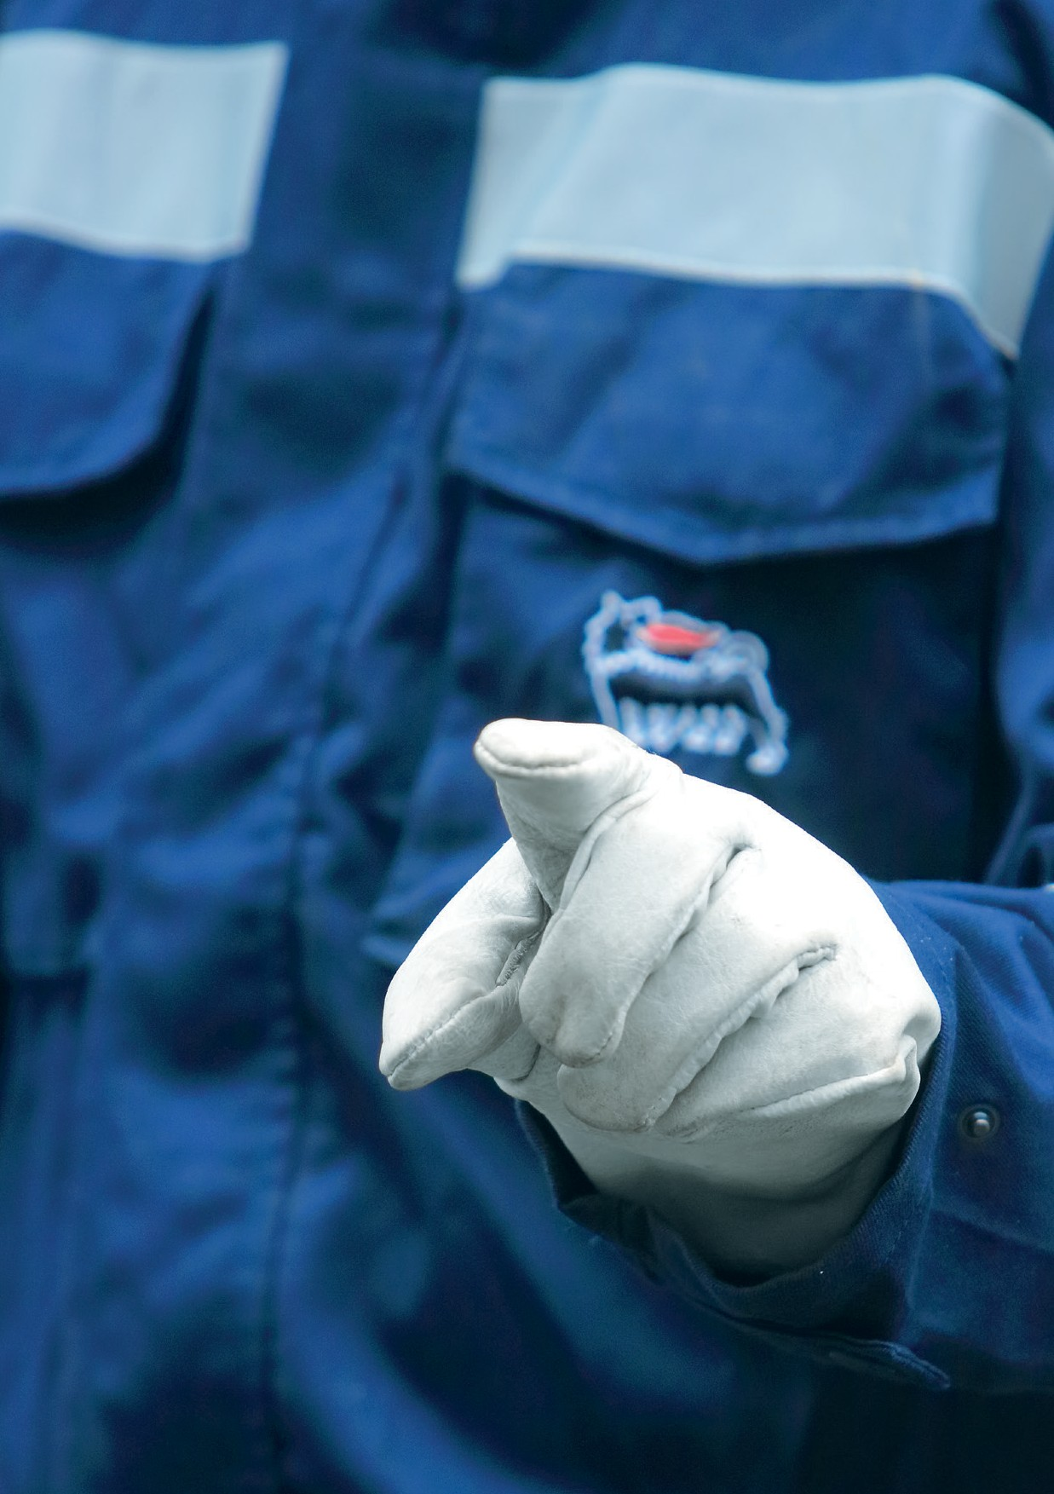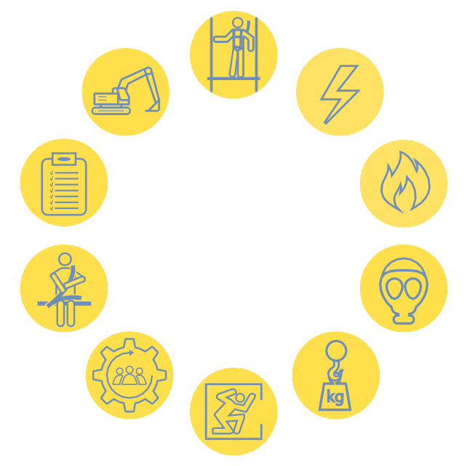

SUMMARY
Golden Rule 1 - Working at height 4
Golden Rule 2 - Energized systems 6
Golden Rule 3 - Fire safety 8
® Golden Rule 4 - Toxic gases 10
Golden Rule 5 - Lifting operation 12
Golden Rule 6 - Confined space 14
Golden Rule 7 - Management of change 16
-i Golden Rule 8 - Driving safety 18
i- Golden Rule 9 - Permit to work 20
Golden Rule 10 - Excavation safety 22

With the Stop Work Authority, anyone working within Eni sites, as either an employee or contractor, is empowered to interrupt an activity whenever he observes an unsafe act
or an unsafe condition.

We cannot accept to have an injury due to a predictable cause, or to actions that are unsafe.

Therefore, whenever we find a hazard, we have to report it in order to eliminate it.

It is our duty to ensure that any activity is conducted in a safe manner, keeping both ourselves and our colleagues safe!

You have the
stop work authority!

Safety is our value
This booklet provides a concise guide to the basic rules
to be followed during working activities, with the intention
to raise awareness on safety at site respecting the Eni minimum Safety requirements.

The 10 Safety Golden Rules must become part of our way of approaching and conducting any working activity.

We must ensure that
- All job activities are adequately planned, assessed and executed.
- All personnel are adequately informed, trained and have all the
necessary equipment to perform the work.
- All personnel are empowered to intervene and to stop activities anywhere or at any time when the Safety Golden Rules are
not correctly applied.

Our commitment

The 10 Safety Golden Rules apply to anyone working within Eni sites, as either an employee or contractor, anywhere in the world.

Introduction

Top and Middle Management
- Provide adequate resources to support the continued
implementation of the 10 Safety Golden Rules.
- Demonstrate their personal commitment, leadership and accountability.

Supervisors
- Ensure that work conditions are safe.
- Ensure, leading by example, that their teams know
and observe the rules and that they comply with them before
starting, during and at the end of a working activity.

Workers
- Be responsible for the safety of themselves and that of their co-workers.
- Be aware that compliance is mandatory.
- Immediately report to their supervisor/person in charge, about
any unsafe event (i.e. accident, near miss, unsafe act, unsafe
condition) that occurs at the work site.

Golden Rule 1 – Working at height

Controls and monitoring of the reliability of equipment and protection systems during work at height activities ensure the workers safety.

Golden Rule 1 – Working at height

PLAN
- Avoid working at height wherever a practical alternative option is available.
- Prefer fall prevention systems to fall protection systems.
- Guarantee that fall protection systems (e.g., full body safety
harness, shock absorbing lanyards) are periodically inspected
and maintained by a competent person.
- Guarantee that arrangements for emergency rescue at height are in place.

READY?
- Is the PTW in place, completed with the risk assessment for each work at height activity?
- Are scaffolds inspected by a competent person prior to use
and equipped with a valid tag/panel certifying the inspection?
- Are personnel working at height provided with specific training?
- Are the PPEs identified by the Employer in the specific risk
assessment for the required task, in good condition and worn
by all people?

GO!
- Guarantee that work surfaces and holes are always adequately protected from fall of personnel and objects.
- Guarantee that all scaffolds are built according to the vendor
manual/specifications or a specific project done by an
authorized engineer.
- Guarantee that only authorized workers (specifically trained) access the scaffolds.

Golden Rule 2 – Energized systems

Implementation of procedures, controls and specialized personnel guarantee safety during activities where energized systems are present.

Golden Rule 2 – Energized systems

PLAN
- Verify that a specific energy isolation procedure is in place.
- Each job shall be both risk assessed and performed
by competent personnel.
- Ensure that the permit to work refers unambiguously
to the equipment on which the intervention is requested.
- Guarantee to periodically inspect and maintain portable appliances and equipment, which work under energy.

READY?
- Is an energy isolation certificate completed in conjunction with and referred to in the PTW?
- Have you verified that no stored energy or other hazards
remain prior to start your job, and that the energy isolation
is properly done?
- Does authorized competent personnel, who has been appointed by the Company Management, perform
the energy isolation?
- Are the PPEs identified by the Employer in the specific risk assessment for the required task, in good condition and worn
by all people?

GO!
- Do not carry out unauthorized activities. Follow the provisions of the permit to work.
- Use lockout and tagout devices to inform of isolation and to
prevent non-authorized operations.
- Ensure that no work or equipment movement is allowed under or near an overhead power line unless precautions
have been taken.

Golden Rule 3 – Fire safety

Fire risk must be assessed and control measures such as procedures and active/passive fire protection systems implemented.

Golden Rule 3 – Fire safety

PLAN
- Ensure that a competent person for each site performs a fire risk assessment.
- Guarantee that a fire emergency response plan is developed
and all personnel is trained.
- Guarantee the use of a specific PTW when the activity foreseen the use of free flame, equipment with ignition
sources, and foresee the proper fire fighting measures.
- Plan, for a sufficient number of workers, specific training in the proper use of firefighting equipment.
- Periodically inspect and maintain the fire prevention and
protection measures.

READY?
- Are all work places equipped with means of fire detection, alarm and firefighting equipment?
- Are sources of ignition under control and unnecessary ones
removed?
- Are escape routes and muster points clearly marked and kept easily accessible at all time?

GO!
- Handle and store flammable materials properly.
- Ensure that workers do not smoke at the plant, except
in authorized areas, and they do not use naked flames a/o
non-explosion proof equipment unless expressly authorized.
- Keep all areas clean and tidy.

Golden Rule 4 – Toxic gases

Procedures, staff training, specific collective and personal protective equipment are required to work
in the presence of toxic gases.

Golden Rule 4 – Toxic gases

PLAN
- Guarantee that the operating procedures, work instructions and ERP have been developed considering the risks related
to toxic gas release.
- Guarantee that everybody is informed on toxic gas risk
and properly trained on their specific role during emergencies,
and on collective/personal protective equipment.
- Guarantee that each worker has both a personal toxic gas detector and a proper breathing escaping device (full face
mask / hood with specific filter / air bottle).
- Post safety signs and any other means, warning of the potential presence of toxic gas.

READY?
- Are you authorized to enter a toxic gas classified area?
- Is the ERT present on site and alerted?

GO!
- Always wear your full face mask / hood with specific
filter / air bottle, to be used exclusively in case of emergency,
and your personal detection devices when working in an area where there is or could be the presence of toxic gas (provided that breathable air is guaranteed, otherwise, use a breathing apparatus).

Golden Rule 5 – Lifting operation

Lifting operations properly planned, implemented and monitored, prevent the workers risk of falling or being
crushed or struck.

Golden Rule 5 – Lifting operation

PLAN
- Plan the lift with a specific risk assessment.
- Always inspect the equipment/machines and accessories as per
manufacturer’s instructions and site procedure requirement:
check and record damages, color code, SWL and certificate.
- Lifting authority be involved in all activities.
- Personnel lifts shall be done only with man-rated equipment
and under a PTW.

READY?
- Is lifting equipment certified by a Third Party in accordance with relevant local legislation or international standards and regularly
maintained according to the planned schedule?
- Are all persons engaged in lifting and hoisting operations competent for that role and supervised at all times?
- Are lifting and hoisting equipment, machines and accessories
(cranes, forklifts, slings, handles, hooks, baskets, etc.) in good
condition according to national legislation and international best practices?
- Have you verified that the lifting area is marked out
to prohibit unauthorized access?
- Are the PPEs identified by the Employer in the specific risk assessment for the required task, in good condition and worn
by all people?

GO!
- Always ensure the presence of a banksman during the entire lifting operation and avoid unplanned blind lifts.
- Never allow personnel to be under or close to suspended
loads for any reason.
- Ensure that the lifting operator keeps the machine/equipment under control at all time.

Golden Rule 6 – Confined space

Atmospheric testing, specific training on confined space activities,
implementation of dedicated emergency procedures, are mandatory to work safely in a confined space.

Golden Rule 6 – Confined space

PLAN
- Each job shall be risk assessed and all hazards and controls shall be identified and implemented.
- Plan specific training for all persons engaged in confined
spaces activities.

READY?
- Is a Confined Space certificate completed in conjunction with and referred to in the PTW?
- Did you verify that the confined space is positively isolated
from all possible sources of hazards?
- Have qualified and authorized personnel tested and recorded the atmosphere inside the confined space as designated
in the permit/confined space entry certificate?
- Is the Emergency Response and Rescue Plan prepared
and tested? Is the ERT ready in location and communication
means ready and tested?
- Are the PPEs identified by the Employer in the specific risk assessment for the required task, in good condition and worn
by all people?

GO!
- Suspend the work if ERT and/or means of communications are unavailable on site.
- Suspend the work if a dedicated qualified attendant (watcher)
is not present close to the confined space.
- Suspend the work if there is no specific PTW and Confined space certificate for the activity.
- Suspend the work if Rescue Equipment are not in place.
- Keep always visual or voice contact with the entrants.

Golden Rule 7 – Management of change

Any plant/organizational change must be identified, assessed and authorized by the responsible of the work place.

Golden Rule 7 – Management of change

PLAN
- Identify, analyze and assess any change or deviation to plant design, work procedures/practices and organization.
- Support any change, in particular overriding/disabling/change
of a safety critical element, with a specific risk assessment.

READY?
- Is the change, in particular deviations from mandatory requirements, duly structured, documented and approved by
a Company authorized and competent person?
- Is the change properly recorded and tracked in a dedicated system?

GO!
- Communicate any change to all concerned personnel and keep track of the identified and implemented actions.

Golden Rule 8 – Driving safety

Driving behavior and recommendations for proper vehicle management reduce the risk of accidents.

Golden Rule 8 – Driving safety

PLAN
- Always ensure that the driver is in good physical condition.
- Drivers shall be certified and authorized for driving the utilized
vehicle.

READY?
- Is your vehicle in good condition and regularly maintained?
- Are seat belts fastened and appropriate shoes worn?
- Are you free from the influence of alcohol and drugs?
- Are loads properly secured and within the capacity
of the vehicle?
- Are you sufficiently rested to drive a vehicle?

GO!
- Adopt defensive behavior in respect of other road users.
- Respect speed limits, adjusting your speed according to road
and weather conditions, local legislation and Company rules.
- When you drive, do not use any mobile phone and respect the daily maximum driving hours and rest period.

Golden Rule 9 – Permit to work

Work permit is an essential and mandatory management tool to be adopted for non-routine or dangerous activities.

Golden Rule 9 – Permit to work

PLAN
- A PTW system must be in place with the relevant supporting procedures and systematically implemented.
- Simultaneous/concurrent activities shall be planned
and subjected to risk assessment and PTW in order
to eliminate/reduce interferential risks.
- Non-routine and high-risk activities shall be planned and subjected to risk assessment and PTW.
- Guarantee that all personnel receive proper training on using
the PTW system.

READY?
- Is the PTW discussed in dedicated meetings?
- Have all personnel working under a PTW received
the necessary information about its contents?
- Have you verified that all requirements specified in the PTW are implemented on site?

GO!
- Suspend and re-assess your work if a change occurs in the scope of the work, tools, equipment, personnel, shift change
or any other condition of the PTW.

Golden Rule 10 – Excavation safety

Soil characterization, protected excavation areas and correct use of machinery, guarantee the workers safety.

Golden Rule 10 – Excavation safety

PLAN
- A soil survey shall be carried out and all the risks shall be identified and assessed.
- Always consider underground services in the area, those shall
be identified, marked and isolated (if necessary).
- Plan specific training for all personnel involved in excavation works.

READY?
- Do you have a valid excavation clearance certificate and the PTW?
- Has the site been inspected by a competent person?
- Are the PPEs identified by the Employer in the specific risk
assessment for the required task, in good condition and worn
by all people?

GO!
- Effectively shore, slope, bench, barricade and sign all excavations.
- Provide suitable entry and exit point when working in trenches,
considering any possible emergency and weather condition.
- Guarantee that workers stand outside the area of action of the excavator.

Printed in February 2018

