Scaffolds Safety

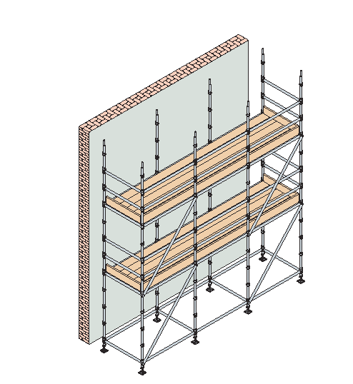

Introduction:
A scaffold is an elevated, and usually temporary platform used to support workers, materials and tools during construction work.
It is being used when it is not possible to perform works with other safe means.
There are various types of scaffolds being used at construction sites , including supported scaffolds, such as: Frame Scaffolds, Tube and Clamps Scaffolds, System Scaffolds, Suspended Scaffolds, and Mobile Tower Scaffolds.

Employees working on scaffolds are exposed to many hazards such as falls, complete collapse of scaffolds.
This section covers the general safety guidelines for scaffolds higher than 2 m from the ground adjacent to the location where the scaffold is erected, also this section determines specific requirements for different types of scaffolds.

1- General Requirements:
- Scaffolds must be provided for employees engaged in work that cannot be done safely from the ground or from solid construction.
- All scaffolds must be erected, moved, dismantled or altered, only under the supervision of a competent persons and by skilled and experienced workers.
- Each scaffold and scaffold component shall be capable of supporting, without failure, its own weight and at least 4 times the maximum intended load applied or transmitted to it.
- The contractor shall prepare the construction designs, drawings, and design loads for all scaffolds used on site including forms concrete ceiling supports, platforms used for storage of materials and others, and same must be approved by the consultant engineer, prior to erection of scaffolds. All these information must be kept on site for inspection purposes.
- Scaffolds cannot be erected, used, closer than 3 m (10 feet) near energized power lines to avoid any contact between the scaffold components and these power lines.
- Supported scaffolds with a height to base width ratio of more than four to one (4:1) shall be tied to the building structure vertically and horizontally. The first bottom tie must be placed no higher than four (4) times the minimum base width and vertical ties shall be repeated at intervals not greater than 8 m (26 feet). Horizontal ties shall be placed at each end and at intervals not greater than 9 m (30 feet) horizontally.
- Supported and suspended scaffolds shall be inspected by a third party safety company and a proper certificate shall be issued by this company, the inspection will be repeated in case of any change on the location of erection or suspension.

2- Scaffolds Foundations:
- Scaffolds must have base plates, even when setting on a concrete floor.
- When setting the scaffold on soft soil, the soil shall be compacted to avoid the presence of any holes and to enhance its ability to support the intended loads. Scaffold legs must be set on base plates and adequate mudsills with not less than 5 cm thick and not less than 25 cm wide to distribute the load on bigger area. (See fig. # 1).

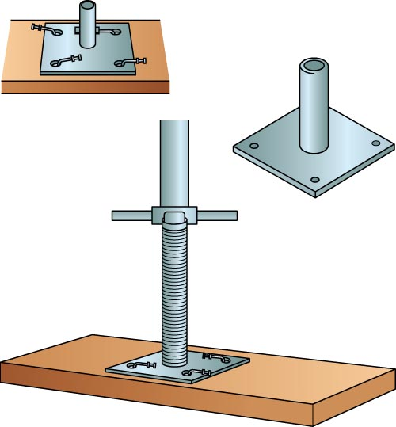

Fig. # 1

  - Scaffold Platform:
- The front edge of all platforms shall not be more than 35 cm (14 inches) from the face of the work, unless guardrail systems are erected along the front edge and/or personnel fall arrest systems are used.

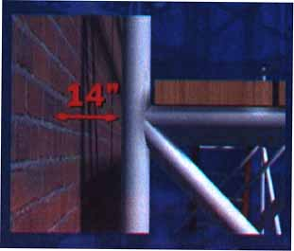
Fig.# 1a

- The width of the platform of a scaffold shall be determined according to the purpose of use and height from the ground to provide adequate area to work safely, but the width of each platform shall not be less than:
  - be not less than 60 cm wide (3 boards) when used for persons only and not for materials.
  - Be not less than 80 cm wide (4 boards) when used for persons and materials.
  - Be not less than 150 cm wide (7 boards) when used for the support of any higher platform or used to dress roughly shaped stones.
  - Be not less than 43 cm when used as wooden passages.
- The open side edges of platforms higher than 2 m shall be provided with standard guard rail not less than 95 cm and not more than 115 cm high and consists of top rail and mid rail and toe-board not less than 15 cm high above the platform, taking into consideration that the distance between the top rail and the mid rail or between the mid rail and the toe-board should not be more than 47 cm. (see fig. # 2).

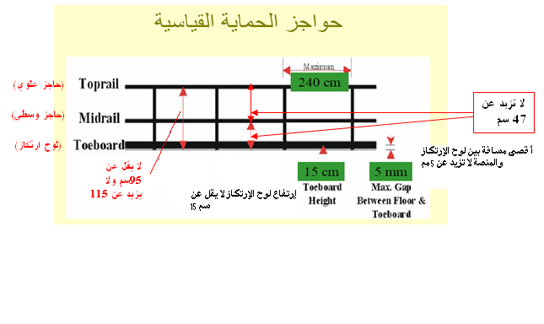
Fig. # 2

- When the provision of providing scaffolds and platforms with guard rails is not possible or not practical, all employees working on scaffolds shall use safety harnesses which will be anchored at the building or strong structure or a safety line at the nearest point on top of the worker head. If it is not possible to do so, the worker shall be tied to the strong components of the scaffold or provide adequate alternative methods to protect from fall hazards such as safety nets, etc.
- Wood scaffold planks should be nominal 5 cm x 25 cm. Gaps between adjacent planks or toe-boards should not exceed 2.5 cm. Planking should extend a minimum of 15 cm over the center of each support (unless cleated to prevent the plank from sliding) and a maximum of 30 cm. the ends of wooden planks shall be encased in metal sleeves or jackets to protect them from damage,
- Where persons are required to work or pass under the scaffolds. Scaffolds shall be provided with a screen between the toe-board and the guardrail, extending along the entire opening. (see fig. # 3).

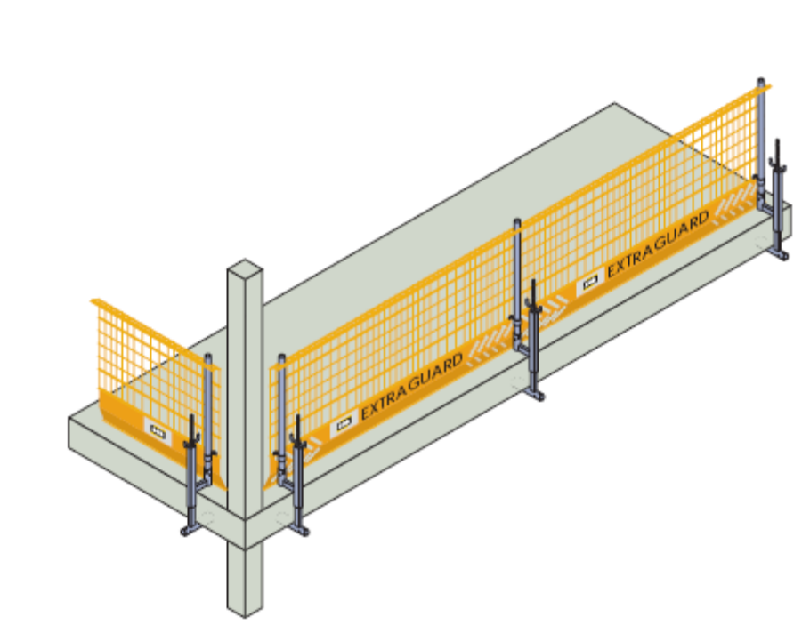
Fig. # 3

- Faces of scaffolds shall be covered with tarpaulin sheeting covers (Containment Sheeting) to protect against scattering of dust and debris on people and cars in the street. (in this case, wind loads shall be considered). (see fig. # 4).

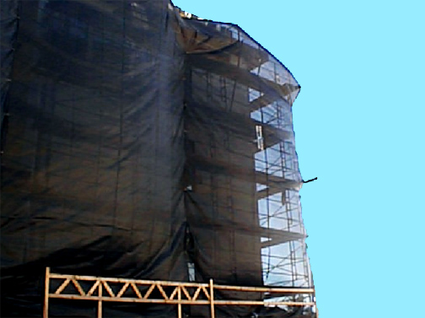
Fig. # 4

4- Safe Access to Scaffolds:
- A safe way access, secured adequately for entrance and exit to or from any place where one person works at any time shall be provided.
- It is preferable to provide a ladder inside the scaffold to reach to the work platform. (See fig. # 5a).
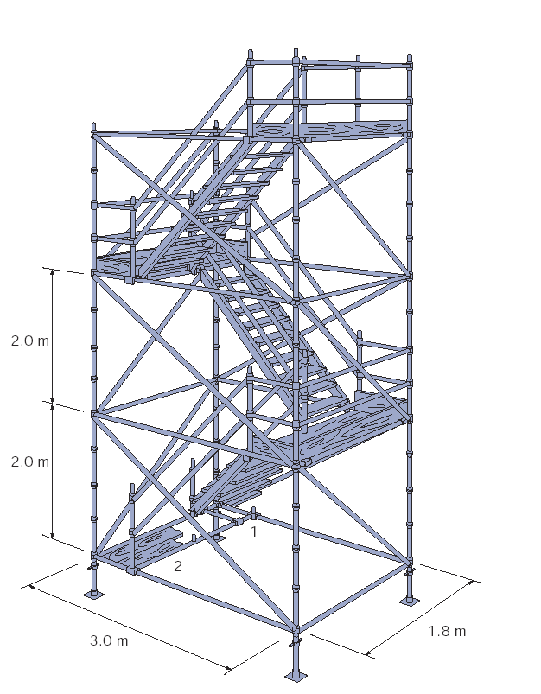
Fig 5a

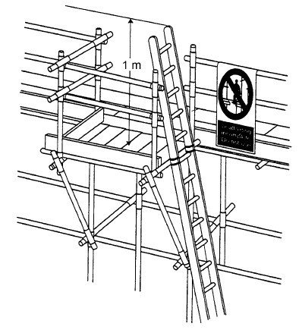
Fig. 5b
- Portable single ladders when used as access means to the scaffold platform, shall not have a slope more than 4 (vertical) : 1 (Horizontal) i.e. one meter out for every 4 meters of height, and extend at least 1 m above platform level to provide adequate handhold at all stepping-off points. (See fig. # 5b).
- When the length of the ladder exceeds 9 m, it shall be provided with intermediate landing, which shall not be used as a working platform or for storage of materials. These landing shall be provided with a standard guard rail system to protect against fall hazards.
- In case of using a vertical ladder more than 6 m height, a fall protection system must be provided to protect employees from fall hazards, such system may be a cage or a ladder safety device.
- Ladders shall be securely tied from upper and bottom to prevent slipping and shall be fixed on stable and level surfaces using their slip-resistant feet.

5- Capacity:
Working Loads of Scaffolds:
Working load is the total load of all persons, equipment, tools, materials, transmitted loads, and other loads reasonably anticipated to be applied to a scaffold or scaffold component at any one time. There are three different types of scaffolds according to load (Light Duty Scaffolds, Medium Duty Scaffolds, and Heavy Duty Scaffolds). As follows:
- Light Duty Scaffolds: Designed and constructed to carry a working load of 1.2 Kilo Newton per square meter (25 pounds per square foot.
- Medium Duty Scaffolds: Designed and constructed to carry a working load of 2.4 Kilo Newton per square meter (50 pounds per square foot).
- Heavy Duty Scaffolds: Designed and constructed to carry a working load of 3.6 Kilo Newton per square meter (75 pounds per square foot).

- Each scaffold shall be designed to be capable of supporting, without failure, its own weight and at least 4 times the maximum working load applied or transmitted to it.
- Each suspension rope, used on non-adjustable suspension scaffolds shall be capable of supporting, without failure, at least 6 times the maximum intended load applied or transmitted to that rope.
- Scaffolds shall not be loaded in excess of the working load they are intended, and this load shall be evenly distributed on the scaffold platform.
- Materials or loads shall be moved or deposited without imposing any violent shock.
- Material shall not be kept up on a scaffold unless needed for work within a reasonable time. These loads shall not exceed the designed load limit of the scaffold.

6- Maximum Heights of Scaffolds & Maximum Number of Working Levels: (Tube and Clamp Scaffolds)
1. Each contractor shall prepare a design for scaffolds systems according to the nature of work, and the expected intended loads, and the methods of fixing the scaffolds, the consultant engineer shall approve such designs.
2. The maximum height of scaffold shall not exceed 38 m (125 feet), and in case the need for higher scaffolds, the contractor shall submit a design prepared by specialized third party company and shall obtain the approval of the consultant engineer on that design before starting the erection of the scaffold, this approved design shall be kept on site for inspection by the concerned department personnel.
3. The maximum number of working levels at the same time and the maximum number of additional planked levels shall be determined by referring to table # 1 below:

Table # 1
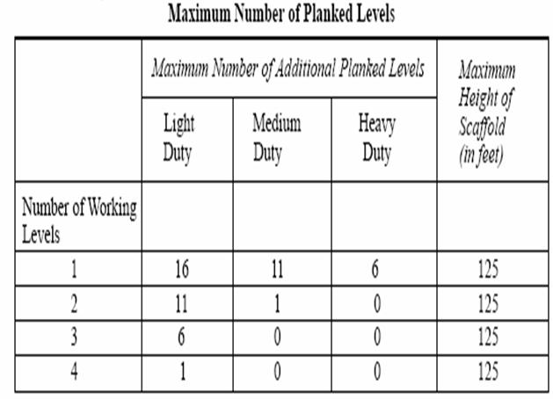

7- Scaffolds Materials:
- Metal parts used for scaffolds shall be of suitable quality and be in good condition and free from corrosion or other patent defect likely to affect their strength materially.
- Nails or bolts used in the construction of scaffolds shall be of adequate size and in sufficient numbers at each connection to develop the designed strength of the scaffolds. Fiber rope lashing, nails, clamps and any other means shall be used according to the manufacturing recommendations.
- All lumber used in construction of scaffolds shall be free of large knots, split, wraps, decay, twist, dry rot or any other defects, and shall have straight-grained, and shall not be painted or treated by any means so that to hide defects.
- It is strictly prohibited to use any ropes that have been affected by acids or bases (alkalis) or damaged ropes for scaffolds.
- Fiber ropes shall not be used for scaffolds in places that might cause the rope to be damaged.
- All necessary precautions shall be taken to avoid the split of planks.
- All material used for erection of scaffolds shall be stored properly and away from any other materials that might affect it.

8- Erection of Scaffolds:
- Scaffolds shall be erected or dismantled by a skilled workers, trained and qualified to perform such work, under the supervision of a competent person.
- Scaffolds shall not be extended beyond its highest fixing point to the extend that will affect its stability.
- Worker erecting and dismantling scaffolds shall be provided with proper fall protection measures and shall be provided with the suitable personal protective equipment to protect them from fall hazard.
- Where materials of the scaffolds are handled manually during erection or dismantling, no workers shall exist under these materials.
- All scaffold materials used for the support of the working platform shall be sound rigid and of adequate strength and firm footing and well strutted and braced.
- Loose bricks and drain pipes or any other unsuitable materials shall not be used for erection or supporting scaffolds.
- Proper protection from the hazard of falling objects shall be provided to the top of scaffold if this hazard exists.
- All faces of the scaffold shall be braced diagonally, both internally and externally to adequately support the scaffold.
- Partially erected or dismantled scaffolds shall not be used, and a prominent warning notice indicating that the scaffold is incomplete and not safe to be used (Red Scaffold Tag) shall be posted. The access to the scaffold shall physically be blocked.
- Scaffolds and scaffold components shall be thoroughly inspected by a competent persons who is authorized by the contractor to ensure that the scaffold is stable, and capable of supporting the intended loads and then he shall post the green scaffold tag after signing it which indicates that the scaffold is complete and safe to use.

9- Scaffolds Ties:
- When the height of scaffolds exceeds 4 times its width, the scaffold shall be tied to the fixed building structure, vertically and horizontally. The first bottom tie must be placed no higher than four (4) times the minimum base width and vertical ties shall be repeated at intervals not greater than 8 m (26 feet). Horizontal ties shall be placed at each end and at intervals not greater than 9 m (30 feet).
- At least 50 % of all ties shall be positive (+ ve) ties, that is, they do not get their strength from friction as in the case with the reveal ties.
- There are 5 various types of ties as follows:
  - Through Ties (+ Ve)
  - Reveal Ties (Not Positive)
  - Box Ties (+ Ve)
  - Anchor Bolt Ties (+ Ve).
  - Other Methods of Tieing

3-1 Through Ties: (See fig. # 6)
3-1-1 A tube is taken through any convenient opening, such as a window, and coupled to another parallel horizontal tube.
3-1-2 Another two tubes will be connected vertically to the horizontal tubes using proper right angle clamps.
3-1-3 These vertical tubes shall be fixed to the scaffold using right angle clamps.
3-1-4 This type of ties is a positive tie.

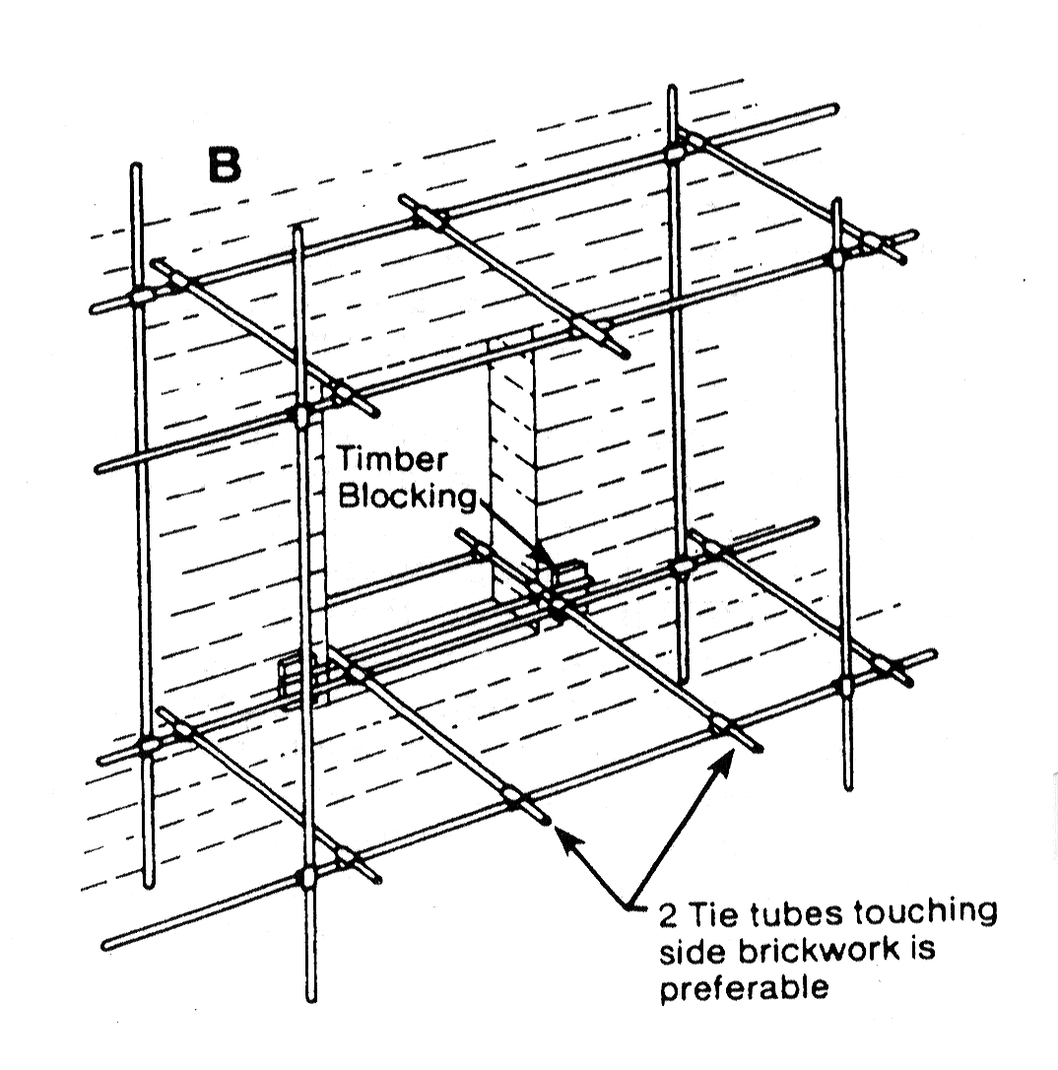
Fig. # 6
3-2 Reveal Ties: (See fig. # 7):
3-2-1 A tube is wedged into an opening in the wall by means of ‘Reveal Pin’.
3-2-2 A second tube is then fixed between this tube and the scaffold to form the tie. The reveal pin normally consists of a piece of tube with a base plate at one end and a screw jack at the other.
3-2-3 This type of ties is considered not positive type of ties.

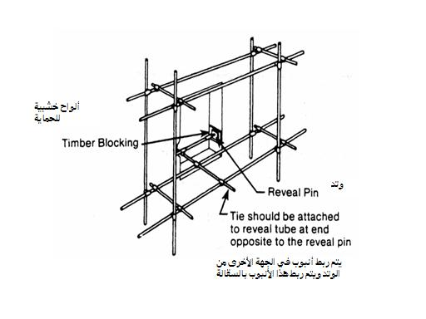
Fig. # 7

3-3 Box Ties: (See fig. # 8)
3-3-1 This tie can be used if there is a column close to the scaffold.
3-3-2 Tie tubes run both sides of the column, with cross tubes tied back and front to both tie tubes.
3-3-3 This type of ties is considered a positive tie.

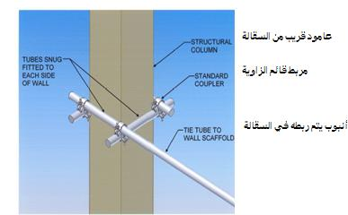
Fig. # 8

3-4 Anchor Bolt Ties: (See fig. # 9)
3-4-1 There are many types of anchors available. They do however, vary in pull out strength and they leave a hole behind which has to be repaired. A pull out force of at least 800 lbs, 1200 lbs, and 1600 lbs, is necessary for light, medium and heavy duty scaffolds respectively. Therefore the proper type of anchor bolt should be selected according to the type of scaffold.
3-4-2 An anchor bolt shall be fixed to the wall through a drilled opening in steel plate.
3-4-3 A proper tube is welded to the steel plate (which is fixed to the wall by the anchor bolt).
3-4-4 This tube shall be tied to the scaffold using the proper right angle clamps.
3-4-5 This type of ties is considered a positive tie.

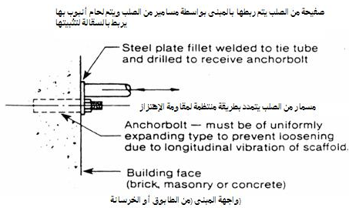
Fig. # 9

3-5 Other Methods of ties:
3-5-1 Tower scaffolds my be tied using guy rope which will be tied to the scaffold (only at joints) and to a point on the ground using anchor bolt with an optimum angle of 45 degree. (See fig. # 10).

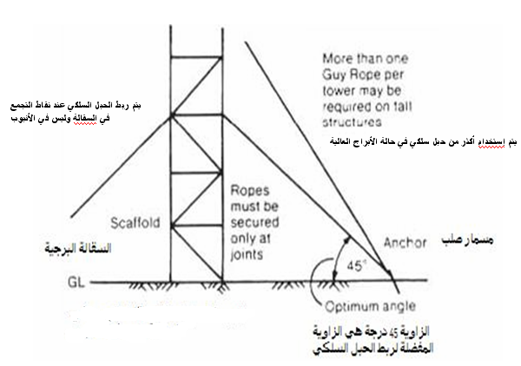
Fig. # 10

3-5-2 More than one guy rope per tower may be required on tall structures.
3-5-3 Also an elevated tube with an angle of 45 degree with the horizontal may be used to tie the scaffold. (Raker Ties) (See fig. # 11).
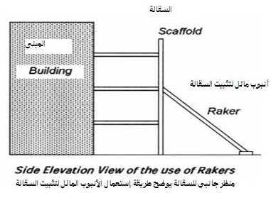
Fig. # 11

3-5-4 The raker tube shall be tied to the scaffold using proper clamps and the other end will be fixed on base plate and mud sill.
In case the scaffold cannot be tied using any one of the above methods, the
contractor shall arrange to prepare a special design for the said scaffold and
obtain the approval of the consultant engineer on that design, and must
keep a copy of this design at site for inspection by the concerned
local authority.

10- Inspection and Maintenance:
- Scaffolds shall be inspected by a competent person who has been provided with the necessary and adequate training to qualify him to supervise the erection, dismantling and inspection of scaffolds. This person(s) must obtain a training certificate as a scaffold competent person issued from a company approved by concerned local authorities.
- Scaffolds shall be inspected before use by a competent person to ensure of the following:
  - The scaffold is adequately secured and stable (safe foundations and methods of ties).
  - Of sound material, free from patent defects.
  - It is suitable to the purpose of work to be done.
  - The necessary required protection measures are provided.
- All the scaffolds shall be inspected by a competent person as follows:
- On daily basis before each use.
- After bad weathers or when the scaffold is not in use for long period.
- In case any alteration is made to the scaffold or its components.
- All material for any scaffold shall be inspected before being taken into use to ensure that they are in good and safe conditions.
- Every scaffold shall be properly maintained and every part shall be kept so fixed, secured or placed in position as to prevent so far as is practicable accidental displacement.
- No scaffold or part of a scaffold shall be partly dismantled and remain in such a condition that it is capable of being used unless, that part is safe to be used according to the regulations mentioned in this section after being inspected by a competent person and declared that it is safe to be used.
- No excavation operations shall be carried out near the foundations of any scaffold, and when it is necessary to do so, safe alternative methods shall be provided to secure scaffold foundations in such a way to guarantee its safety and stability.

Types of Scaffolds

11- Supported Scaffolds:
11-1 Metal Scaffolds:
Supported scaffolds such as Frame Scaffolds, Tube and Clamps Scaffolds,
Systems Scaffolds, and Mobile Tower Scaffolds and others.

11-1-1 General Requirements:
- All scaffolds shall be erected according to the manufacturer’s recommendations. Intermixing of different types of metal is not allowed when erecting the same scaffold unless, it has been approved by a competent person who has enough knowledge about the effect of such intermix on the integrity and strength of the scaffold.
- Metal parts used for scaffolds shall be straight and of suitable quality and in good condition and free from bent, cracks, corrosion, and all other defects. All metal parts used for scaffolds must be inspected by a competent person before use.
- Metal parts used for scaffolds shall be securely connected together by adequate and strong method.
- Scaffolds shall be provided with proper ladders or stairways to be used for access to the scaffold and shall be attached to the structure of the scaffold.
- Scaffolds components materials shall be stored in well protected stores to protect them from being affected by different weather conditions.
- Paints covering metal pipes shall be kept and maintained to protect it from being damaged the matter which may cause alteration of the metal pipes specifications and consequently affect its designed support and stability.
- Metal pipes coated by special paints to protect them from rust and corrosion shall be used in places with high humidity when the possibility of exposure to rust and corrosion is very high.
- All clamps shall be inspected regularly and maintained properly and inspect them before each use, and grease moveable parts to ensure that the threaded parts are in good operational condition.

11-1-2 Tube & Clamp Scaffolds:
This type of scaffolds consists of vertical pipes (Posts) and horizontal
Longitudinal pipes running parallel to the structure (Runners) and pipes
supporting the platform (Bearers) and diagonal pipes (Bracing) all of
these components are joined together by means of special clamps of two
different types. Right angle clamps and swivel joint clamps (See fig. 12 &
13).
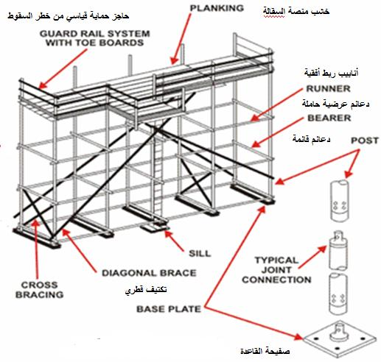
Fig. # 12
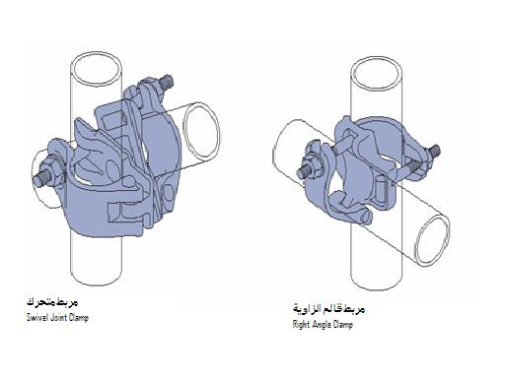
Scaffold Clamps
Fig. # 13

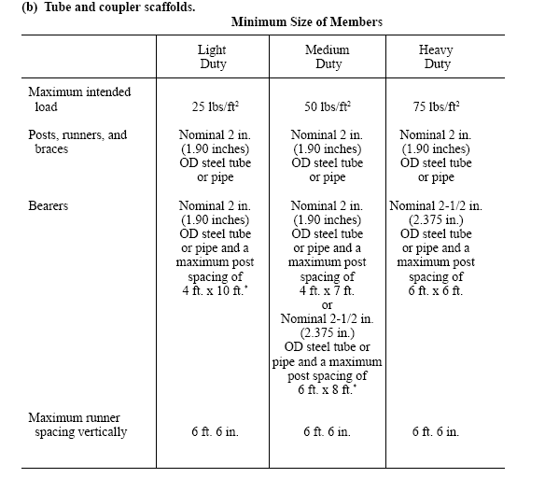

11-1-3 Frame Scaffolds:
This type of scaffolds consists of Steel fabricated frame and cross bracing.
Frame scaffolding is relatively simple and fast to erect, provided that the
surface is level, and the access is not restricted. It considered easy to be
erected and does not need great experience since every part is being
connected at the predetermined place.
The scaffold shall be erected on base plates with adjustable leveling screw
and proper mud sill on a well compacted soil. (See fig. # 14).

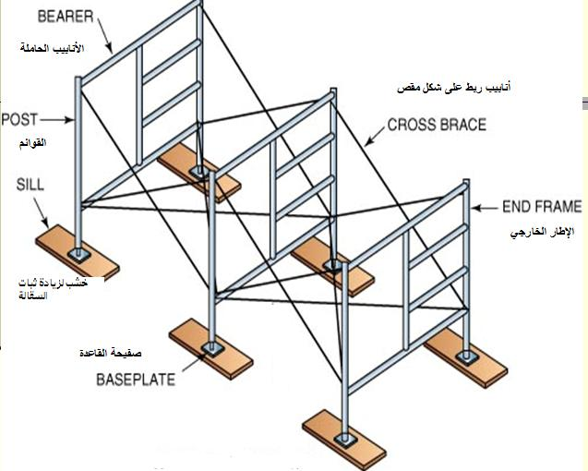
Fig. # 14
11-1-4 System Scaffolds:
There are various types of this scaffold, and it consists of vertical pipes
with different lengths (posts), and the runners and bearers are connected
to fixed locations.
The most popular one is the cup-lock system scaffold, where all the
blades of the pipes are located into lower cup, and the upper cup is lowered
down and tightened with a hammer blow.
The advantage that modular systems have is that they do not require a high
degree of expertise to erect them since the location of the connections are fixed. (See fig. # 15).

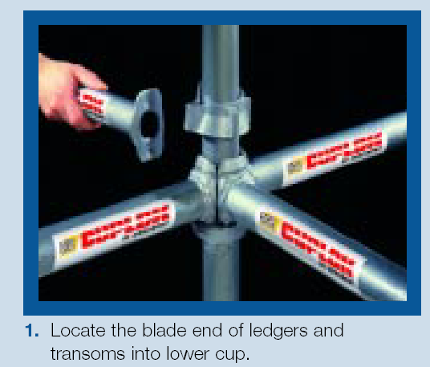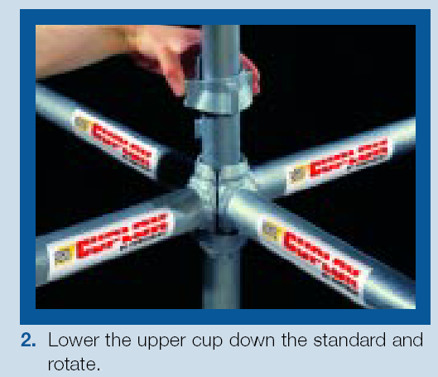
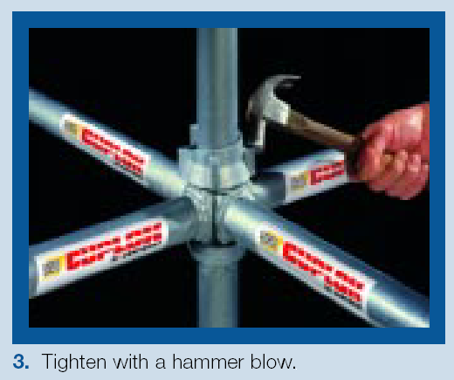
Fig. # 15
11-1-5 Mobile Tower Scaffolds:
It is a scaffold mounted on wheels and may be made of normal tube and fittings and has only one platform. The platform shall not extend outward beyond the base support of the tower and shall have standard guard rails and toe-boards (See fig. # 16).
Means of access (an access ladder) shall be provided from inside the tower or fixed outside the tower according to the safety requirements of ladders.
Mobile tower scaffolds are equipped with casters at the bottom and positive locking brakes to prevent the tower from movement during use. These casters shall be capable of supporting the safe working load of the scaffold.

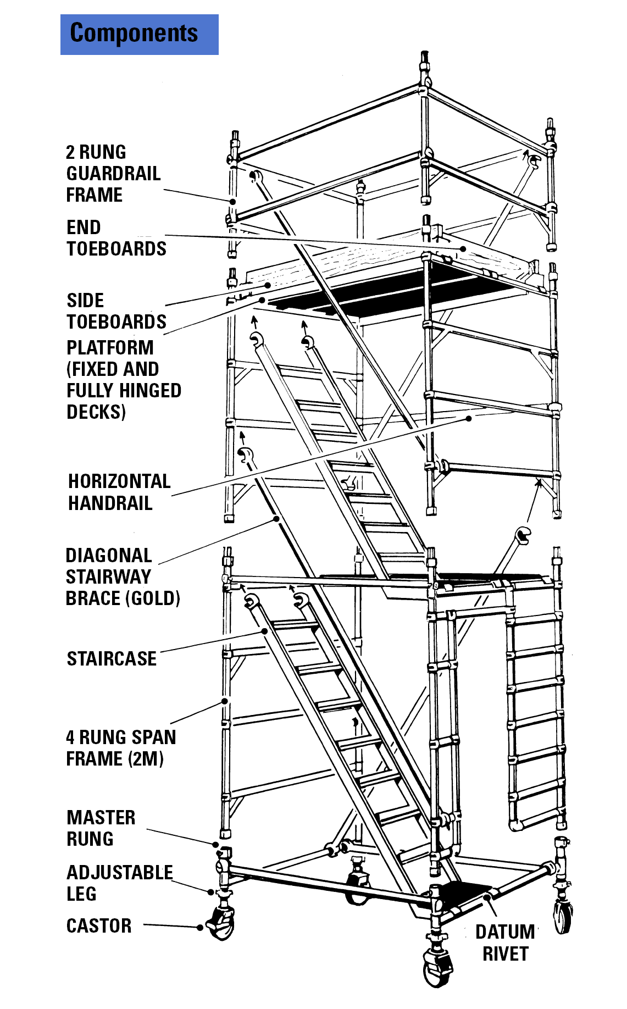
Fig. # 16

11-1-5-1 General Requirements:

- The height of the mobile tower shall not exceed 4 times the smallest base width of the scaffold, in case the height is exceeding 4 times the width of the scaffold, special out riggers shall be used to increase the width of the scaffold, and consequently increasing the permissible height.
- Rolling scaffolds shall be used only on firm, level, clean surfaces.
- Rolling scaffolds shall be moved on leveled surfaces only by pushing or pulling or both. Manual force used to move the scaffold shall be applied as close to the base as practicable, but no more than 1.5 m (5 feet) above the supporting surface. No persons, equipment or materials are allowed to be on the platform during moving it. Scaffold casters and wheels shall be locked with positive wheel locks after the ending of moving the tower and before any one is allowed to work on the platform.
- It is recommended to use a ladder (internal staircase) to access to and from the platform (see fig. # 16), in case of using a vertical ladder higher than 6 m, it shall be protected by a cage or provide workers with proper fall protection equipment.

11-1-6 Suspended Scaffolds:
Suspended scaffolds consist of platforms suspended by proper wire ropes fixed to an outriggers which is installed horizontally on the roofs of buildings where the suspended scaffold shall be used. A proper counter weights shall be attached to the other ends of the outriggers to support the scaffold. Scaffold shall be provided with adequate and suitable means of lowering and raising the scaffold (hoists).
There are many types of suspended scaffolds such as: suspended platforms, cradle scaffolds and boatswain’s chairs.

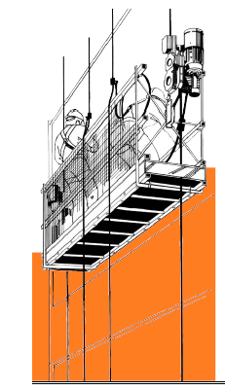
Fig. # 17

11-1-6-1 General Requirements:
- Every suspended scaffold shall be provided with adequate and suitable chains or ropes and winches or other lifting appliances or similar devices and shall be suspended from suitable outrigger beams, joists, runways, rail tracks or other equally safe anchorage.
- The winches or other lifting appliances or similar devices of a suspended scaffold shall be:
- Provided with a brake or similar devices which comes into operations when the operating handle or lever is released.
- Adequately protected against the effects of weather, dust or material likely to cause damage.
- The outrigger beams for a suspended scaffold shall be:
- Of adequate length and strength and properly installed and supported.
- Installed horizontally and provided with adequate stoppers at their outer ends.
- Properly spaced having regard to the construction of the scaffold and of the runway, joist or rail track on which the scaffold is carried.
- When counterweights are used with outriggers, this counterweights shall be securely fastened to the outriggers and shall not be less than four times the total weight of the scaffold (its weight + capacity).
- To avoid using large amounts of counterweights (counterbalance) the part of the outrigger installed on the roof of the building shall be much longer than hang over part of the outrigger where the wire ropes carrying the scaffold will be attached.
- All workers using such types of scaffolds shall be provided with appropriate fall protection system consisting of a full body harness, lanyard, shock absorber, rope grabbing device and lifeline (See fig. # 18).

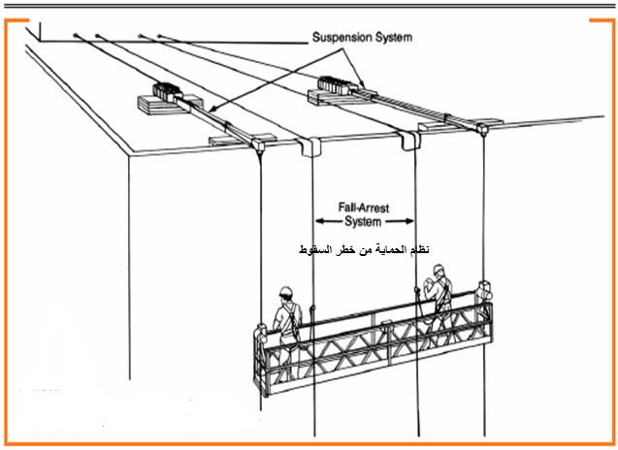
Fig. # 18

- The points of suspension of every suspended scaffold shall be an adequate horizontal distance from the face of the building or other structure.
- Every runway joist and rail track supporting a suspended scaffold shall be:
- Of suitable and sound material;
- Of adequate strength for the purpose for which it is used.
- Free from patent defect.
- Provided with adequate stoppers at each end; and
- Properly secured to the building.
- The suspension ropes or chains of a suspended scaffold shall be:
- Securely attached to the outriggers or other supports and to the platform framework or to any lifting appliance or other device attached thereto, as the case may be; and
- Kept in tension.
- Where winches are used with suspended scaffolds the suspension ropes shall be of such a length that the lowest position at which the scaffold is intended to be used, there are not less than two turns of rope remaining on each winch drum and the length of each rope shall be clearly marked on its winch.
- Every part of a suspended scaffold, and all plant and equipment used for that purpose shall be: of good construction, suitable and sound material, and properly maintained, and where constructed of metal, free from corrosion.
- No wire other than wire rope shall be used for the raising, lowering and suspension of a suspended scaffold. on suspended scaffolds.
- The platform of every suspended scaffold shall be:
- Clearly boarded, planked or plated;
- Be at least 60 cm wide if used as footing only and not for the deposit of any material.
- Be at least 80 cm wide if used for the workers and deposit of material.
- Be acceptable to 43 cm wide if it is used as wooden passage.
- The space between the face of the building or structure and the platform shall not be more than 30 cm.
- All suspended scaffolds shall be inspected by a third party company approved by the concerned local authorities and shall issue a testing certificate, inspection shall be repeated in case there is any alteration to the location of the scaffold, and a new testing certificate shall be issued.

11-1-6-2 Cradle Scaffolds:
This type of scaffolds has only one working platform suspended by means of extended outrigger beams fixed on the roof of the building. Cradles may be (traveling) i.e. able to be raised or lowered and traversed horizontally or (fixed) i.e. able only to be raised or lowered.
This type of scaffolds for painting and windows and stone cleaning and other similar activities. (See fig. # 19).
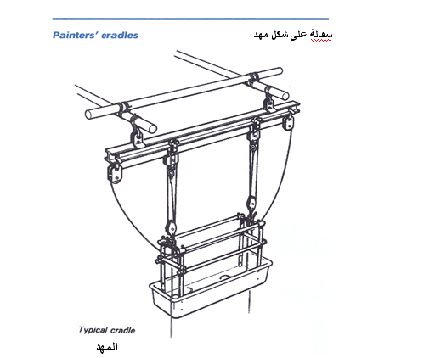
Fig. # 19
11-1-6-3 Boatswain’s Chairs, Cages, Skips etc. (Not Power Operated) :

- No boatswain’s chair, cage, skip or similar plant or equipment, not power driven appliance, shall be used unless :
  - It is of good construction, suitable and sound material, adequate strength, free from patent defect and properly and adequately maintained.
  - The outriggers or other supports are of adequate strength and properly installed and supported.
  - Chairs, ropes and lifting gear are firmly secured to the outriggers and to the chair, skip, etc.
  - Suitable means are provided to prevent any occupant falling out.
  - It is free of materials or articles liable to interfere with the occupant’s handhold or foothold or otherwise endanger him.
  - Suitable measures are taken to prevent spinning or tipping in a manner dangerous to any occupant.
  - In the case of any skip or other receptacle it is at least 0.9 x 1.15 m deep.
  - Its installation has been, and its use is, supervised by a competent person.
- Boatswain’s chair, cage, skip or similar plant or equipment not power operated, shall be used as a working place only when the work would not take long enough to make use of a suspended scaffold reasonably practicable.

=========================================================

