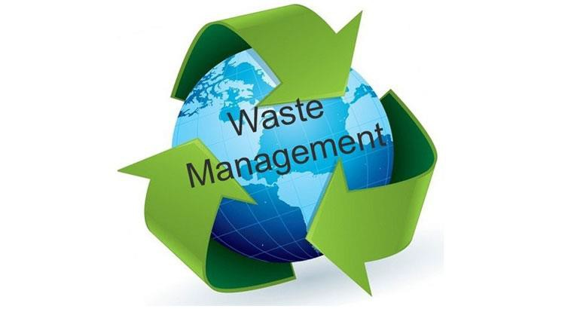

Waste management
(EM506)

Dr. Abeer M. Salama

Waste:
Waste management

Wastes are materials that are not prime products (that is products produced for the market) for which the initial user has no further use in the purposes of production, transformation or consumption, and needed to be disposed.
Wastes may be generated during the extraction of raw materials, the processing of raw materials into intermediate and final products, the consumption of final products, and other human activities.

Wastes classification:
wastes are divided into Three main categories:

Hazardous wastes:
Hazardous waste is waste that is dangerous or potentially harmful to our health or the environment. Hazardous wastes can be liquids, solids, gases, or sludges. They can be discarded commercial products, like cleaning fluids or pesticides, or the by-products of manufacturing processes.

Solid wastes:
EPA defines solid waste as any garbage or refuse, sludge from a wastewater treatment plant, water supply treatment plant, or air pollution control facility and other discarded material, including solid, liquid, semi-solid, or contained gaseous material resulting from industrial, commercial, mining, and agricultural operations, and from community activities.

Non-classical wastes:
includes disaster wastes, geo-hazards and electronic wastes.

Waste minimization:

Waste Minimization, as currently defined by EPA, is the reduction in the amount of toxicity or waste produced by a facility.
it includes:
- Source reduction
- On-site recycling

Source Reduction :
Changing practices and processes to reduce or eliminate the generation of hazardous wastes and materials.
It includes any practice which
- reduces the amount of any hazardous substance, pollutant, or contaminant entering any waste stream or otherwise released into the environment prior to recycling, treatment, or disposal.
- reduces hazards to public health and the environment associated with their release.
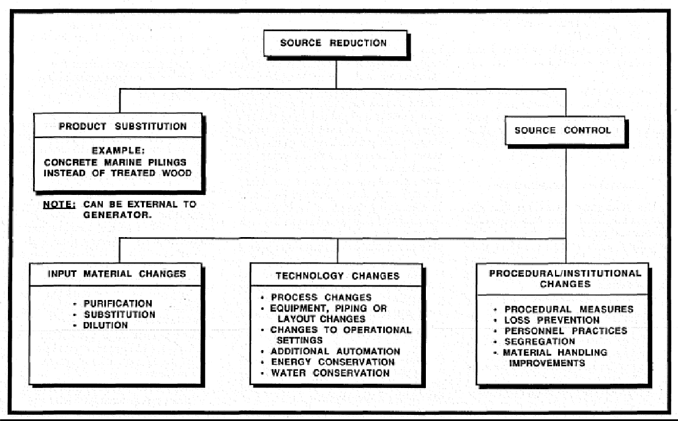

Recycling

The use or reuse of a waste as an effective substitute for a commercial product, or as an ingredient or feedstock in an industrial process.
Recycled materials are used for another purpose, treated and reused for the same purpose, or reclaimed for another use, rather than being discarded as waste.
It also means the use, reuse, or reclamation of a waste, either on or off-site, after it is generated by a particular process.

On-site recycling | Off-site recycling
recycling of process wastes is best handled within the production facility.  It has many advantages:  wastes can be most efficiently re- used close to the point of generation.  reduce raw material costs as well as waste handling and disposal costs | waste materials can be taken to another off-site facility for recycling. This depends on the availability and location of off- site recycling facilities.  Off-site recycling usually involves chemical or physical processing of waste materials to recover valuable portions.  materials which are commonly recycled off-site include oils and  solvents, electroplating sludges and lead-acid batteries.

Some examples on recycling include:
  - Re-distilling used-solvents for recovering solvents since solvents can be extremely flammable or explosive
  - Returning unused pharmaceuticals to a reverse distribution company

Collecting and reusing acetone or ethanol, used for drying glassware, several times before disposal.

Why Waste Minimization is Important
  - Businesses are facing stricter regulatory requirements in the management, transportation, and disposal of hazardous waste.
  - The number of hazardous waste disposal facilities has decreased.
  - There are greater restrictions in the use of landfills.
  - Transportation and disposal costs are rising.
  - The long-term liability associated with handling and disposal of hazardous waste is substantial.

Solid waste management

Definition of solid wastes:
EPA defines solid waste as any garbage or refuse, sludge from a wastewater treatment plant, water supply treatment plant, or air pollution control facility and other discarded material, including solid, liquid, semi-solid, or contained gaseous material resulting from industrial, commercial, mining, and agricultural operations, and from community activities.

Classification:
Solid wastes can be classified according to:
  - source
  - Biological properties
  - physical properties

1* Solid wastes according to their sources:
- Municipal wastes, is commonly known as trash or garbage— consists of everyday items we use and then throw away, such as product packaging, grass clippings, furniture, clothing, bottles, food scraps, newspapers, appliances, paint, and batteries. This comes from our homes, schools, hospitals, and businesses.

- Industrial wastes Solid, semi-solid, liquid, or gaseous, unwanted or residual materials (not including hazardous or biodegradable wastes) from an industrial operation.

2*Classification according to biological properties:
- Native organic waste: easily biodegradable waste. Includes food waste, agricultural waste, and generally any matter from a living organism.
- Artificially synthesized-organic waste: includes artificially synthesized plastics, textiles and most waste made of polymers and paper.
- Mineral waste: waste composed of metals or other minerals. Includes ferrous metals and nonferrous metals such as aluminum and copper.
- Hazardous waste: wastes or mixtures of wastes that pose a substantial present or potential hazard to human health or any other living organism. Includes toxic, explosive, ignitable, oxidant and radioactive waste, heavy metals containing waste and hospitals waste. Their transport and treatment is highly regulated, especially by the Basel convention.

3*Classification according to physical properties

Specific Weight (Density) is defined as the weight of a material per unit volume (e.g. kg/m3) Usually it refers to uncompacted waste.
It varies with geographic location, season of the year, and length of time in storage.

Moisture Content: The moisture in a sample is expressed as percentage of the wet weight of the MSW material.
Particle Size and Distribution The size and distribution of the components of wastes are important for the recovery of materials, especially when mechanical means are used such as magnetic separators.
Field capacity is the total amount of moisture that can be retained in a waste sample subject to the downward pull of gravity. It is critically important in determining the formation of leachate in landfills.
Permeability of Compacted Waste is an important physical property because it governs the movement of liquids & gases in a landfill.

Impact of solid waste on the environment

- The accumulation of solid waste at landfill sites can lead to a contamination of air, water, groundwater and soil.
- Solid waste disposal sites are found on the outskirts of the urban areas, and have negative impacts…
- The incubation and proliferation of flies, mosquitoes, and rodents; that, in turn, are disease transmitters that affect population's health
- This situation produces gastrointestinal, dermatological, respiratory, genetic, and several other kind of infectious diseases.
- Dumping sites have a very high economic and social cost in the public health services

Waste minimization of solid wastes

Waste minimization is near the top of almost every version of a waste management hierarchy and is considered to be the most important management technique to be applied to solid waste.

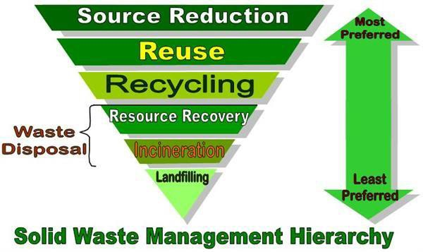

  - includes source reduction or practices that reduce or eliminate waste generation at source and environmentally sound recycling practices.
- It does not include waste treatment (or any process designed to change the physical, chemical or biological composition of wastes.

- Source reduction, or waste prevention, is designing products to reduce the amount of waste that will later need to be thrown away and also to make the resulting waste less toxic.

Benefits of Reducing and Reusing

  - Saves energy;

  - Reduces greenhouse gas emissions that contribute to global climate change;
  - Helps sustain the environment for future generations;

  - Saves money;

  - Reduces the amount of waste that will need to be recycled or sent to landfills and incinerators;
  - Allows products to be used to their fullest extent.

  - Source prevention is done by any change in design, manufacture, purchase, or use of materials or products to reduce their amount or toxicity before they become municipal solid waste.
- Recycling is the recovery of useful materials, such as paper, glass, plastic, and metals, from the trash to use to make new products, reducing the amount of new raw materials needed.

The steps of recycling

1- Collecting and sorting discarded materials by type, 2 taking the materials to a recycling facility,
- cleaning the discarded materials so that they can be shredded or crushed
- reusing the shredded or crushed material to manufacture new products

Composting

  - It is considered to be a form of recycling of solid wastes. It is consisted of the aerobic decomposition of organic waste by micro (bacteria, yeasts, fungi…) and macro organisms (earth worms, mites, other insects…).
  - Collecting organic waste, such as food scraps and yard trimmings, are stored under conditions designed to help it break down naturally.
  - The process is controlled through monitoring the temperature of the compost pile and the CO₂ level, turning and moisturizing it when needed.
  - According to EPA composting can then be used as a natural fertilizer.
  - Recycling and composting prevented 85.1 million tons of material away from being disposed of 2010.
  - This prevented the release of approximately 186 million metric tons of carbon dioxide equivalent into the air.

Treatment and disposal of solid wastes include:

- Recovery is the conversion of non-recyclable waste materials into useable heat, electricity, or fuel through a variety of processes.
  - Converting non-recyclable waste materials into electricity and heat generates a renewable energy source and reduces carbon

emissions by offsetting the need for energy from fossil sources and reduces methane generation from landfills.
  - This process is often called waste-to-energy (WTE) and includes:

Incineration: a technology that involves the complete oxidation of organic waste to carbon dioxide and water vapor (combustion) in an incinerator (a furnace) to recover the resulting heat which can be used as so or be converted to electricity.
Pyrolysis: a technology that involves the drying and decomposition of organic substances in absence of oxygen. The products are synthetic gas (mainly composed of hydrogen H2 and carbon monoxide CO), which can be directly used as a fuel
Gasification: a technology that consists on converting organic substances into fuel gas or synthesis gas by partial oxidation with pure oxygen. The byproduct is a dense inert solid compound, destined to the landfill or to serve as construction material.

Disposal (landfilling)

Landfills are engineered areas where waste is placed into the land. Landfills usually have liner systems and other safeguards to prevent polluting the groundwater.
  - Some materials may be banned from disposal in municipal solid waste landfills including common household items such as paints, cleaners/chemicals, motor oil, batteries, and pesticides.
  - Leftover portions of these products are called household hazardous waste. can be dangerous to your health and the

environment. Many municipal landfills have a household hazardous waste drop-off station for these materials.

e* Solid wastes in Egypt
  - The total quantity of solid wastes generated in Egypt is 63 – 69 million tons/year, including municipal solid waste (garbage), industrial waste, agricultural waste, sludge resulting from sanitation treatment, hospital wastes, construction and demolition debris and wastes from the cleaning of canals and drains.

Case study from Dakahleya Governorate

The problem :

A much of the governorate is prime agricultural land, the availability for landfilling is severly limited.
  - Wastes generation at Mansoura and its surrounding is estimated to be 305 ton per day.
  - This waste contains:
*Orgainc content 60-70%
*Recyclable material 3-7%
  - For the waste management of organic wastes in the governorate, a 150 ton per day municipal solid waste composting plant has been constructed at Mansoura.
  - This waste was previously disposed it in the city’s dumpsites.
  - Composting reduced the material to be landfilled by 40%.
  - Governorate is being reclaimed for which compost will be used as soil conditioner.

E-waste (solid waste)
- E-waste contains more than 1000 different It may be ‘hazardous’ or ‘non-hazardous’.
- it consists of ferrous and non-ferrous metals, plastics, glass, wood and plywood, concrete and ceramics, rubber, etc.
- Iron and steel constitute about 50% of the products, plastics – 21%, non-ferrous metals – 13%, and other constituents account for the rest.
- Non-ferrous metals are the likes of copper, aluminium, silver, gold, platinum, and palladium. The presence of elements such as lead, mercury, arsenic, cadmium, selenium, hexavalent chromium, and flame retardants classifies e-waste as hazardous waste

Electronics and Moore’s law

- Moore's Law is well known as a description of the dramatic and continuing reduction in the size and cost of computer technology.
- When the size of such electronic devices decreases the amount of raw materials needed for their production is reduced, and thus the resources can be conserved. Likewise when the hardware size decreases, the amount of e waste created and disposed also decreases.
- By reducing both the quantity of hazardous materials used in the process and the amount of excess raw materials in stock, the quantity of waste generated can be reduced.

- Usage of raw materials carefully and ordering only the needed quantity of materials for production can reduce the adversity of e waste recycling. This also helps in lowering the production cost of devices, since the raw materials used are waste, resources can be acquired at a much lower cost than fresh resources.
- improved operating and maintenance procedure, thereby increasing the efficiency of the existing production equipment, help in improving the efficiency of production process.
- Instituting standard operation procedures can optimize the use of raw materials in the manufacturing process and also can reduce the potential for materials to be lost through drips, leaks and spills. A strict maintenance course, which stresses corrective maintenance, can reduce waste generation caused by equipment failure.
Using cloud computing ………. technology that uses the internet and central remote servers to uphold data and applications.
- Customers are buying physical space on the company’s servers for their web files to reside, when they pay the companies to host their website. Using the Internet clients can add, remove, or modify those files just as one would if that server was in their office - except in this occasion they are working with equipment that may be thousands of miles away. This way is a pay-as- you-go form which allows clients to scale up or down depending on their needs. When it comes to expensive hardware, clients can save a lot by buying only what they use.

- seizes the conventional components of IT infrastructure,

- the hardwares are replaced by online services and softwares

- Reducing the storage and network sprawl reduces the need to build more data centers.
- This solution gives the customers the capability to deliver products and services in a fast as well as a convenient way
- The methodology helps the clients to use the resources available at different servers located at different geographical area, thus they have access to the various data and applications

Hazardous waste

What is a hazardous waste?

- EPA defines hazardous waste as "a solid waste, or combination of solid wastes, which because of its quantity, concentration, or physical, chemical, or infectious characteristics may (A) cause, or significantly contribute to an increase in mortality or an increase in serious irreversible, or incapacitating reversible, illness; or (B) pose a substantial present or potential hazard to human health or the environment when improperly treated, stored, transported, or disposed of, or otherwise managed.
According to Egyptian Law 4/1994 hazardous waste is defined as:

“Waste of activities and processes or its ashes which retain the properties of hazardous substances and have no subsequent original or alternative uses, like clinical waste from medical treatments or the waste resulting from the manufacture of any pharmaceutical products, drugs, organic solvents, printing fluids, dyes and painting materials”.

The Hazardous Characteristics

Solid, liquid, or gaseous wastes are considered hazardous if they possess one or more hazardous characteristics of the following:
  - Flammable: capable of burning or causing fire. It describes:

    - waste liquids that give off flammable vapors at a
0
temperature of 60.5 C.

    - solid waste which under transport conditions are readily combustible or may cause or contribute to fire through friction.
    - waste which is liable to spontaneous heating under normal conditions and then being liable to catch fire.

Corrosive: able to corrode steel by chemical reaction as a result of extreme acidic or basic properties and is capable of causing severe damage when in contact with living tissues.
Examples include waste alkalis such as caustic soda (sodium hydroxide) and waste acids such as sulphuric acid, nitric acid, hydrochloric acid, etc.
- Reactive: undergoes violent reactions with air and/or water. It describes waste that:
  - is normally unstable and undergoes violent change without detonation.
  - is readily capable of detonation or explosive decomposition or reaction at standard temperature and pressure
  - forms potentially explosive mixture with water

  - When mixed with water, generates toxic gases, vapors, or fumes in a quantity sufficient to present danger to human or environment.

Examples include wastes containing alkali and alkaline earth metals, phosphorus pentachloride.

2
- Oxidizing: waste giving rise to highly exothermic
reactions when

in contact with other substances, particularly flammable substances and may, by yielding oxygen, cause or contribute to the combustion of other materials.

Examples include waste nitric acid, peroxide-containing waste.
- Irritant: non-corrosive wastes which, through immediate, prolonged or repeated contact with the skin or mucous membranes can cause inflammation or other skin symptoms.

Examples include waste chemicals such as tetra chlorobenzene, triethyl amine, acetic acid.
- Toxic: waste containing substances which are poisonous. It describes:

  - waste which, if inhaled or ingested, or penetrates the skin may involve delayed or chronic effects including carcinogenity
  - poisonous waste which may cause death or serious injury if swallowed or inhaled or contacted the skin. Examples include wastes containing cyanide, chromium VI, arsenic, cadmium, and other heavy
3
metals, in a dispersible form .

Harmful: waste containing substances and preparations which, if inhaled or ingested or penetrates the skin, may involve limited health risks.
Examples include waste xylene, pyridine, styrene, lubricant oils and emulsions.
- Ecotoxic: waste which may have toxic effects on biotic systems and which if released may present immediate or delayed environmental adverse impacts by means of bioaccumulation and/or toxic effects on one or more sectors of the environment.

4
Examples include PCB
pesticides.

5
waste, DDT

waste, some waste

- Carcinogenic: waste which, if inhaled or ingested or penetrates the skin, may induce cancer in man or increase its incidence. Examples include waste benzene.

Teratogenic: waste containing substances and preparations which if inhaled or taken internally or penetrates the skin may induce non-hereditary genetic deformations, or increase their incidence.
Examples include waste containing ethylene thiourea, tetra ethyl lead, lead alkylates.
- Mutagenic: waste containing substances and preparations, which if inhaled or taken internally or penetrates the skin may induce hereditary inherent deformations, or increase their incidence. Examples include vinyl chlorides, DDT, aldrin and dieldrine

Hazardous Waste Classification System:

HW is classified on the basis of four main characteristics Ignitability, Corrosiveness, Reactivity and Toxicity.

listings :

- List S including special waste such as medical waste, radioactive waste, asbestos, waste oil and empty containers;
- List F including waste from non-specific industrial sources such as solvents, sledges from wastewater treatment, etc.
- List K including waste generated from specific industrial processes;

- List P including waste containing acutely hazardous materials;

- List U including waste containing discarded toxic off-specification materials.

EPA has established four hazardous waste lists:

- Hazardous waste from non-specific sources, or F wastes;

- Hazardous wastes from specific sources, or K wastes;

- Discarded commercial chemicals that are toxic, or P wastes; and

- Discarded commercial chemicals that are acutely hazardous, or U wastes.

Impacts of Hazardous Waste

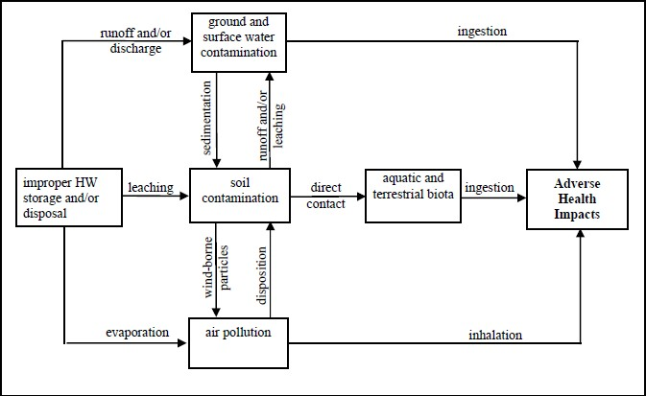

Management of Hazardous Waste:

- Handling License

- Reduction of source

- Identification

- Segregation

- On site Storage

- On Site treatment

- Transportation

- Disposal

Handling License:

  - The handling is any [activity] that leads to the movement of materials, with the intention of collection, transporting, storing, treating, or using them
  - handling license for :

on-site handling, on-site storage, on-site transportation, on-site recycling and recovery) do not need handling licenses.

Identification

Establish complete descriptions of their generated hazardous waste, indicating quantities and composition

Segregation

Hazardous waste must be separated at source from other types of non- hazardous waste. Besides, the different types of hazardous waste must not be mixed together in order to avoid any undesired harmful interaction between.

On-site Storage of Hazardous Waste A-Storage areas
- should be away from public places in order to prevent any harm to the public

- These areas should be clearly designated and equipped with the necessary safety and protection equipment such as fire extinguishers, protective clothing, absorbing materials and first aid equipment.

- The industrial establishment must have an emergency plan for accidents, particularly spills and fire.

B- Storage containers

- Hazardous waste storage containers must be of inert materials . corrosive waste can be stored in plastic drums, or plastic-lined metal drums.
- Storage containers must also be properly sealed to avoid any leakages or spills during storage or movement.

- The hazardous waste containers should be labeled with clear signs indicating their content, the handling requirements and the associated hazards if improperly handled.
- It is recommended that the storage area is inspected on periodic basis for the purpose of detecting leaks or deteriorations of containers.

On-site Treatment of Hazardous Waste
- For on-site treatment, the industrial establishment should obtain a license from the Ministry of Industry.
- The treatment site is to be equipped with the necessary protective and safety requirements prescribed in the labor and occupational health regulations.

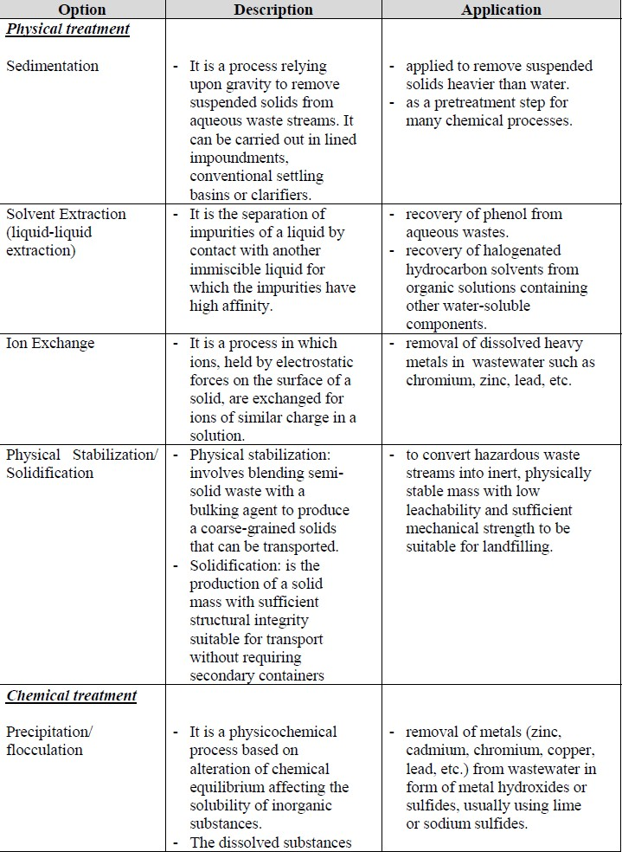

Transportation of Hazardous Waste
- Collection of hazardous waste for off-site transfer should be carried out according to an appropriate time schedule set to avoid accumulation of waste on site for long periods.
- In case the waste is not transported by the industrial establishment generating it, it should be delivered only to licensed hazardous waste transport contractors,

- For hazardous waste transported off-site by the generating industrial establishment, the establishment should obtain HW transportation licenses from the concerned authority.
- The generating establishment is also to ensure that vehicles used in transport meet the requirements of the Law, namely:

The capacity of the vehicles
- The vehicles must be clearly signed indicating the type of waste transported.
- The vehicles must be equipped with the necessary safety equipment, such as fire extinguishers, protective clothing and absorbing materials in case of spills, as well as first aid equipment, etc.

- Drivers of these vehicles must be trained to take the necessary action in case of emergencies and accidents.
- Hazardous waste transport vehicles should not pass through populated areas through daytime, in order to minimize risks in case of accidents.

Disposal of Hazardous Waste
disposal license from the Ministry of Industry. Sites where hazardous waste are disposed of are to be located at a minimum distance of 3 km from populated and residential areas. Moreover, such sites must meet the following requirements:
- Their areas must be adequate to accommodate the waste to be disposed of.

- The sites must be surrounded with brick walls of minimum height of 2.5 m.
- The sites must be provided with more than one entrance gate of suitable width to enable easy access of waste transport vehicles.
- The sites must be equipped with all necessary safety equipment described in the labor and vocational health laws, a telephone line, water supply, and all other equipment and facilities necessary for the disposal of the waste.

Hazardous Waste Minimization:

  - Reducing the amount of hazardous substances

  - Reducing the hazard (toxicity)

Waste Minimization Options

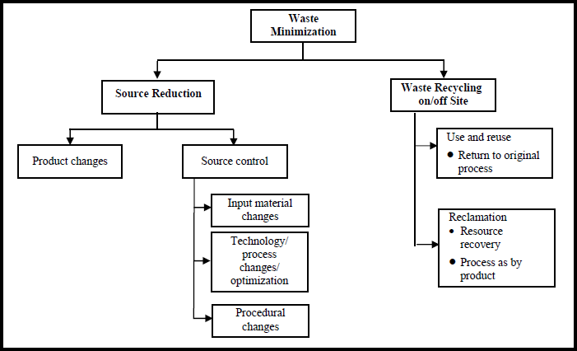

- Source Reduction
Source reduction is the use of materials, processes, or practices that reduce or eliminate the generation of wastes at the source .

The adoption of source reduction approach is usually encouraged because it is often the most cost-effective option as it may reduce raw material losses, energy and water consumption, the reliance on expensive "end-of-pipe" treatment technologies and disposal practices and most importantly reduces the potential liability associated with improper management of waste

A- Product change:
- This involves the replacement of a product with another one suitable for the same end use, with the generation of less or no hazardous waste
- Examples for product change include:
  - Batteries can be redesigned such that the toxic constituents, for example mercury and cadmium are reduced or eliminated.
- Using PET (Polyethylene Terephthalate) instead of PVC (Polyvinyl Chloride) in pipes and plastic manufacturing

B- Source control
- Source control encompasses input material substitution, re- engineering production processes and/or improving procedural practices.

A- Input material changes
This reduction can be achieved by replacing the hazardous input materials with less or non-hazardous ones.
Examples for input materials substitution include:
  - The use of non-toxic, non-carcinogenic dyes with no heavy metal content in the textile industries

- The use of water-base inks and pigments instead of the solvent- base ones.

B- Technology/ process changes
This option can be implemented through improving or modifying the existing technologies used in production processes.

Good housekeeping
Good housekeeping or sound procedural practices play a considerable role in controlling waste at source.

Recycling:
The second option for waste minimization is recycling. When a waste material is used for another purpose, treated and reused in the same process, or reclaimed for another process, this is called recycling.

Reuse:
Reuse refers to the direct use once more of the waste, in the form it is generated in, in the same industrial process it is generated from, or in another processes, without the need for prior treatment or modification.
  - Examples for waste reuse:
    - Reuse of solvents for equipment cleaning
    - Reuse for acidic and alkali solution
    - Reuse of ferric chloride waste from manufacture of titanium oxide as wastewater conditioner
    - Reuse of chromium solutions in tanneries

Recovery or reclamation
This involves recovering and treating “waste” byproducts to be used as raw materials in the same or another process. Reclamation processes include chemical, physical and electrochemical separation; some of the major reclamation technologies include the following:
    - Distillation of solvent wastes
    - De-chcloronation of halogenated solvent wastes
    - Metal concentration techniques such as leaching, solvents extraction, ion exchange, precipitation, crystallization, and evaporation to treat dilute metal-bearing waste streams

Case Studies:

Case Study for Industrial Hazardous Waste Minimization: Sulphur Black dyeing in Textile Industry:
  - Sulphur dyes are mainly used for dyeing cotton, rayon and cotton- synthetic blends
  - Sulphur black dyes are converted from the insoluble state into the water soluble state using a reducing agent such as sodium sulphide in order to be easily absorbed.

Problem Description
The adverse aspects of sluphur black dyeing result from the use of both sodium sulphide (skin irritant, can cause eye injuries, and corrosive substance) and the dichromate solution (chromium VI which can cause cancer, and chronic irritation of the respiratory

track) which may leave harmful residues on the fabric and generate effluents that are damaging to the environment.
  - The minimization measures implemented entailed substituting the hazardous sodium sulphide and potassium dichromate by less harmful substances, while retaining the quality of the dyeing process.
  - Possible sodium sulphide substitutes included glucose dextrose, dextrine and hydrol.
  - Acidified Dichromate substitutes included hydrogen peroxide, sodium perborate, ammonium persulphate and potassium iodate
  - Sodium perborate and glucose were found acceptable as substitutes for dichromate and sodium sulphide respectively. This was mainly due to their reasonable costs as well as their good operation results.
  - saving of 2 to 16 % for all consumable materials has been achieved for each ton of fabric.
  - Decrease the concentration of Sodium sulphide and acidified dichromare.

RADIOACTIVE WASTE MINIMIZATION AND PROCESSING:
  - The application of radioactive materials and radiation provides numerous benefits to people and society, and plays a significant role in everyday life. This includes scientific, medical, agricultural and industrial applications.

Radioactive waste is material that is radioactive that is no longer needed at the plant and can be disposed of.

  - Radioactive waste management involves treatment, conditioning, transportation, storage and disposal of all categories of radioactive wastes, including administrative, operational and safety-related activities.

Radioactive Waste Minimization:
The process of reducing the amount and activity of radioactive waste
A- by reducing waste generation and
B- by means such as recycling and reuse, and treatment,

Consideration of waste minimization
A- in the design and construction phases of nuclear facilities. The main design-related, technical options are:
  - the proper choice of materials (resistance to corrosion, high- quality surface treatments, low tendency to activate and/or produce radionuclides that may cause problems
  - application of the most effective, reliable and up-to-date technology.
  - minimization of leakage/drainage to .
  - strong separation of radioactive and non-radioactive media .

Recycle / Reuse
  - the segregation of materials for recycle or reuse can be an effective way to minimize the amount of radioactive waste that needs to be managed.

  - Factors supporting this shift the ever-increasing cost of radioactive waste disposal

  - treatment: operations intended to benefit safety and/or economy by changing the characteristics of the waste. Three basic treatment objectives are
- volume reduction,
- removal of radionuclides from the waste,
- change of composition of the waste.
The current, commonly used methods for treating include: 1- compaction, super compaction, and incineration (solids)
2-chemical precipitation, evaporation, ion-exchange, and membrane separation (liquids)

  - conditioning: operations that produce a waste package suitable for handling, transport,
storage and/or disposal.
Conditioning may include the conversion of the waste to a solid waste form, enclosure of the waste in containers and, if necessary, providing an over-pack.

Cradle to Cradle: Turning Nuclear “Waste” into Nuclear Fuel:
  - Most of the spent fuel from nuclear reactors follows a typical one- way cradle-to-grave model.
  - The cradle-to-cradle concept, technical closed-loop options for used nuclear fuel, benefits and limitations to closed-loop

processes, as well as key figures for a cradle-to-grave versus cradle-to-cradle nuclear industry are provided.
  - nuclear power plants, their model of eco-effectiveness provides an appropriate framework for taking a look at spent fuel recycling.

Cradle-to-Cradle – Technical Options for Used Nuclear Fuel
  - There are various recycling technologies of varying maturity, including:
- Hydrometallurgical processes (well-proven technologies). These processes involve dissolving the fuel elements in concentrated nitric acid and separating products through solvent extraction steps:
    - Plutonium Uranium Extraction (PUREX, a hydrometallurgical process that produces reusable uranium following re-enrichment, plutonium, intermediate and high level wastes)
- Uranium Reduction Extraction (UREX process where uranium is recovered initially for recycle
- Co-extraction (COEX™, a hydrometallurgical process that separates a combined uranium and plutonium from the other products.
  - Vitrification is a process used to solidify concentrated solutions of fission products and trans-uranic elements separated during spent fuel recycling by mixing them with a glass matrix at high temperature; this glass can safely store the radioactive products (thermal stability, lixiviation, resistance, irradiation resistance, resistance to alternation with time, homogeneous).

  - The uranium recovered through recycling can be re-enriched and used as new fuel in a reactor. The plutonium-uranium mixture recovered from used fuel can be used to make mixed oxide fuel (MOX), and used as new fuel in a nuclear power plant

Waste Minimization in Cement Industry

  - Cement is a mixture of compounds, consisting mainly of silicates and aluminates of calcium, formed out of raw materials consisting calcium oxide, silica, aluminum oxide and iron oxide.
  - Cement is manufactured by burning a mixture of calcareous and argillaceous raw materials and suitable corrective materials at high temperatures in a kiln, and then finely grinding the resulting clinker along with gypsum. The end product thus obtained is called Ordinary Portland Cement (OPC).
  - The cement industry is an energy intensive industry with total energy cost typically accounting for 40 – 45 % of production costs
•
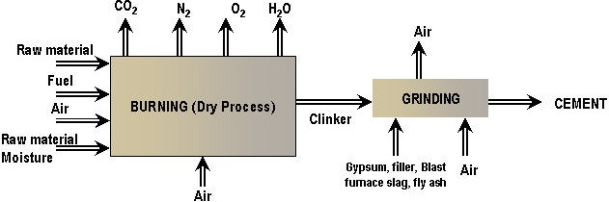

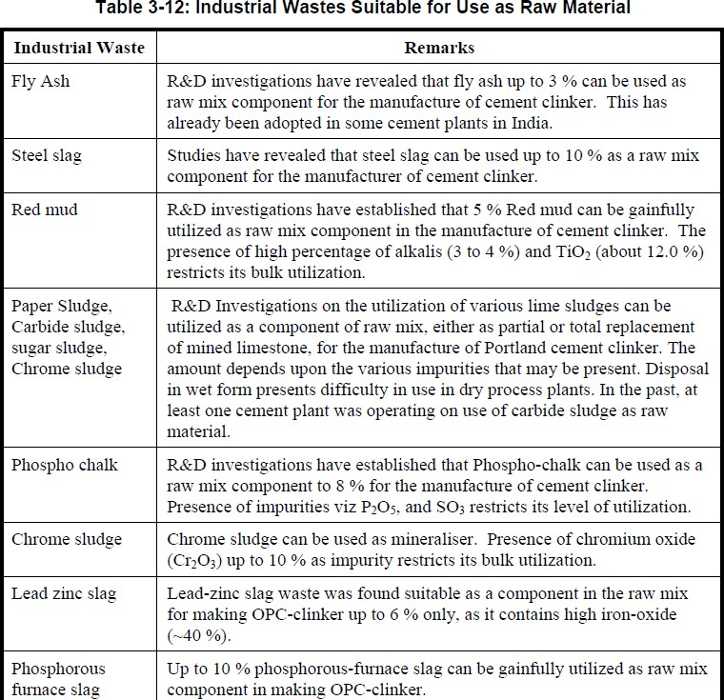

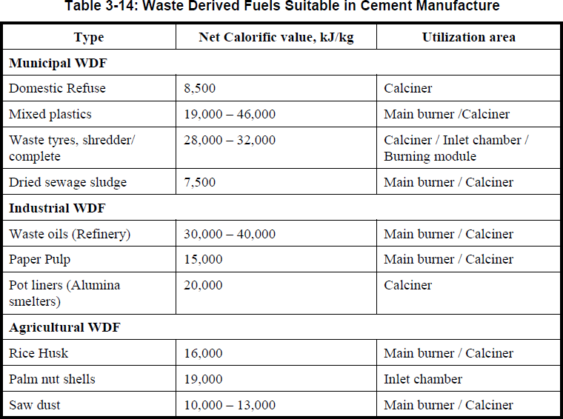

- Internationally, the cement industry is moving toward the use of alternative fuels such as tires, lubricants and oils.
- The use of alternative fuel can save cost and contribute to solution of the environmental problems.

Suez Cement Group Company:

  - All SCGC plants apply the requirements of Environment Management System (EMS) ISO 14001/2004 and renew their ISO 14001 certificates separately.
  - SCGC is currently applying CSI guidelines with regards to the

responsible use of resources, utilizing non-quarried materials

slag and broken clay bricks as a substitution of clinker in cement with 10.42% of quarried raw materials in cement production.
  - The group’s Kattameya plant was authorized to utilize alternative fuels as partial replacement of fossil fuels in September 2011, burning biomass. Now, five big kilns out of a total of 7 in the whole group are authorized to utilize alternative fuels such as biomass, refuse derived fuel (RDF) and sewage sludge.
  - Conversion of three electrostatic precipitators for raw mills and replacement of the two gravel bed filters with one bag house filter in line 8 at Tourah plant. This resulted in a drastic reduction of dust emissions from 250 to 20 g/m3

